

CAPSTONE PROJECT REPORT
Report 4 – Software Design Document

– Hanoi, August 2019 –

Table of Contents
I. Record of Changes 3
II. Software Design Document 4
1. System Design 4
1.1 System Architecture 4
System Architecture Diagram 4
Detail: System Architecture 4
1.2 Package Diagram 5
Backend Package Diagram 5
Detail: Backend Package Diagram 5
WebApp Package Diagram 6
Detail: WebApp Package Diagram 6
MobileApp Package Diagram 7
Detail: Mobile Package Diagram 7
2. Database Design 7
3. Detailed Design 8
3.1 Account, Trust & Access Control 8
3.2 Mother Care Journey 14
3.3 Baby Care Journey, Growth & Vaccination 20
3.4 Community Q&A & Moderation 25
3.5 Verified Expert Network & Contribution 29
3.6 AI Nurse Assistant & Risk Triage 33
3.7 Emergency Map & Nearby Care Support 37
3.8 Personal Health Records & Source Labeling 40
3.9 Reminders, Tasks & Care Plan 44
3.10 Family Sync & Cooperative Care 46
3.11 Verified Content & Checklist Hub 51
3.12 Expense & Preparation Planner 54
3.13 Connected Device & Health Data Integration 56
3.14 Smart Activity Monitoring & Safety Support 58

I. Record of Changes
Date | A*  M, D | In charge | Change Description
20/6/2026 | A | HuyND | Add 1.1 System Architecture
1/7/2026 | M | HuyND | Edit 1.1 System Architecture
9/7/2026 | A | HuyND | Add 3. Detailed Design
9/7/2026 | A | PhuongNT | Add 1.2 Package Diagram
10/7/2026 | A | PhuongNT | Add 2 Database Design
15/7 | M | PhuongNT | Edit 1.2 Package Diagram
18/7/2026 | M | HuyND | Edit 3. Detailed Design
20/7/2026 | M | PhuongNT | Edit 1.2 Package Diagram
26/7/2026 | M | PhuongNT | Edit 2 Database Design
*A - Added M - Modified D - Deleted

II. Software Design Document

1. System Design

1.1 System Architecture
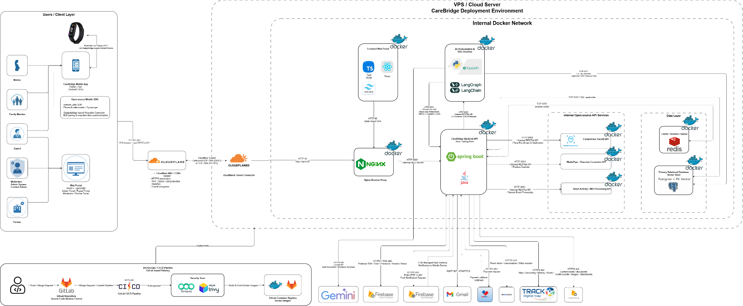
System Architecture Diagram
Detail: System Architecture

1.2 Package Diagram

1.2.1 Backend Package Diagram
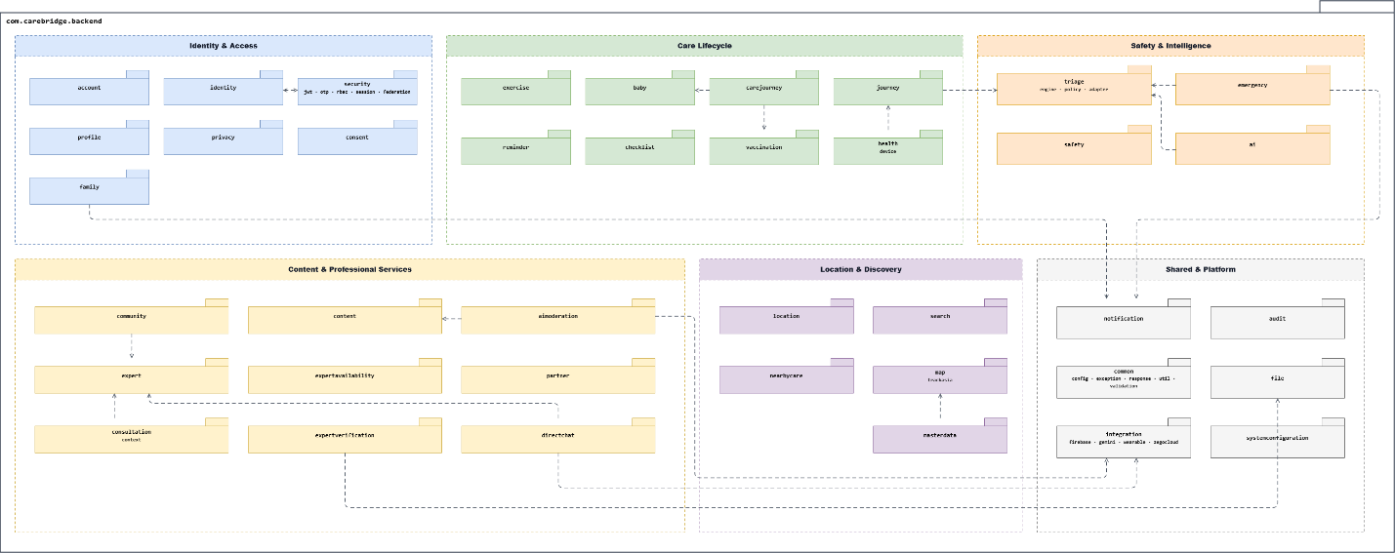
Backend Package Diagram
Detail: Backend Package Diagram
Package Descriptions
No | Package | Description
1 | com.carebridge.backend | Serves as the Spring Boot composition root and component-scanning namespace for the backend application.
2 | account | Manages account-deletion requests, their processing lifecycle, and deletion status.
3 | identity | Manages user sessions and administrative governance of users, staff accounts, and roles.
4 | security | Implements authentication, authorization, JWT and OTP handling, RBAC, federation, and security policies.
5 | profile | Provides retrieval and update operations for user profile information.
6 | privacy | Manages user privacy preferences and profile-visibility settings.
7 | consent | Records, validates, lists, and revokes user consent for protected data and care operations.
8 | family | Manages care groups, invitations, memberships, permissions, shared tasks, and family alerts.
9 | journey | Manages maternal-care journey onboarding, lifecycle transitions, dashboards, and pregnancy outcomes.
10 | baby | Manages baby profiles, profile access policies, archiving, and links between babies and care journeys.
11 | carejourney | Manages baby-care logs, growth measurements, milestones, expenses, timelines, and appointment preparation.
12 | health | Manages health data, measurements, connected devices, synchronization, and related health events.
13 | vaccination | Manages vaccination reference schedules, vaccination records, completion, and postponement.
14 | checklist | Manages personalized checklist items and imports checklist content from templates.
15 | exercise | Manages exercise content, exercise sessions, posture configuration, and posture-feedback processing.
16 | reminder | Manages reminders, medication and vaccination schedules, follow-up tasks, and daily task views.
17 | triage | Provides structured symptom intake, clinical-rule evaluation, AI-assisted risk assessment, health memory, and evidence management.
18 | emergency | Manages emergency sessions, emergency contacts, family alerts, escalation linkage, and map handoffs.
19 | safety | Provides IMU-based fall detection, safety-monitoring sessions, countdown handling, and safety configuration.
20 | ai | Extracts structured intake data with AI and publishes intake and escalation events for triage workflows.
21 | content | Manages health and educational content, categories, engagement, review, and content-moderation workflows.
22 | community | Supports community topics, questions, answers, feeds, engagement, and community-safety rules.
23 | aimoderation | Coordinates automated content scans, moderation policies, moderation cases, and human-review decisions.
24 | expert | Manages expert profiles, professional specialties, verification state, trust state, and contribution points.
25 | expertavailability | Manages expert availability, online status, and controlled location sharing.
26 | expertverification | Manages expert identity checks, professional credentials, document review, and face-verification adapters.
27 | consultation | Manages expert consultation requests and the controlled transfer of triage context and citations.
28 | directchat | Manages direct conversations, messages, calls, conversation policies, and asynchronous chat events.
29 | partner | Manages partner-organization profiles, registration details, approval decisions, and governance status.
30 | location | Captures, stores, and exposes user-location snapshots subject to access controls.
31 | map | Provides care-facility discovery and routing through map-provider integrations such as TrackAsia.
32 | nearbycare | Manages nearby-support requests and responses between users and available care experts.
33 | search | Provides federated search across content and community-question sources.
34 | masterdata | Exposes reference data such as administrative areas, hospitals, and professional specialties.
35 | common | Contains shared configuration, constants, exceptions, responses, utilities, and validation components.
36 | audit | Records audit logs, security events, incident notes, and administrative security investigations.
37 | notification | Manages device tokens, notification preferences, delivery records, FCM delivery, and domain notifications.
38 | file | Manages file metadata, upload and retrieval operations, access policies, cleanup, and cloud-storage providers.
39 | integration | Contains external-system gateways and adapters for Firebase, Gemini, wearable providers, and ZEGOCLOUD.
40 | systemconfiguration | Stores and exposes persistent runtime-configuration values used by administrative and automated services.
Table 1: Backend Package Diagram Descriptions

1.2.2 WebApp Package Diagram
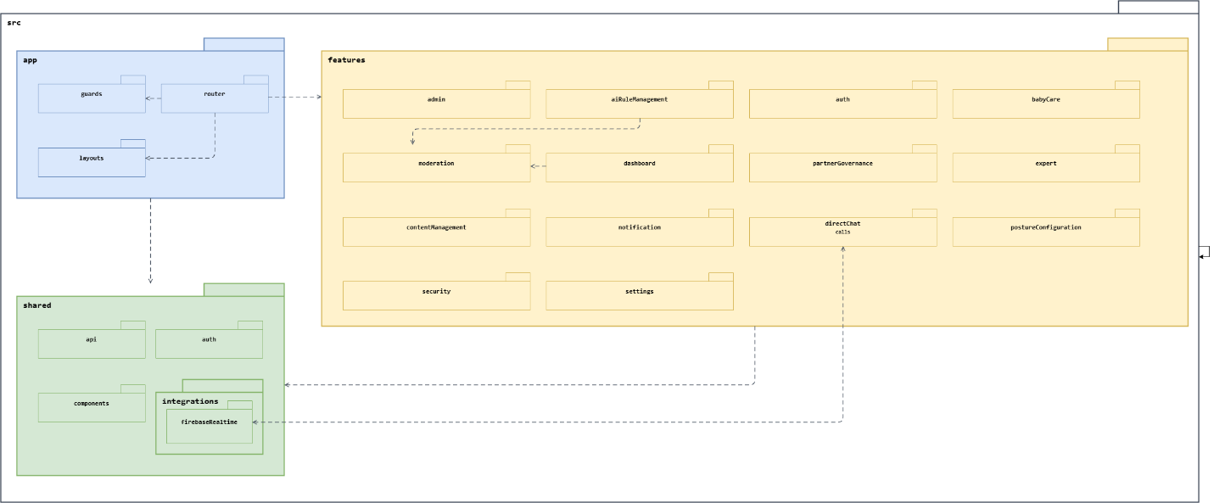
WebApp Package Diagram
Detail: WebApp Package Diagram
Package Descriptions
No | Package | Description
1 | app | Contains the Web application routing, access-control guards, and portal-layout composition.
2 | app.router | Defines the React Router route tree and maps routes to feature pages.
3 | app.guards | Enforces authentication, role authorization, onboarding, and role-aware redirection.
4 | app.layouts | Provides reusable layouts for authentication, administration, expert, and content portals.
5 | features | Contains independently organized business-capability packages for the Web application.
6 | features.admin | Implements administrator dashboards, user management, and audit-log access.
7 | features.aiRuleManagement | Manages AI-moderation policies, red-flag rules, and system-safety configuration.
8 | features.auth | Implements login, federated registration, OTP verification, account profiles, and blocked-account handling.
9 | features.babyCare | Provides Web entry pages for baby-care resources and unavailable-resource handling.
10 | features.contentManagement | Manages articles, FAQs, checklists, topics, exercises, approval workflows, and rich-content editing.
11 | features.dashboard | Presents community-management dashboard information and operational summaries.
12 | features.directChat | Implements expert conversations, real-time messaging, Firebase signaling, and ZEGOCLOUD calls.
13 | features.expert | Supports expert onboarding, profiles, availability, contributions, verification, and administrative review.
14 | features.moderation | Handles moderation queues, account and content reports, AI assessments, and violation history.
15 | features.notification | Presents the Web notification center and notification-detail views.
16 | features.partnerGovernance | Supports partner registration, profiles, verification, approval, and governance workflows.
17 | features.postureConfiguration | Provides listing, viewing, and editing of posture-detection configurations.
18 | features.security | Supports security-event monitoring and incident investigation and resolution.
19 | features.settings | Provides user-facing privacy and account settings.
20 | shared | Groups reusable infrastructure and UI elements shared across Web feature packages.
21 | shared.api | Provides the configured Axios client used to communicate with the CareBridge backend API.
22 | shared.auth | Manages persisted authentication state, role routes, and reusable authentication hooks.
23 | shared.components | Provides shared dialogs and other reusable presentation components.
24 | shared.integrations | Groups Web adapters for external real-time and communication services.
25 | shared.integrations.firebaseRealtime | Initializes Firebase and implements real-time conversation-signaling support.
Table 2: WebApp Package Diagram Descriptions

1.2.3 MobileApp Package Diagram
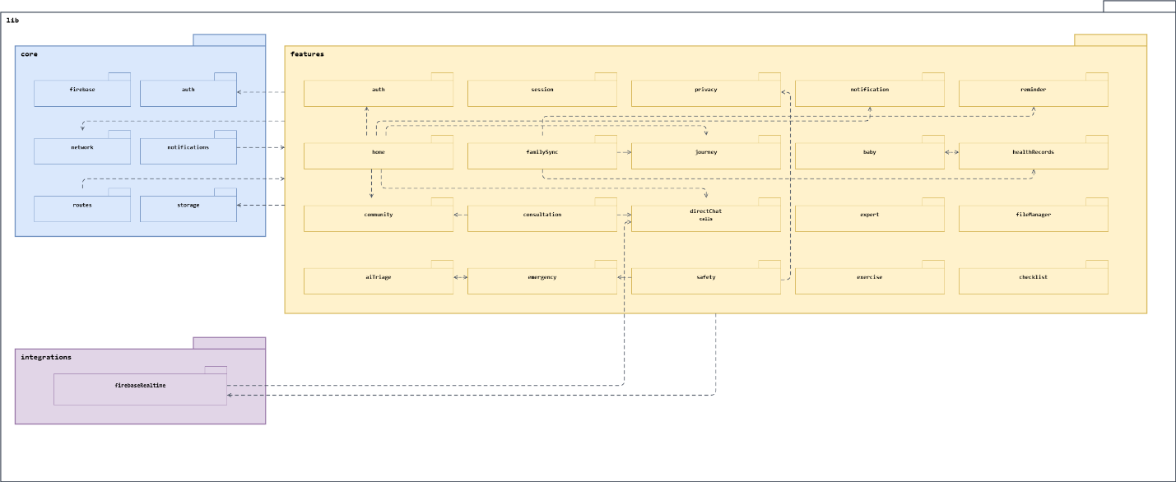
MobileApp Package Diagram
Detail: MobileApp Package Diagram
Package Descriptions
No | Package | Description
1 | core | Contains cross-cutting runtime services used throughout the Flutter application.
2 | core.auth | Maintains authenticated-user state and broadcasts authentication changes.
3 | core.firebase | Initializes Firebase services during application startup.
4 | core.network | Provides the shared HTTP API client and backend error-response parsing.
5 | core.notifications | Configures Firebase Cloud Messaging and coordinates notification-driven navigation.
6 | core.routes | Defines the GoRouter navigation graph and composes implemented feature screens.
7 | core.storage | Stores authentication tokens and resumable AI-triage state securely on the device.
8 | features | Contains independently organized business-capability packages for the Mobile application.
9 | features.auth | Implements authentication, registration, OTP, profile, account-security, and linked-account workflows.
10 | features.session | Displays active login sessions and supports remote-session revocation.
11 | features.privacy | Manages privacy preferences and data-sharing controls.
12 | features.notification | Defines notification data, retrieval, presentation, and notification-route resolution.
13 | features.reminder | Manages medication and vaccination reminders, reminder details, updates, and snoozing.
14 | features.home | Provides role-specific application shells and home screens for mothers, family members, and experts.
15 | features.familySync | Manages care groups, invitations, permissions, shared tasks, calendars, data, and family alerts.
16 | features.journey | Manages pregnancy and postpartum journey setup, onboarding, stages, and pregnancy outcomes.
17 | features.baby | Manages baby profiles, daily logs, milestones, care summaries, and journey linkage.
18 | features.healthRecords | Manages maternal and baby health records, metrics, trends, vaccinations, growth data, and postpartum logs.
19 | features.community | Implements community questions, answers, topic discovery, bookmarks, and verified health content.
20 | features.consultation | Manages consultation requests and AI-triage handoff to experts.
21 | features.directChat | Implements expert discovery, conversations, real-time messaging, and ZEGOCLOUD audio/video calls.
22 | features.expert | Supports expert onboarding, verification, profiles, availability, contributions, and nearby support.
23 | features.fileManager | Supports uploading, viewing, sharing, and deleting user files.
24 | features.aiTriage | Supports symptom intake, risk assessment, RAG chat, safety escalation, and resumable triage sessions.
25 | features.emergency | Manages emergency contacts, alerts, nearby care facilities, maps, and emergency-session details.
26 | features.safety | Supports fall-detection configuration, safety monitoring, emergency escalation, and related privacy controls.
27 | features.exercise | Presents and manages pregnancy-exercise content and related activity workflows.
28 | features.checklist | Provides preparation-checklist retrieval, import, and completion workflows.
29 | integrations | Groups adapters that connect Mobile features to external platforms and services.
30 | integrations.firebaseRealtime | Implements Firestore-based real-time signaling contracts for direct conversations and calls.
Table 3: MobileApp Package Diagram Descriptions

2. Database Design
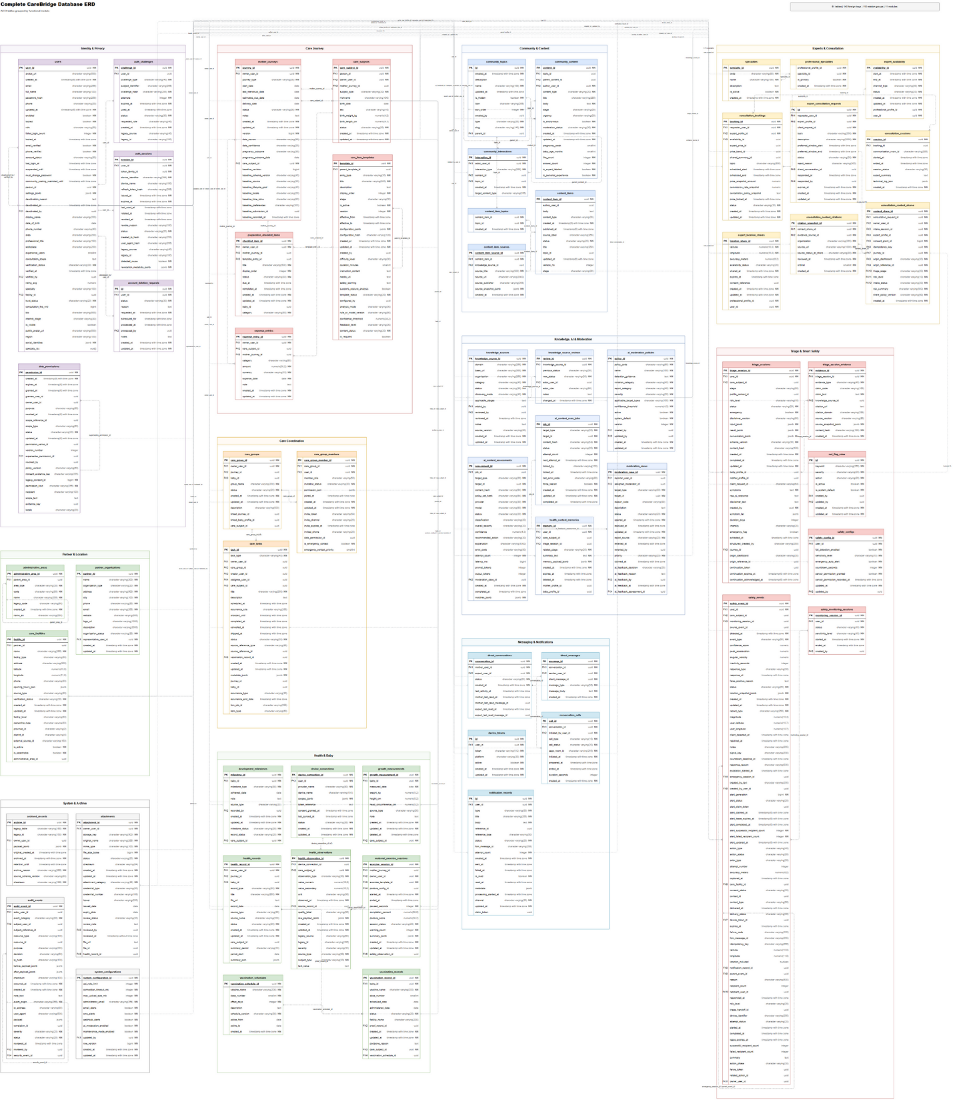
Table Descriptions
No | Table | Description
1 | account_deletion_requests | Stores user account-deletion requests and tracks their scheduling, processing status, and administrative notes.
2 | administrative_areas | Defines hierarchical administrative areas and their local, English, and legacy identification codes.
3 | ai_content_assessments | Records AI moderation assessments, including the applied model and policies, classification, confidence, and recommended action.
4 | ai_content_scan_jobs | Queues and tracks asynchronous AI content scans, processing locks, retries, errors, and completion status.
5 | ai_moderation_policies | Defines versioned AI moderation policies, detection guidance, severity, applicability, and confidence thresholds.
6 | archived_records | Stores archived legacy or compatibility records as checksummed JSON payloads with retention metadata.
7 | attachments | Stores uploaded-file metadata, storage references, credential-review details, and associated health records.
8 | audit_events | Records security and business audit events with actors, affected resources, decisions, payload changes, and review status.
9 | auth_challenges | Stores time-limited hashed authentication or verification challenges, attempt counts, and usage status.
10 | auth_sessions | Tracks user authentication sessions, devices, refresh-token families, rotation, reuse detection, and revocation.
11 | care_facilities | Stores healthcare-facility profiles, locations, contact details, operating hours, ownership, and verification status.
12 | care_group_members | Records care-group memberships, invitations, roles, delegated permissions, and emergency-contact priority.
13 | care_groups | Defines user-owned care groups linked to maternal journeys and care subjects.
14 | care_item_templates | Defines versioned reusable care, checklist, and exercise templates with configuration, instructions, and safety guidance.
15 | care_subjects | Stores canonical care recipients, including ownership, subject type, birth attributes, and journey association.
16 | care_tasks | Stores assigned or scheduled care tasks, recurrence rules, source references, and completion lifecycle.
17 | community_content | Stores community posts and responses with author, topic, stage, engagement, anonymity, and moderation data.
18 | community_interactions | Records user interactions with community content or topics, such as engagement actions.
19 | community_topics | Defines hierarchical community topics and categories with display and visibility settings.
20 | consultation_bookings | Records consultation bookings, selected availability, schedule, status, and locked pricing and policy snapshots.
21 | consultation_context_citations | Stores reviewed evidence-source citation snapshots included in consultation context shares.
22 | consultation_context_shares | Records consent-bound snapshots of triage and journey context shared with an expert.
23 | consultation_sessions | Tracks consultation-room sessions, timing, status, expert summaries, and technical logs.
24 | content_item_sources | Links informational content to source references and preserves source metadata snapshots.
25 | content_item_topics | Maps informational content items to community topics.
26 | content_items | Stores authored informational content with publication status, lifecycle stage, topic, and version information.
27 | conversation_calls | Tracks voice or video calls initiated within direct conversations, including room and timing details.
28 | data_permissions | Stores versioned consent and data-permission grants, their scope, evidence, recipients, and revocation lifecycle.
29 | development_milestones | Records care-subject developmental milestones, achievement dates, sources, and record status.
30 | device_connections | Stores user connections to external health-device providers, authorized scopes, consent, and synchronization status.
31 | device_tokens | Stores user device tokens used for push notifications, including platform and activation status.
32 | direct_conversations | Stores one-to-one conversation threads between mothers and experts with participant read positions.
33 | direct_messages | Stores messages sent within direct conversations, including sender, client identifier, type, and body.
34 | expense_entries | Records care-related expenses by owner, care subject, maternal journey, category, date, and amount.
35 | expert_availability | Defines expert availability slots, communication channels, and booking status.
36 | expert_consultation_requests | Records consultation requests, preferred time windows, response status, rejection reasons, and linked conversations.
37 | expert_location_shares | Stores time-limited, consent-referenced expert location and availability shares.
38 | growth_measurements | Records care-subject growth measurements, including weight, height, head circumference, source, and measurement date.
39 | health_context_memories | Stores temporary health-context summaries and payloads derived from triage sessions for later contextual use.
40 | health_observations | Records normalized health observations from connected devices or other sources with quality and raw-source data.
41 | health_records | Stores health-document and periodic-summary metadata linked to owners, journeys, and care subjects.
42 | knowledge_source_reviews | Records the status-change review history of external knowledge sources.
43 | knowledge_sources | Defines external health-knowledge sources and tracks their provenance, discovery method, version, and review status.
44 | maternal_exercise_sessions | Tracks maternal exercise sessions, completion, posture assessment, safety observations, and session summaries.
45 | moderation_cases | Manages user-reported or AI-flagged moderation cases, assignment, priority, resolution, reversion, and reviewer feedback.
46 | mother_journeys | Stores maternal journey timelines, pregnancy dates and outcomes, lifecycle status, and baseline profile snapshots.
47 | notification_records | Records user notifications and tracks processing, delivery attempts, channel, failure, and read status.
48 | partner_organizations | Stores partner-organization profiles, contacts, representatives, and operational status.
49 | preparation_checklist_items | Records user preparation checklist items derived from templates, including category, due date, order, and completion.
50 | professional_specialties | Maps professional users to specialties and identifies each professional's primary specialty.
51 | red_flag_rules | Defines configurable keyword-based red-flag rules, severity levels, and required actions.
52 | safety_configs | Stores per-user fall-detection sensitivity, emergency-alert behavior, countdown, and sensor-permission settings.
53 | safety_events | Records detected safety incidents and their related location, escalation, notification, delivery, and response lifecycle.
54 | safety_monitoring_sessions | Tracks user safety-monitoring periods, sensitivity level, creator, and session status.
55 | specialties | Defines the active reference list of professional specialties.
56 | system_configurations | Stores platform-wide operational, upload, alerting, AI-moderation, and maintenance settings.
57 | triage_session_evidence | Records evidence and source snapshots supporting claims produced during a triage session.
58 | triage_sessions | Stores symptom intake, AI-assisted triage results, risk and emergency decisions, conversation context, and continuation state.
59 | users | Stores user identities, account state, contact and profile data, preferences, and professional verification details.
60 | vaccination_records | Records scheduled and administered vaccine doses for care subjects, including status, proof, and postponement details.
61 | vaccination_schedules | Defines versioned reference schedules for vaccine doses and their age-based timing offsets.
Table 4: Database Design Descriptions

3. Detailed Design

3.1 Account, Trust & Access Control

3.1.1 Account Registration Authentication Lifecycle

3.1.1.1 Class Diagram
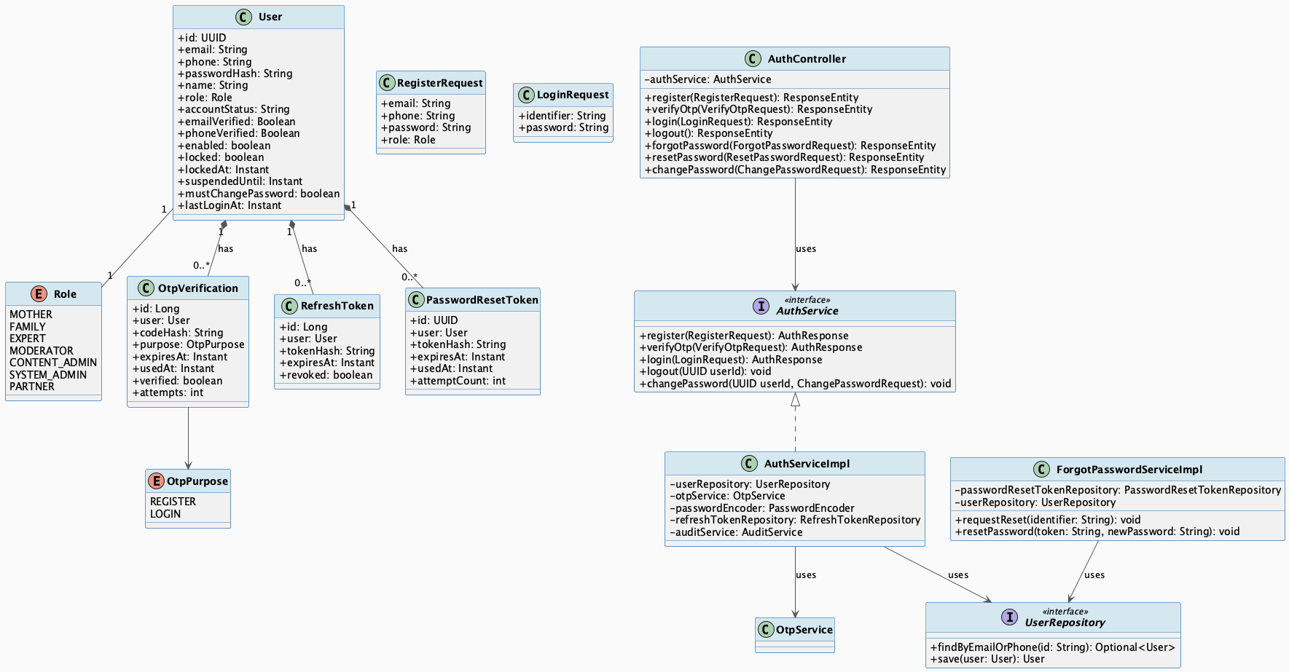
Account Registration Authentication Lifecycle Class Diagram
Detail: Account Registration Authentication Lifecycle Class Diagram

3.1.1.2 Sequence Diagram
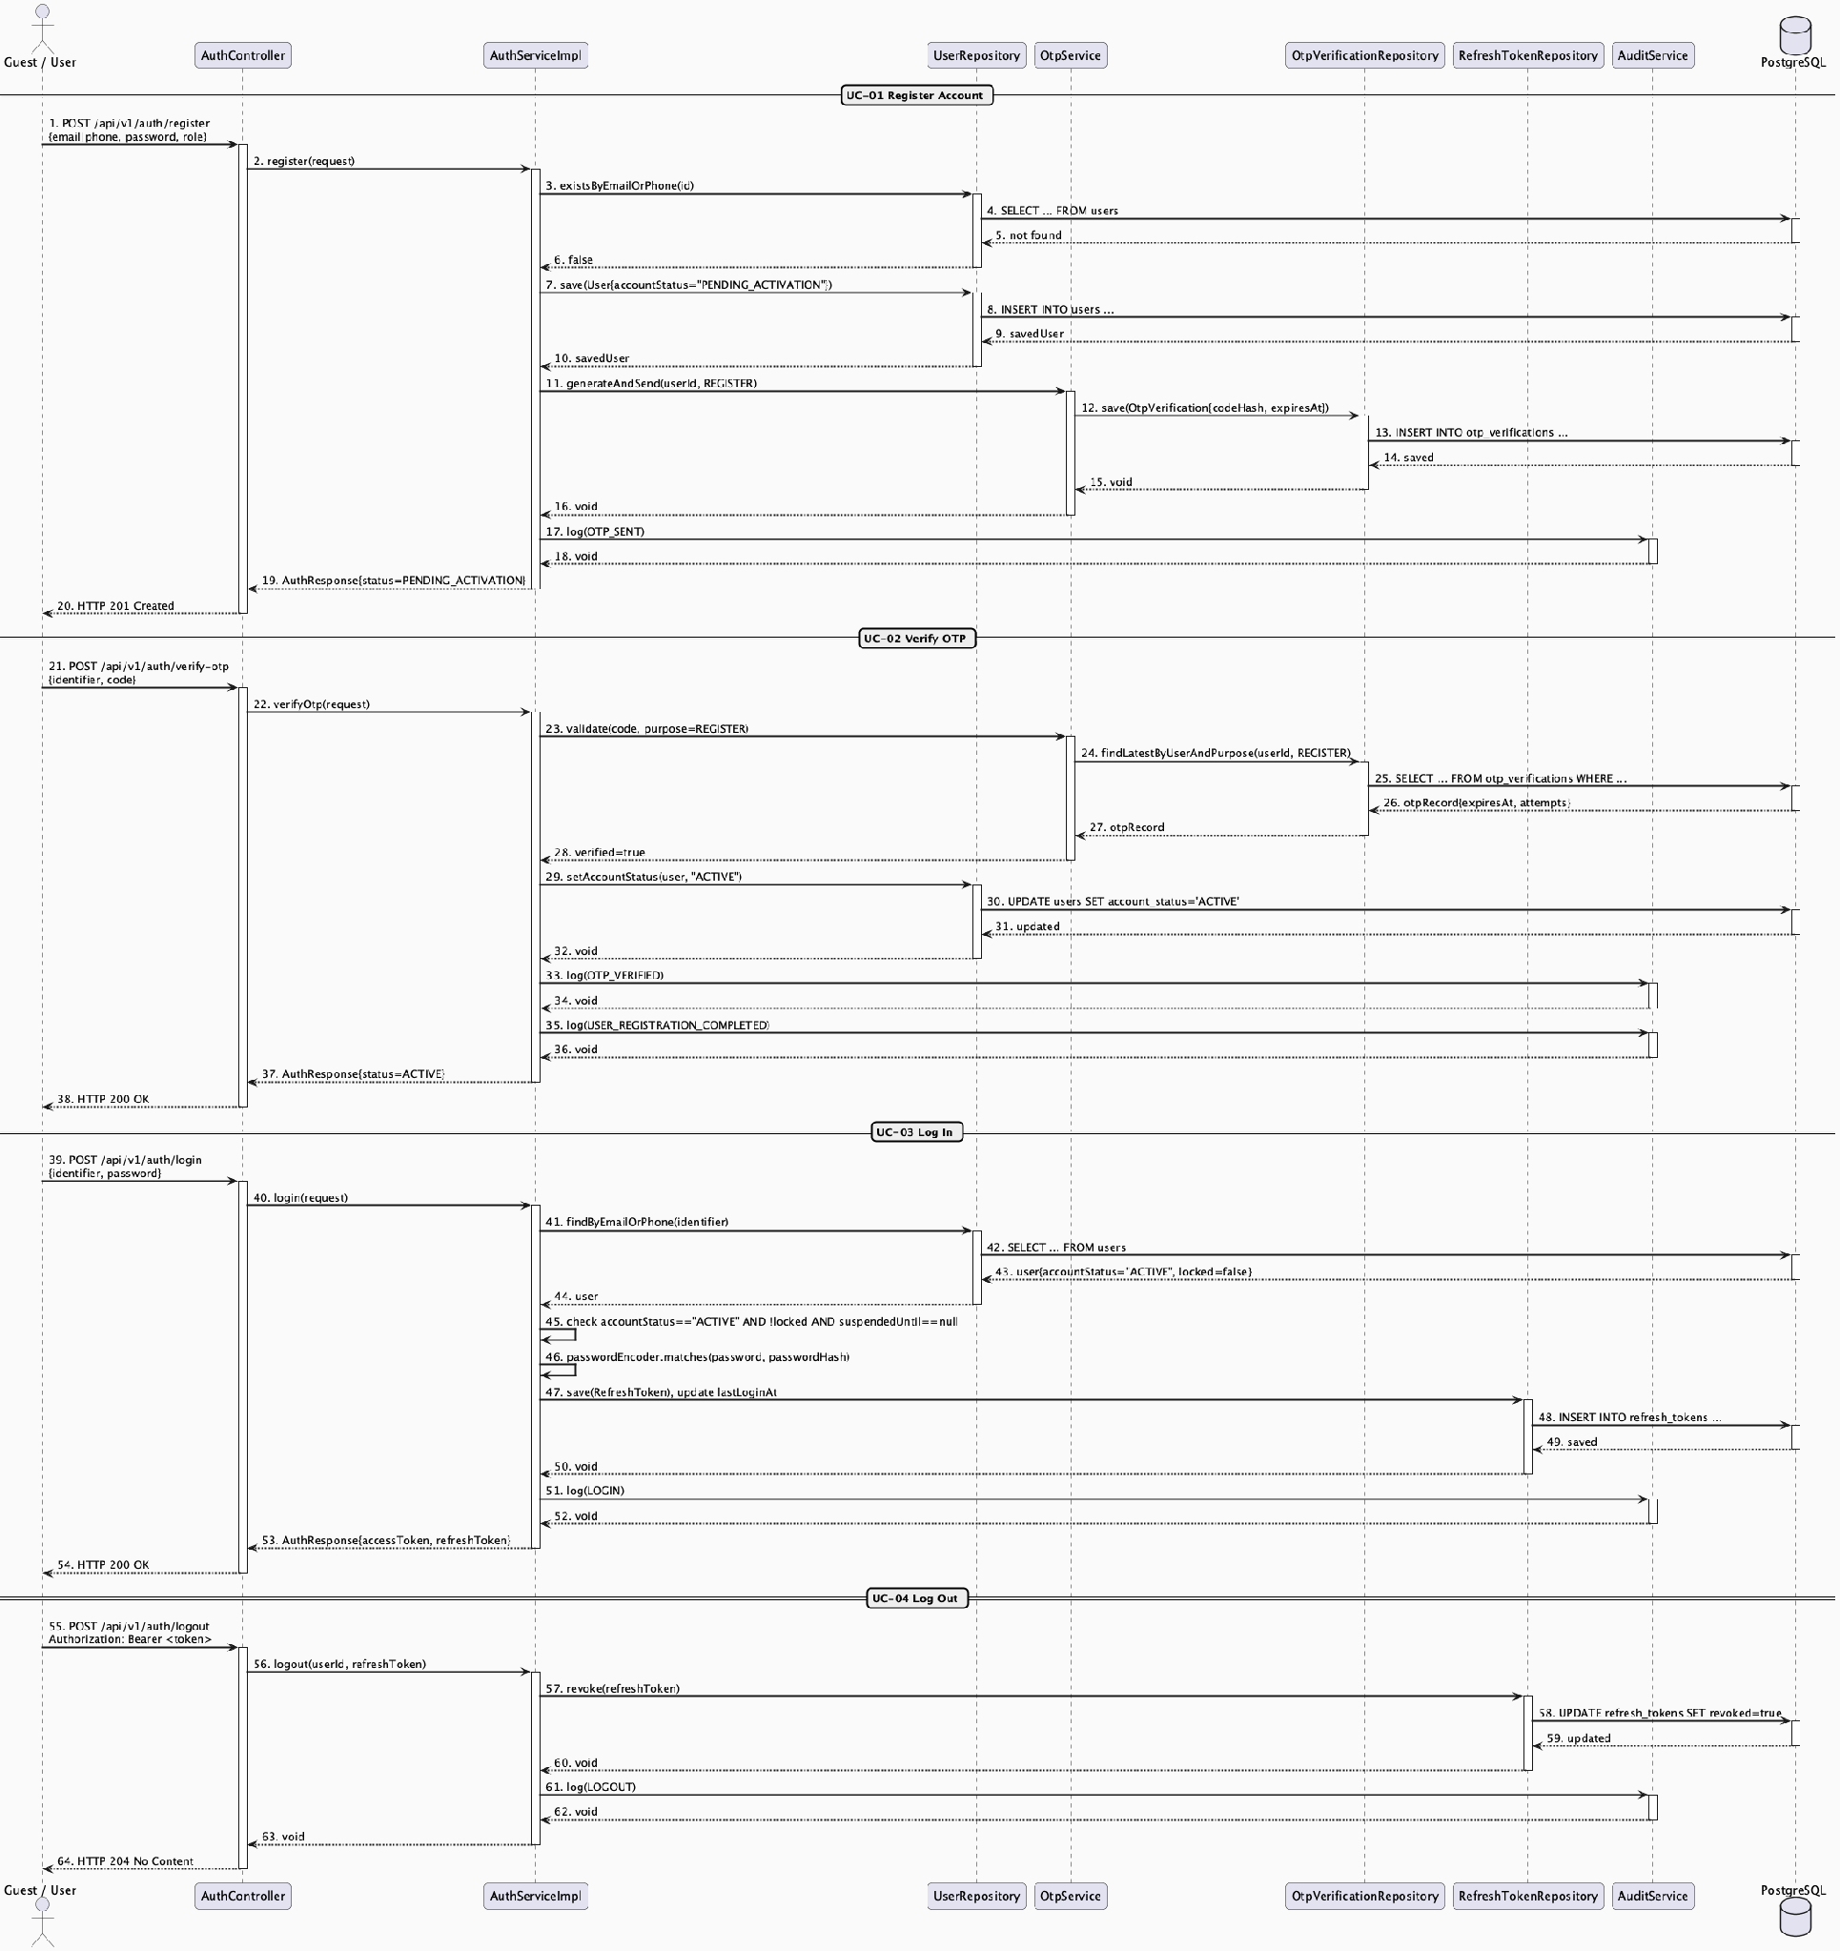
Account Registration Authentication Lifecycle Sequence Diagram
Detail: Account Registration Authentication Lifecycle Sequence Diagram

3.1.2 Community Identity Privacy Consent Sharing

3.1.2.1 Class Diagram
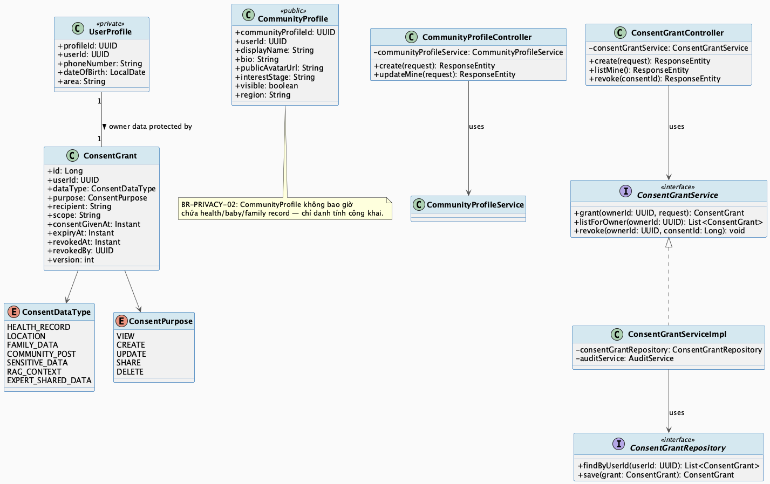
Community Identity Privacy Consent Sharing Class Diagram
Detail: Community Identity Privacy Consent Sharing Class Diagram

3.1.2.2 Sequence Diagram
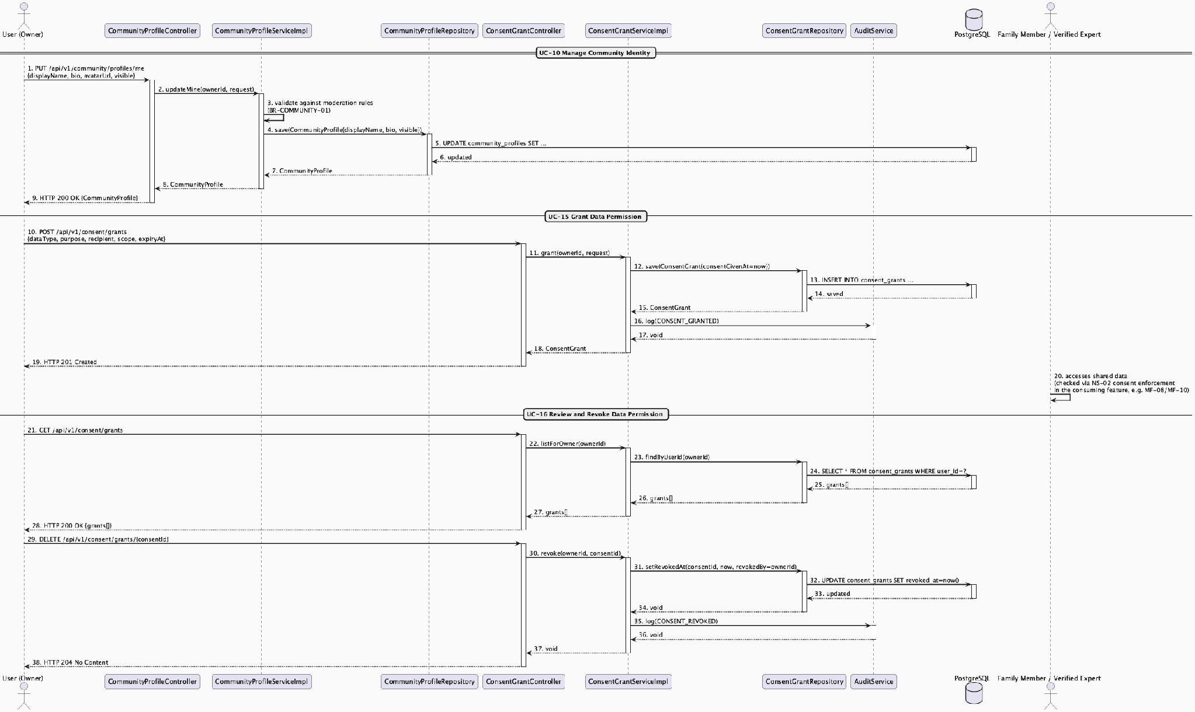
Community Identity Privacy Consent Sharing Sequence Diagram
Detail: Community Identity Privacy Consent Sharing Sequence Diagram

3.1.3 Admin Account Governance Security Audit

3.1.3.1 Class Diagram
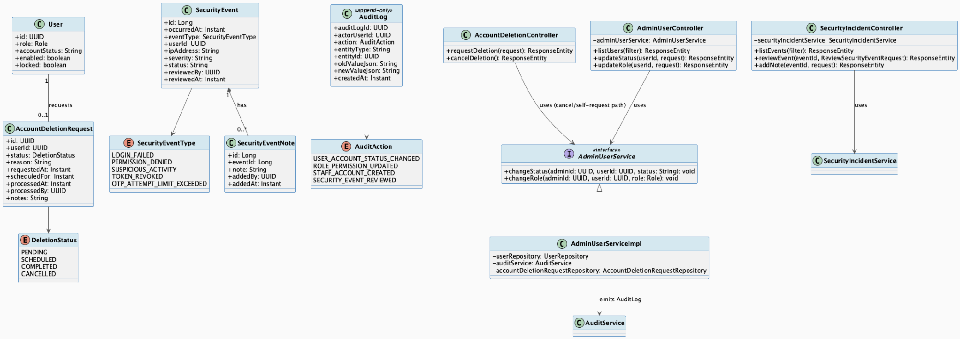
Admin Account Governance Security Audit Class Diagram
Detail: Admin Account Governance Security Audit Class Diagram

3.1.3.2 Sequence Diagram
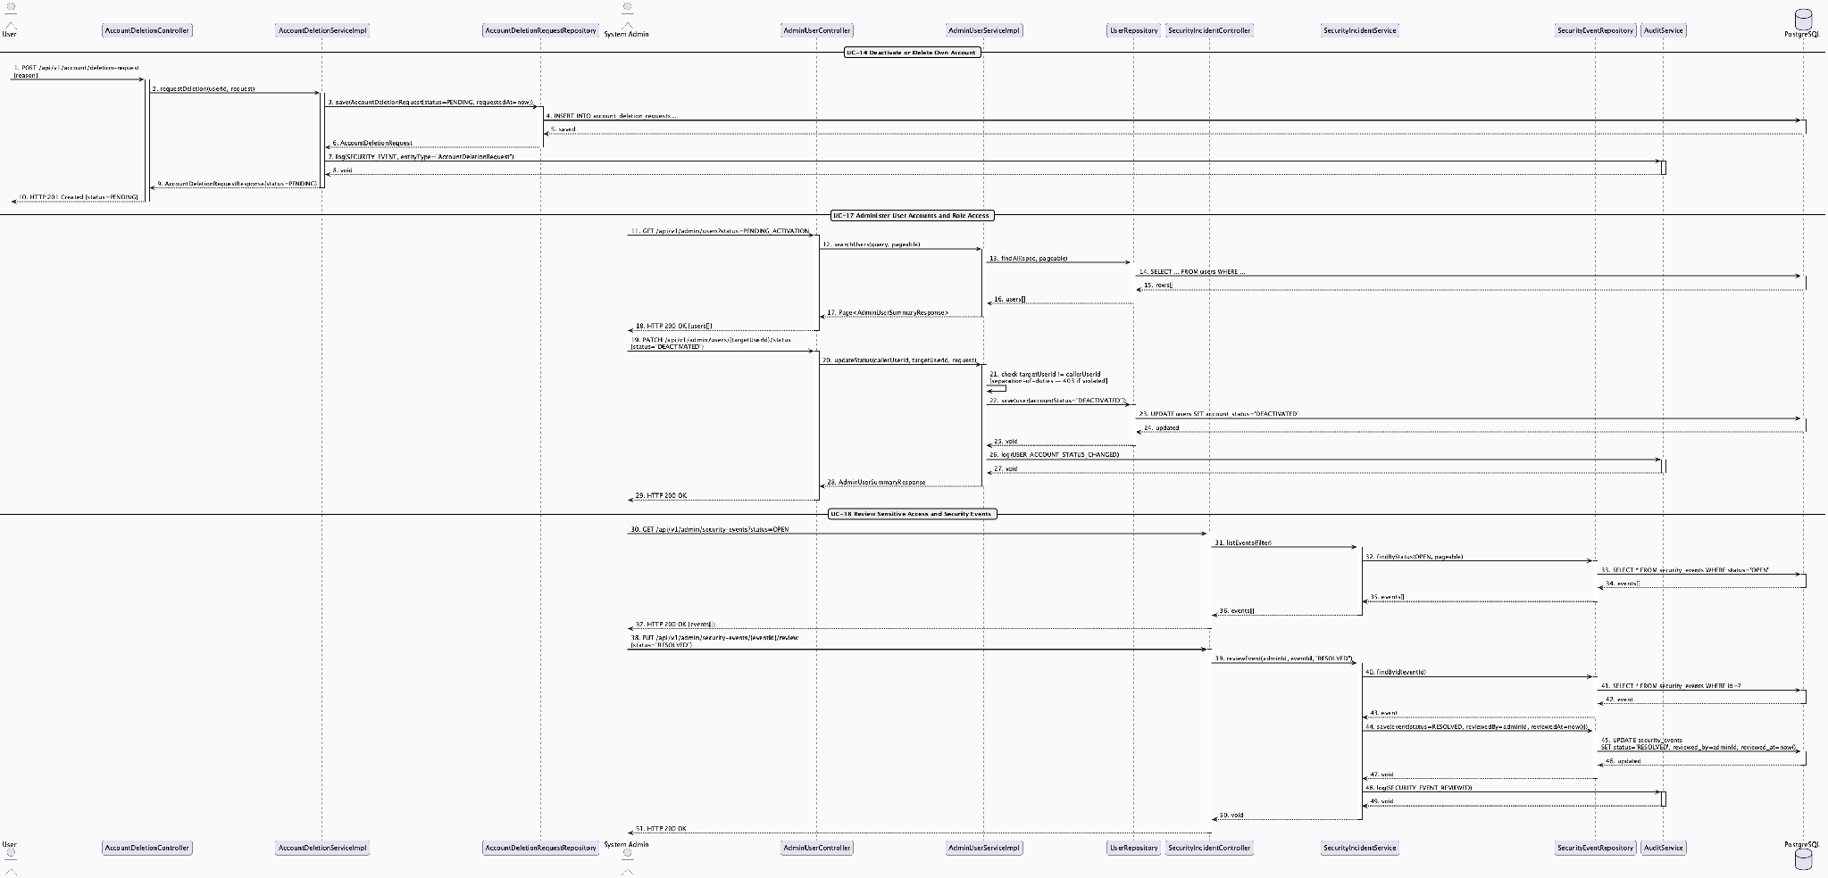
Admin Account Governance Security Audit Sequence Diagram
Detail: Admin Account Governance Security Audit Sequence Diagram

3.2 Mother Care Journey

3.2.1 Mother Journey Lifecycle & Dashboard

3.2.1.1 Class Diagram
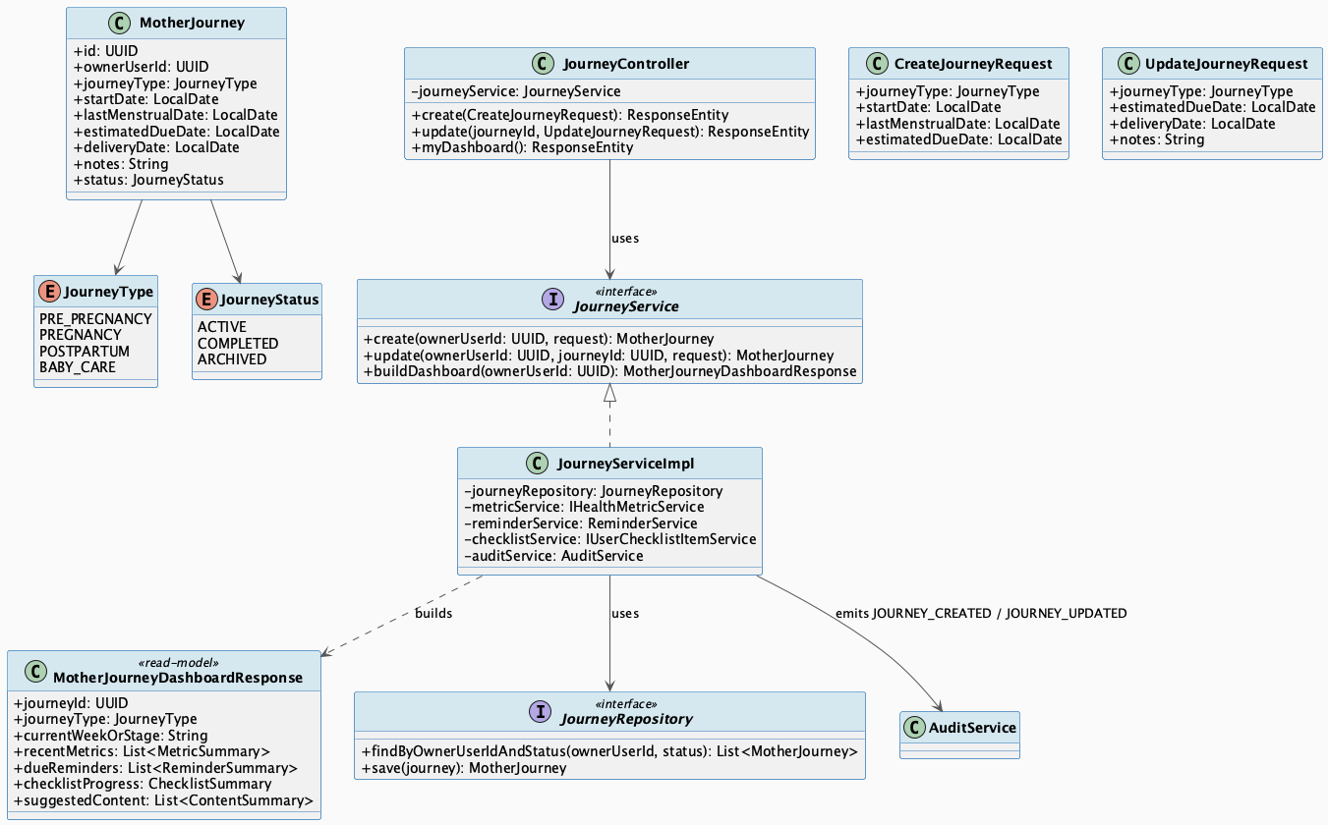
Mother Journey Lifecycle & Dashboard Class Diagram
Detail: Mother Journey Lifecycle & Dashboard Class Diagram

3.2.1.2 Sequence Diagram
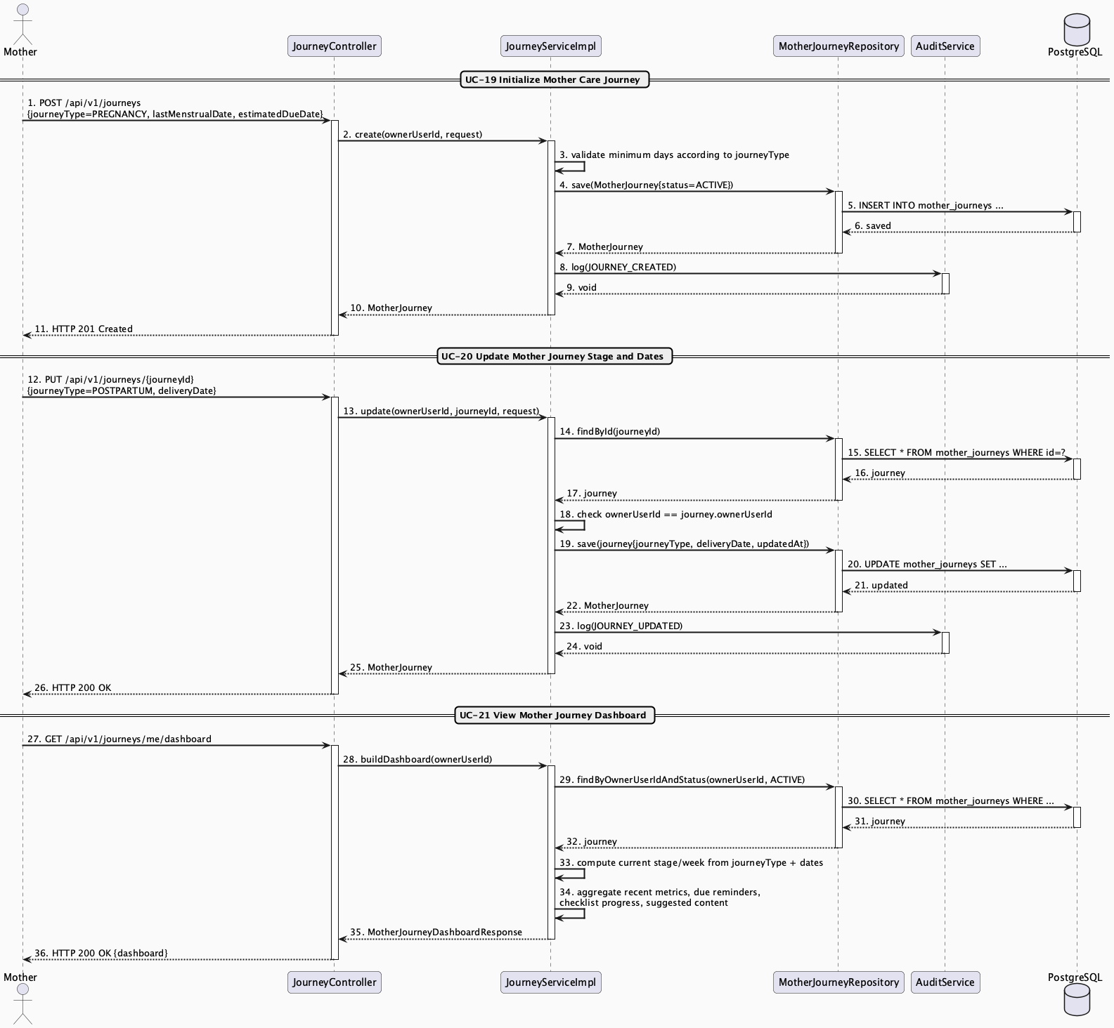
Mother Journey Lifecycle & Dashboard Sequence Diagram
Detail: Mother Journey Lifecycle & Dashboard Sequence Diagram

3.2.2 Maternal Health Metric & Postpartum Recovery Tracking

3.2.2.1 Class Diagram
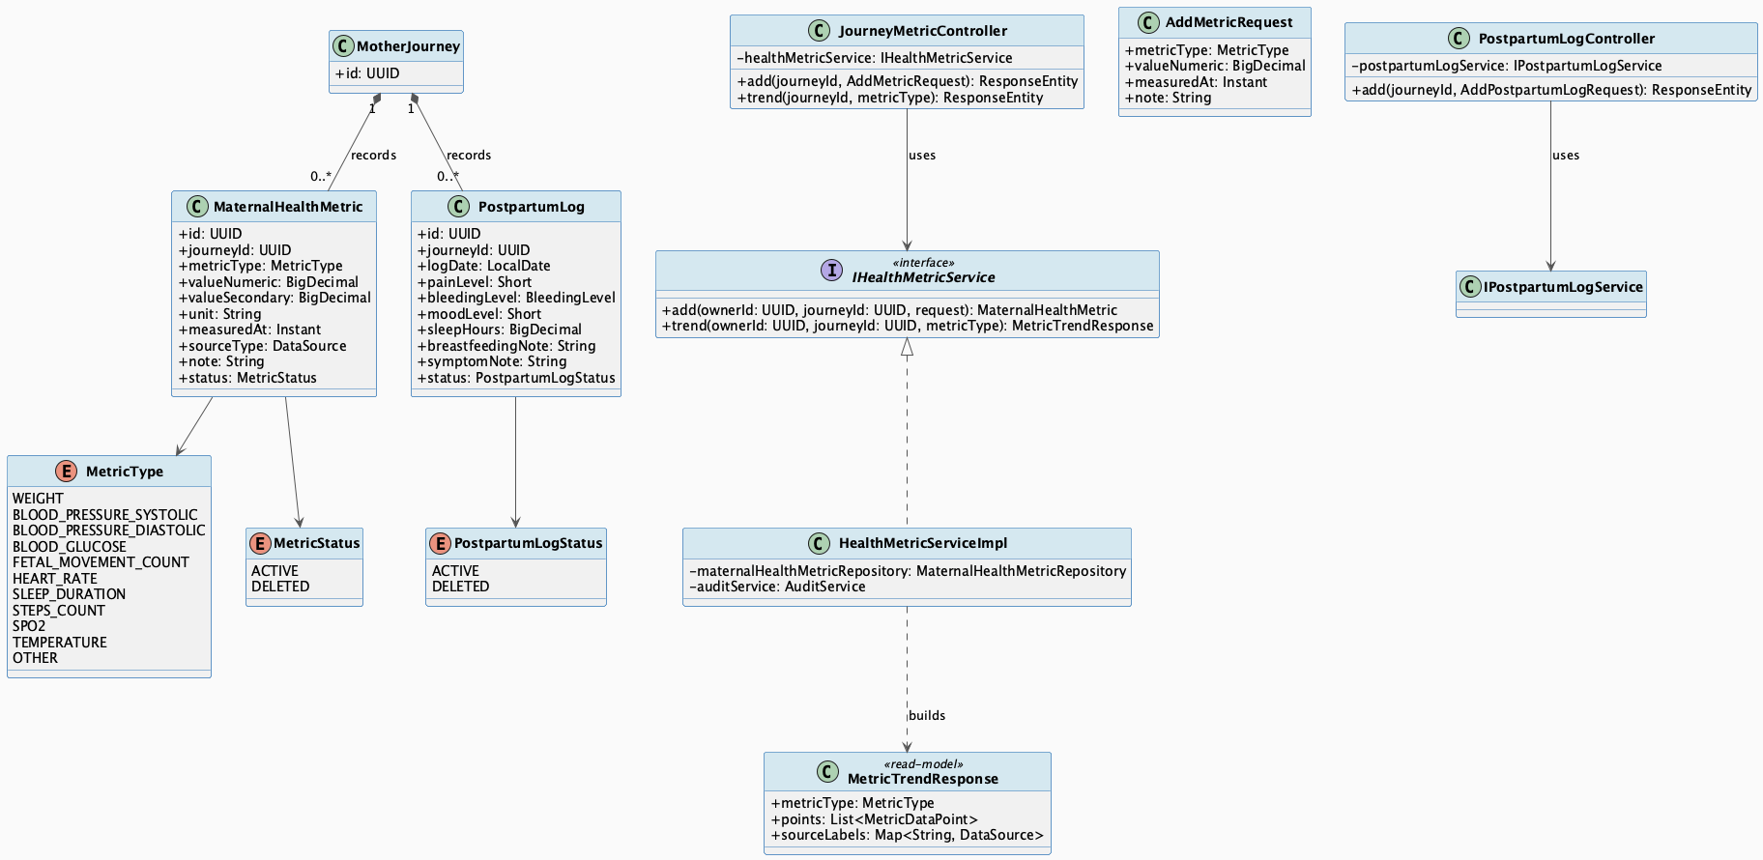
Maternal Health Metric & Postpartum Recovery Tracking Class Diagram
Detail: Maternal Health Metric & Postpartum Recovery Tracking Class Diagram

3.2.2.2 Sequence Diagram
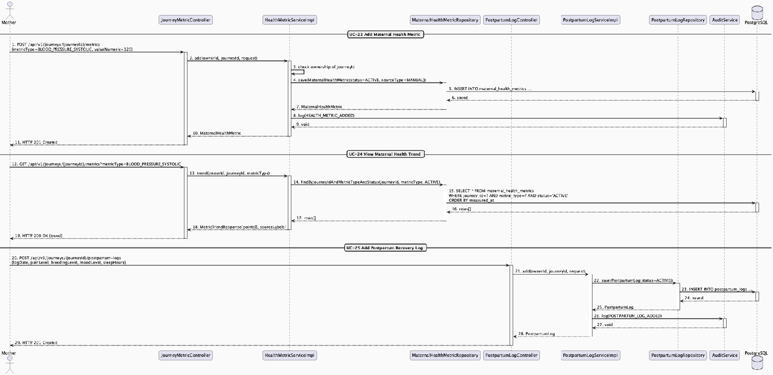
Maternal Health Metric & Postpartum Recovery Tracking Sequence Diagram
Detail: Maternal Health Metric & Postpartum Recovery Tracking Sequence Diagram

3.2.3 Pregnancy Exercise Session with Safety Check & Posture Feedback

3.2.3.1 Class Diagram
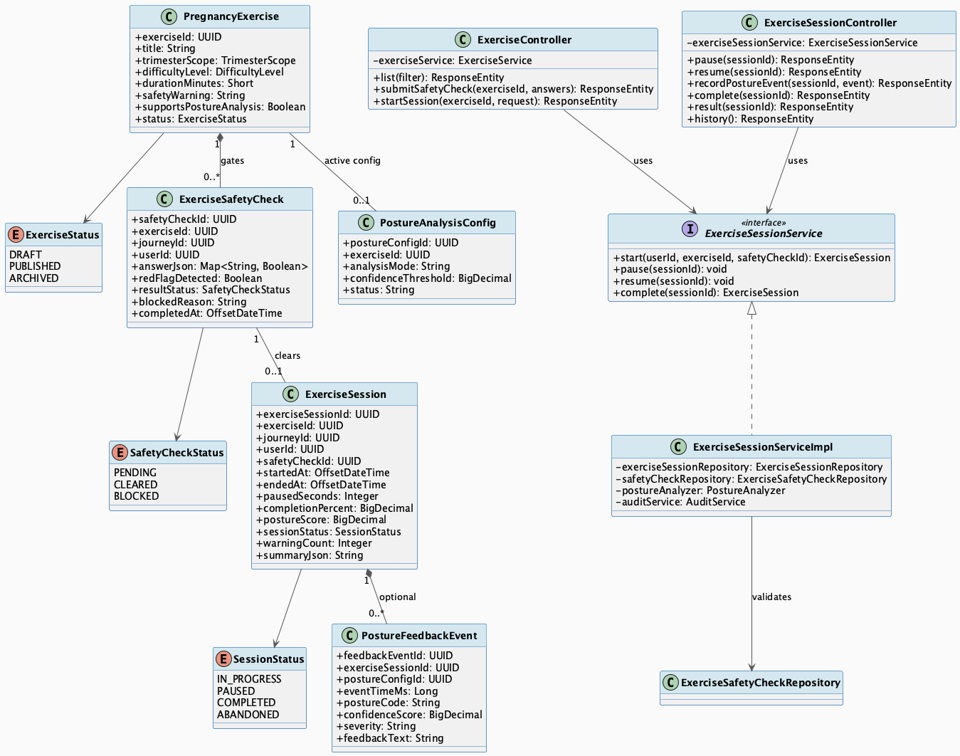
Pregnancy Exercise Session with Safety Check & Posture Feedback Class Diagram
Detail: Pregnancy Exercise Session with Safety Check & Posture Feedback Class Diagram

3.2.3.2 Sequence Diagram
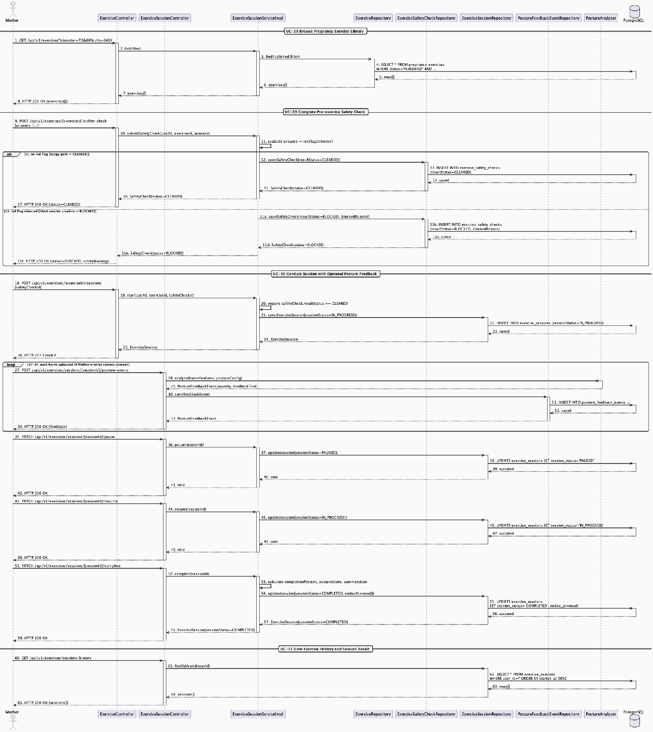
Pregnancy Exercise Session with Safety Check & Posture Feedback Sequence Diagram
Detail: Pregnancy Exercise Session with Safety Check & Posture Feedback Sequence Diagram

3.3 Baby Care Journey, Growth & Vaccination

3.3.1 Baby Profile Lifecycle & Daily Care Overview

3.3.1.1 Class Diagram
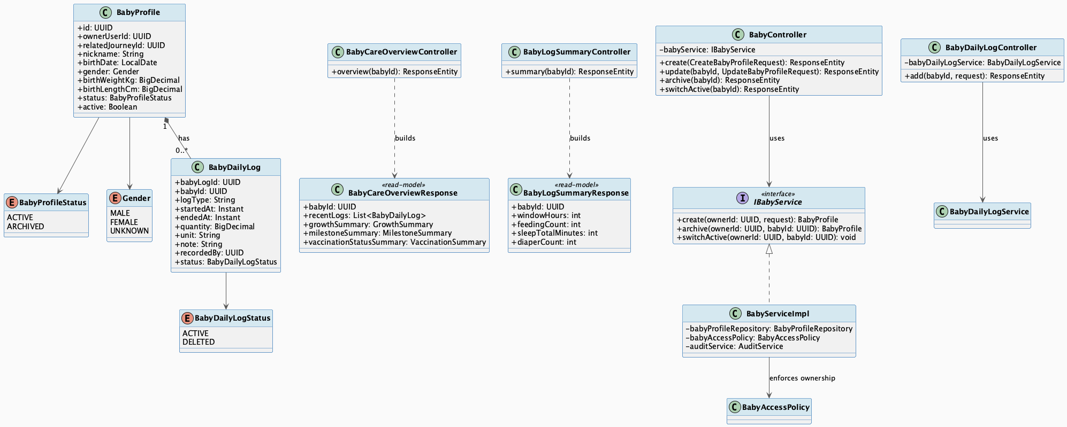
Baby Profile Lifecycle & Daily Care Overview Class Diagram
Detail: Baby Profile Lifecycle & Daily Care Overview Class Diagram

3.3.1.2 Sequence Diagram
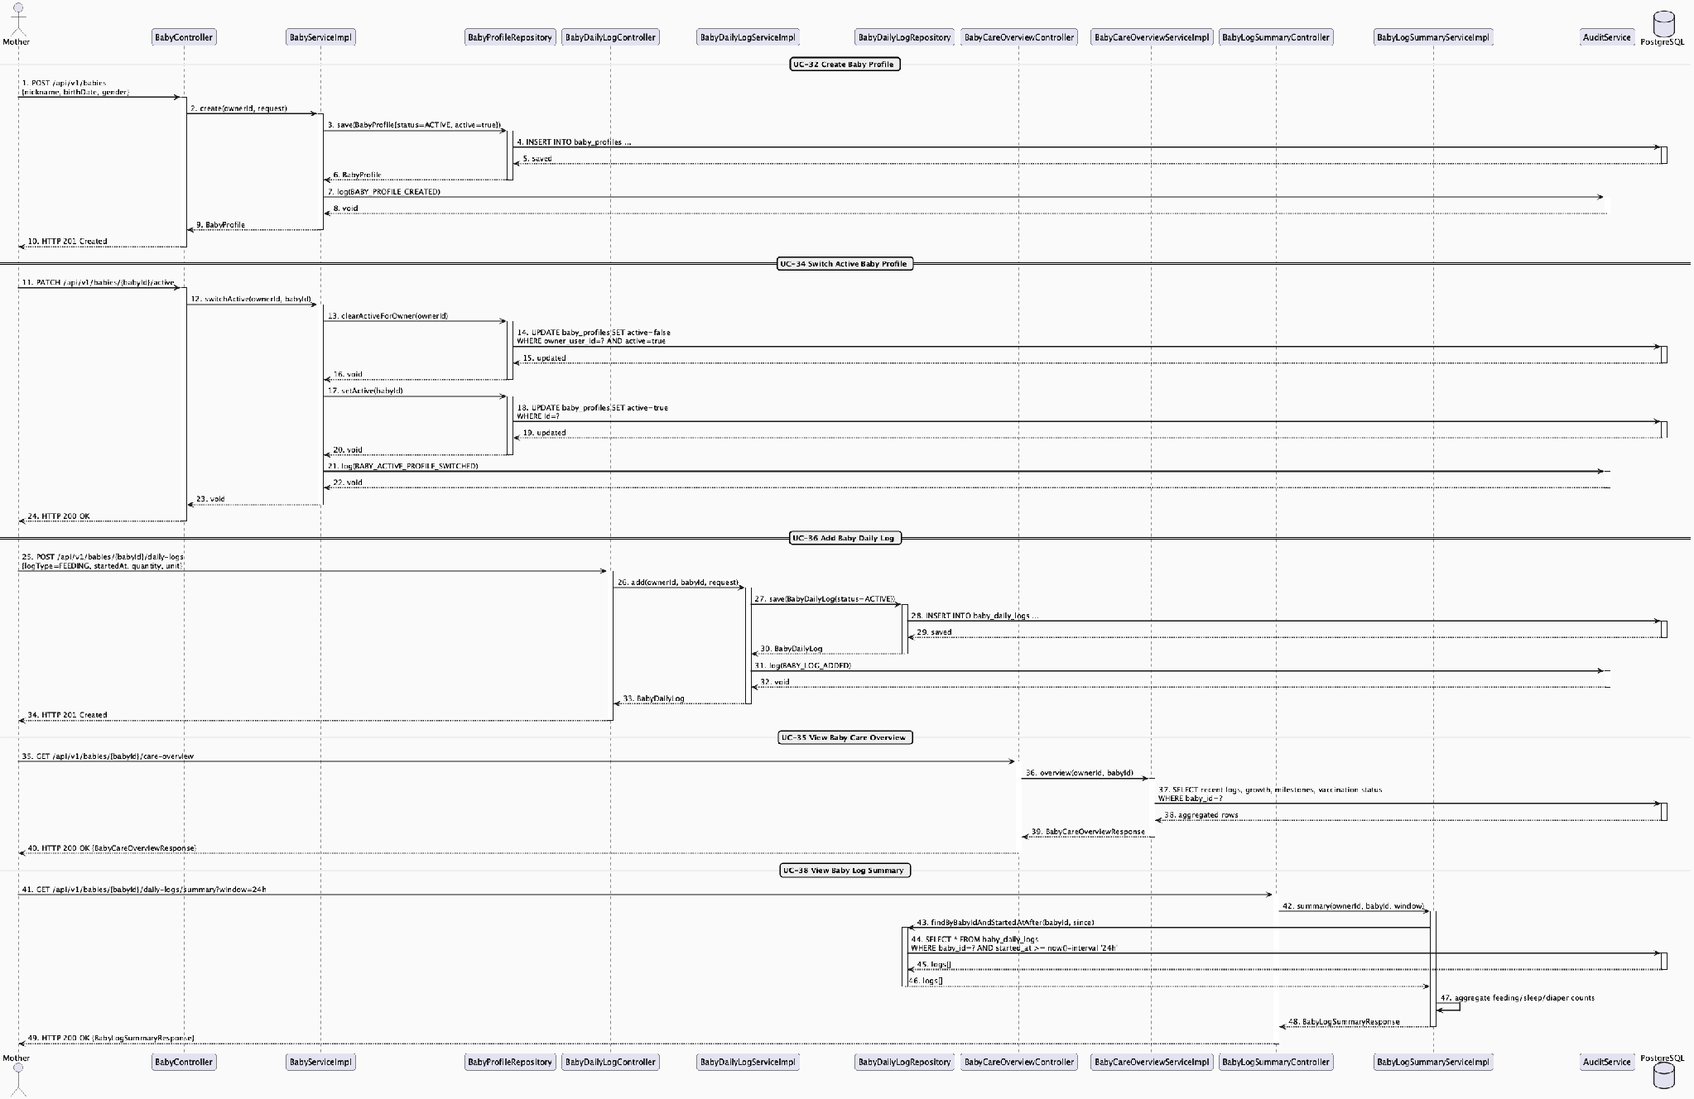
Baby Profile Lifecycle & Daily Care Overview Sequence Diagram
Detail: Baby Profile Lifecycle & Daily Care Overview Sequence Diagram

3.3.2 Growth & Development Milestone Tracking

3.3.2.1 Class Diagram
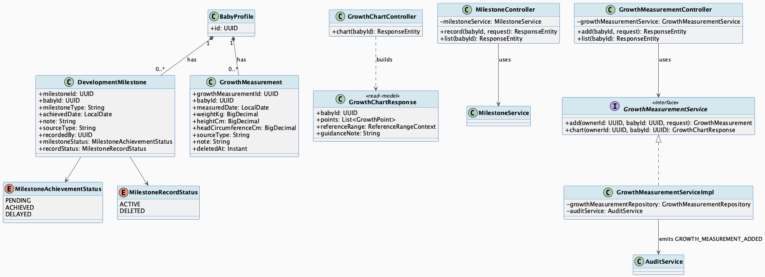
Growth & Development Milestone Tracking Class Diagram
Detail: Growth & Development Milestone Tracking Class Diagram

3.3.2.2 Sequence Diagram
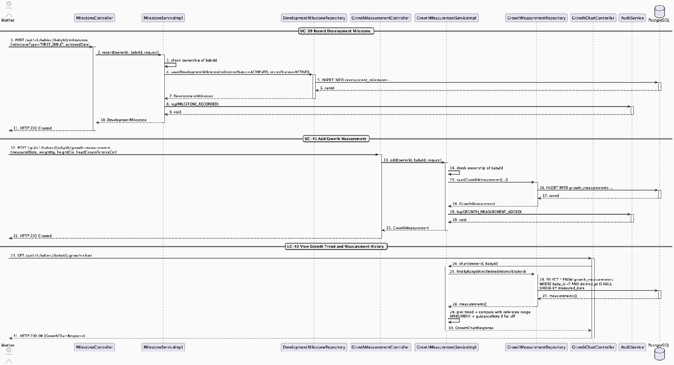
Growth & Development Milestone Tracking Sequence Diagram
Detail: Growth & Development Milestone Tracking Sequence Diagram

3.3.3 Vaccination Record Management & Reference Schedule

3.3.3.1 Class Diagram
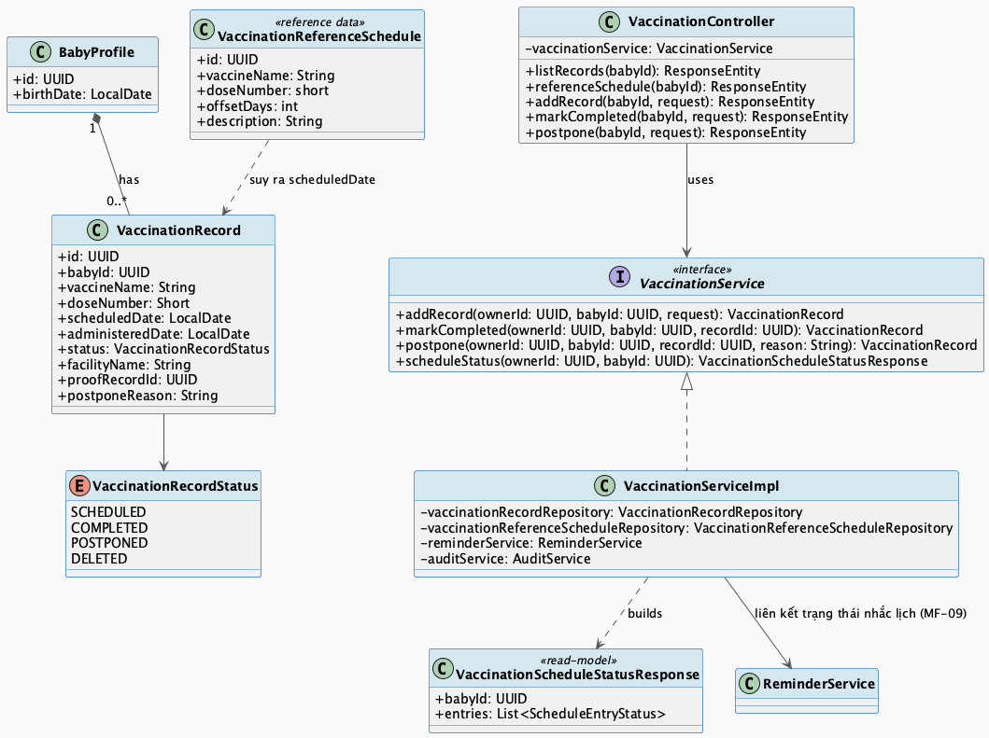
Vaccination Record Management & Reference Schedule Class Diagram
Detail: Vaccination Record Management & Reference Schedule Class Diagram

3.3.3.2 Sequence Diagram
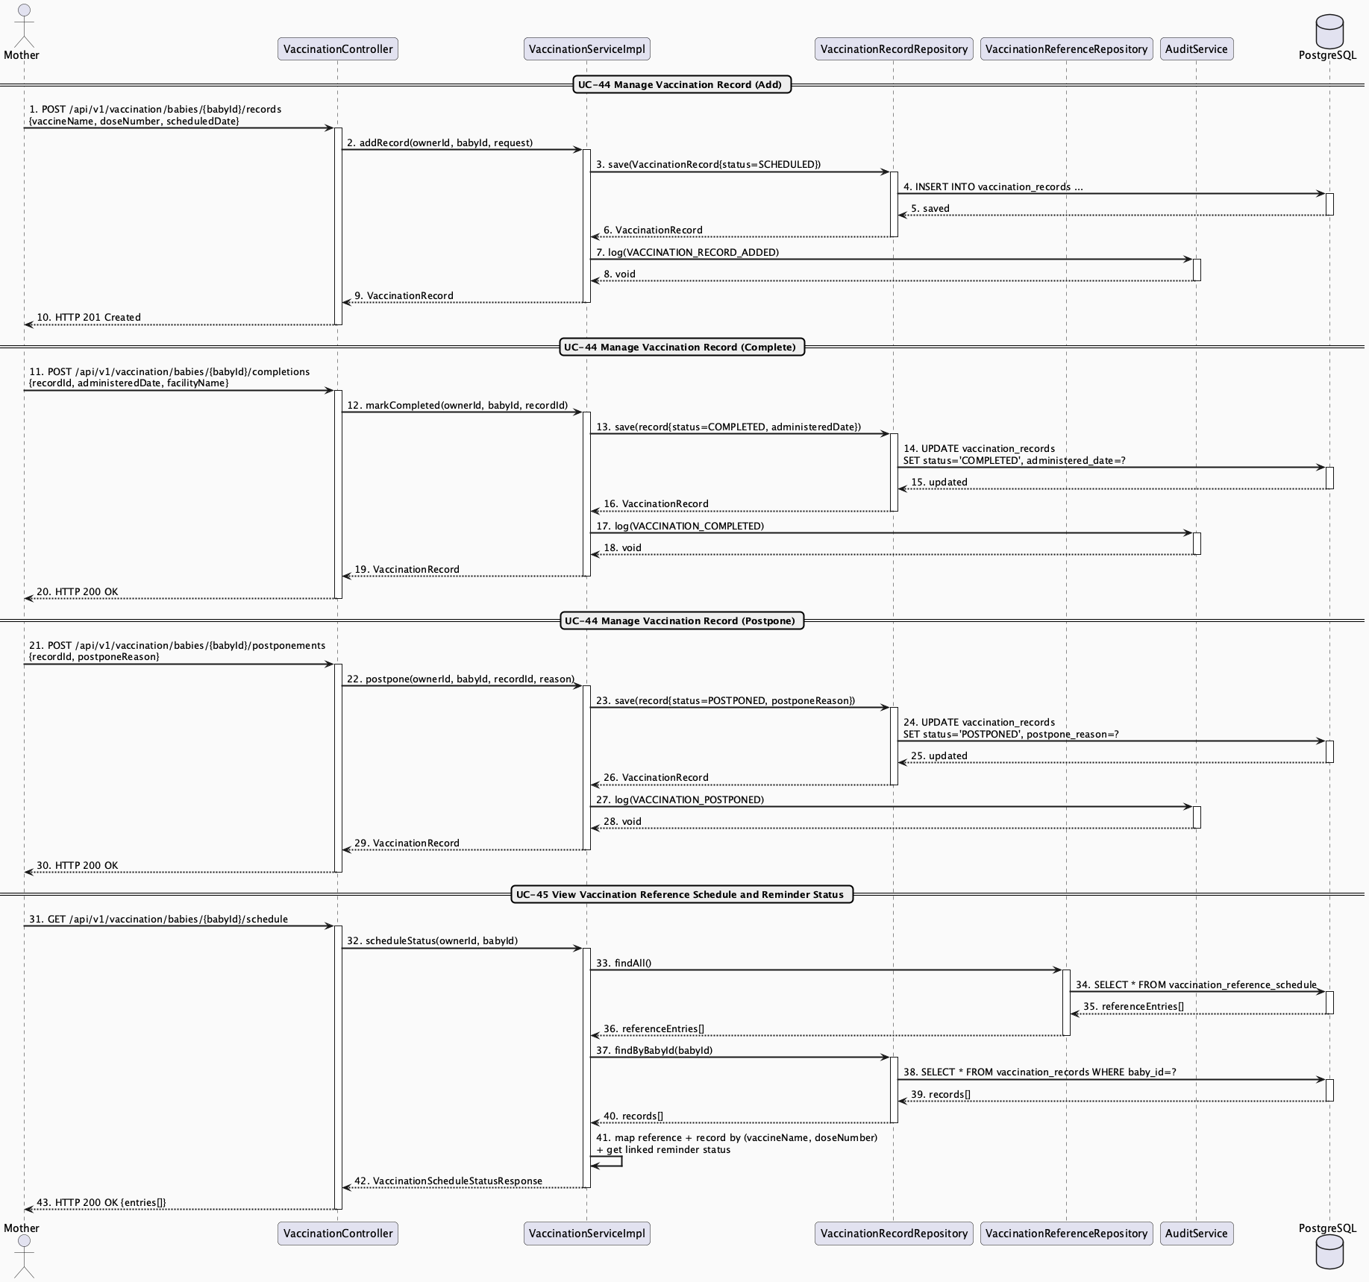
Vaccination Record Management & Reference Schedule Sequence Diagram
Detail: Vaccination Record Management & Reference Schedule Sequence Diagram

3.4 Community Q&A & Moderation

3.4.1 Community Question & Answer Flow

3.4.1.1 Class Diagram
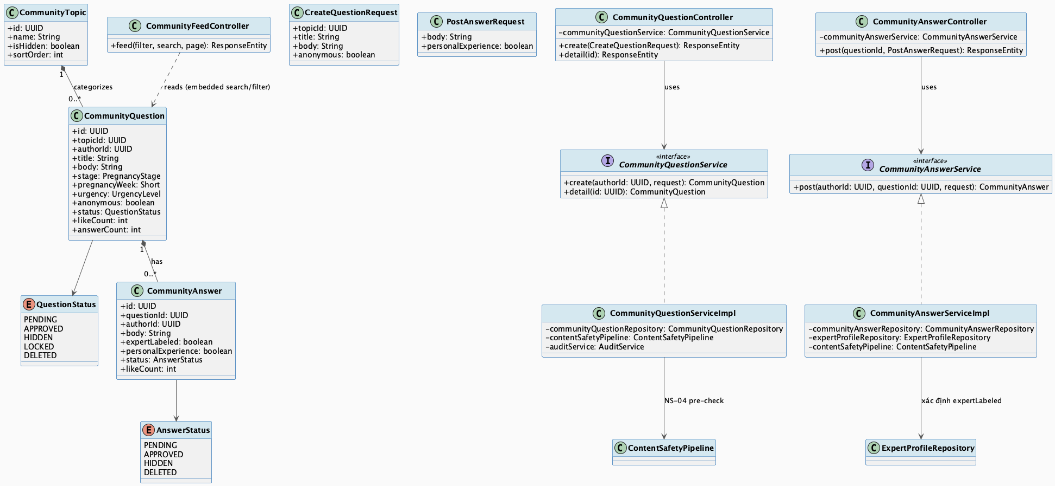
Community Question & Answer Flow Class Diagram
Detail: Community Question & Answer Flow Class Diagram

3.4.1.2 Sequence Diagram
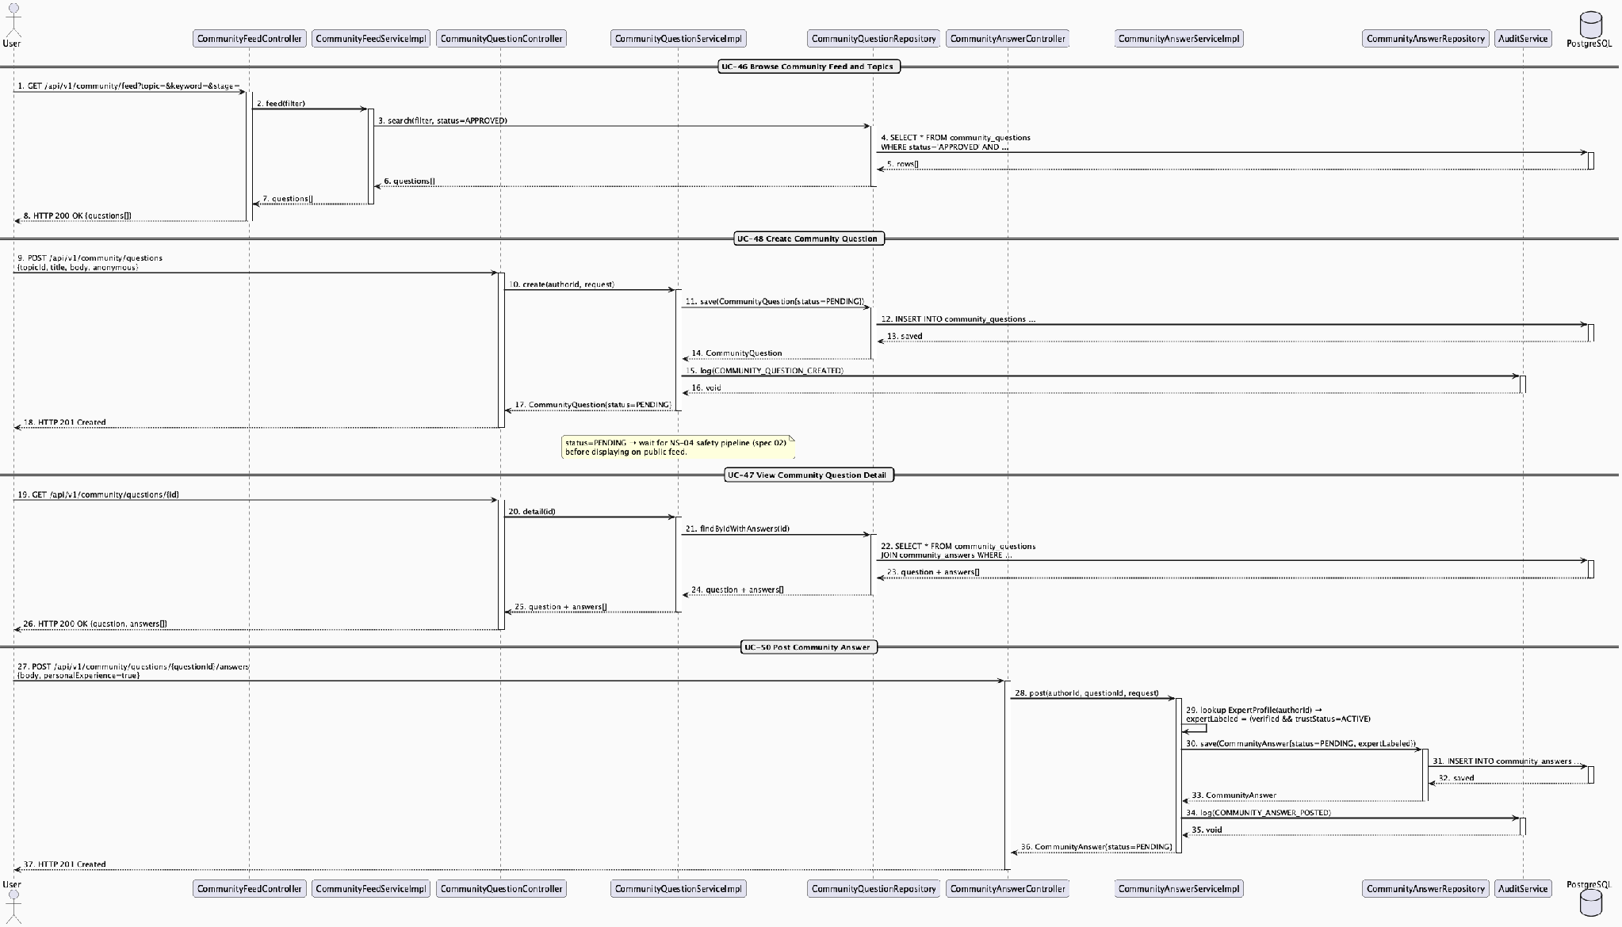
Community Question & Answer Flow Sequence Diagram
Detail: Community Question & Answer Flow Sequence Diagram

3.4.2 Content Moderation & Enforcement Pipeline

3.4.2.1 Class Diagram
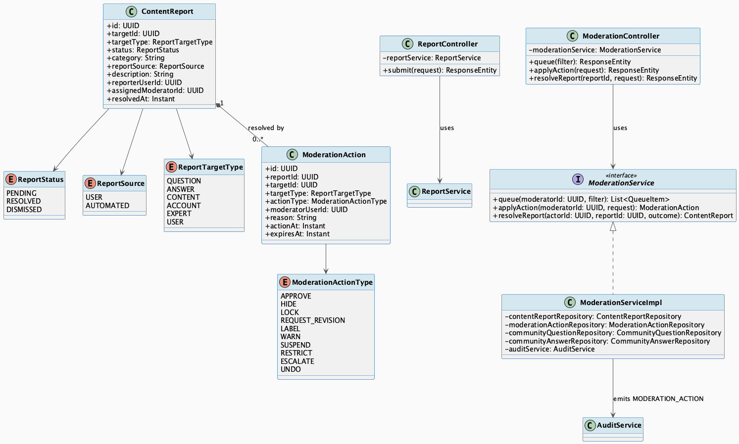
Content Moderation & Enforcement Pipeline Class Diagram
Detail: Content Moderation & Enforcement Pipeline Class Diagram

3.4.2.2 Sequence Diagram
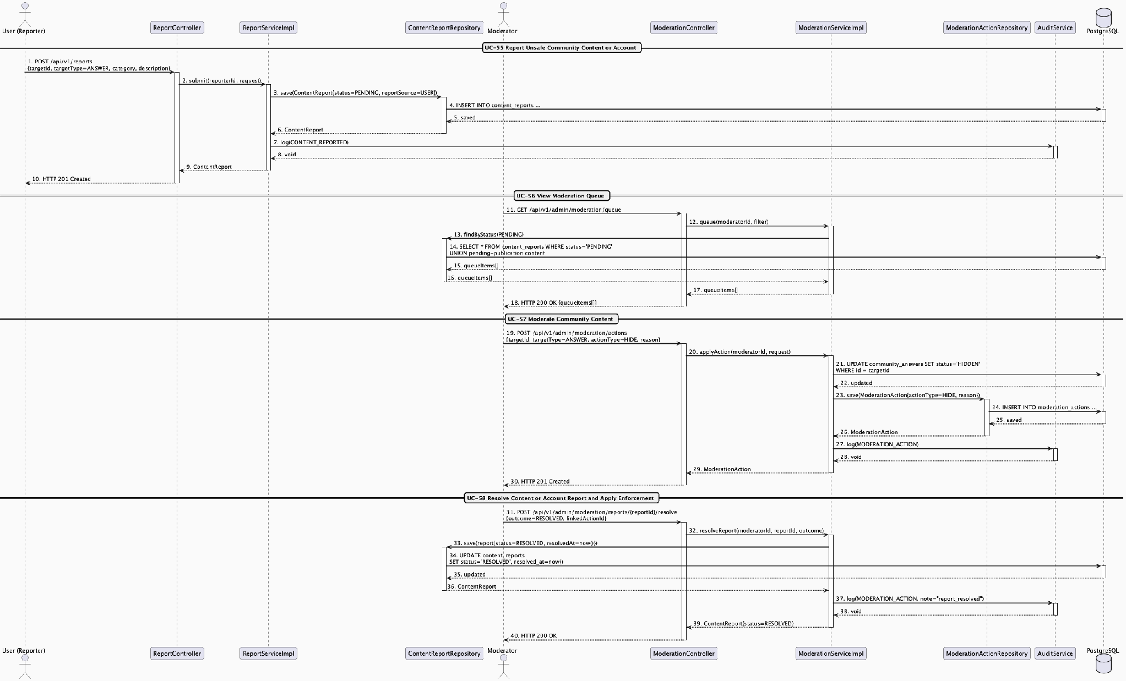
Content Moderation & Enforcement Pipeline Sequence Diagram
Detail: Content Moderation & Enforcement Pipeline Sequence Diagram

3.5 Verified Expert Network & Contribution

3.5.1 Expert Verification & Trust Lifecycle

3.5.1.1 Class Diagram
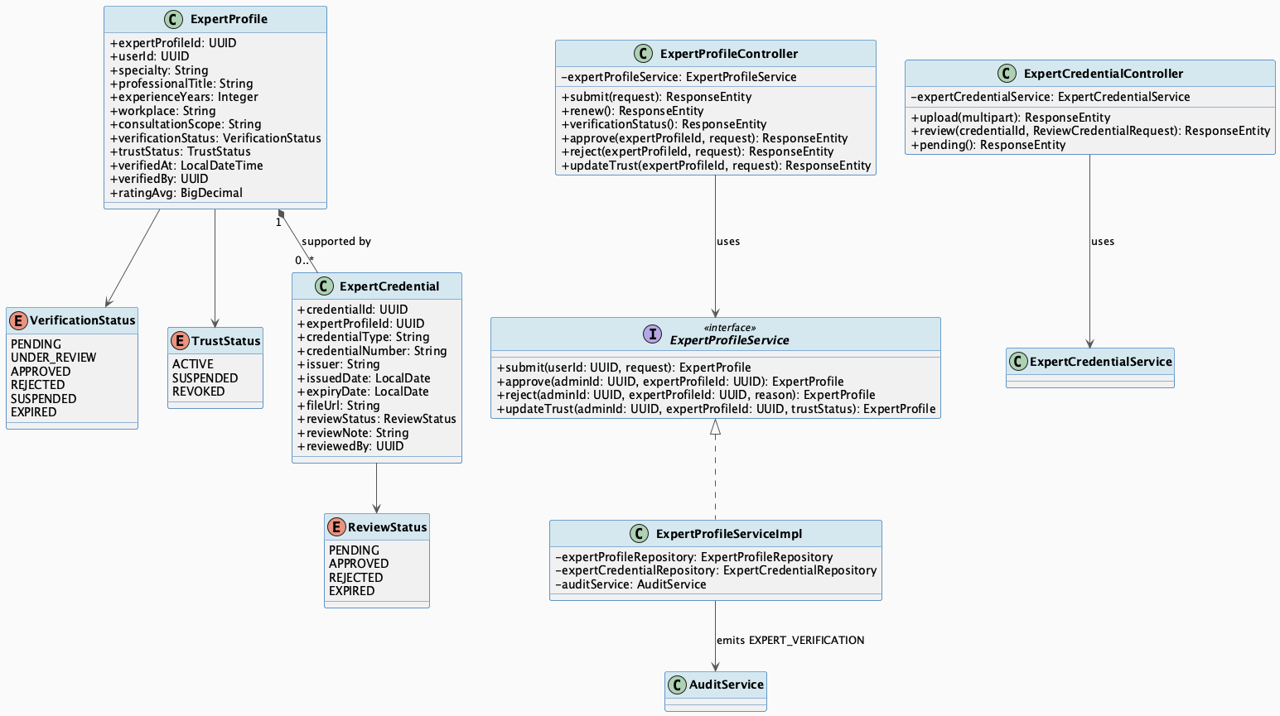
Expert Verification & Trust Lifecycle Class Diagram
Detail: Expert Verification & Trust Lifecycle Class Diagram

3.5.1.2 Sequence Diagram
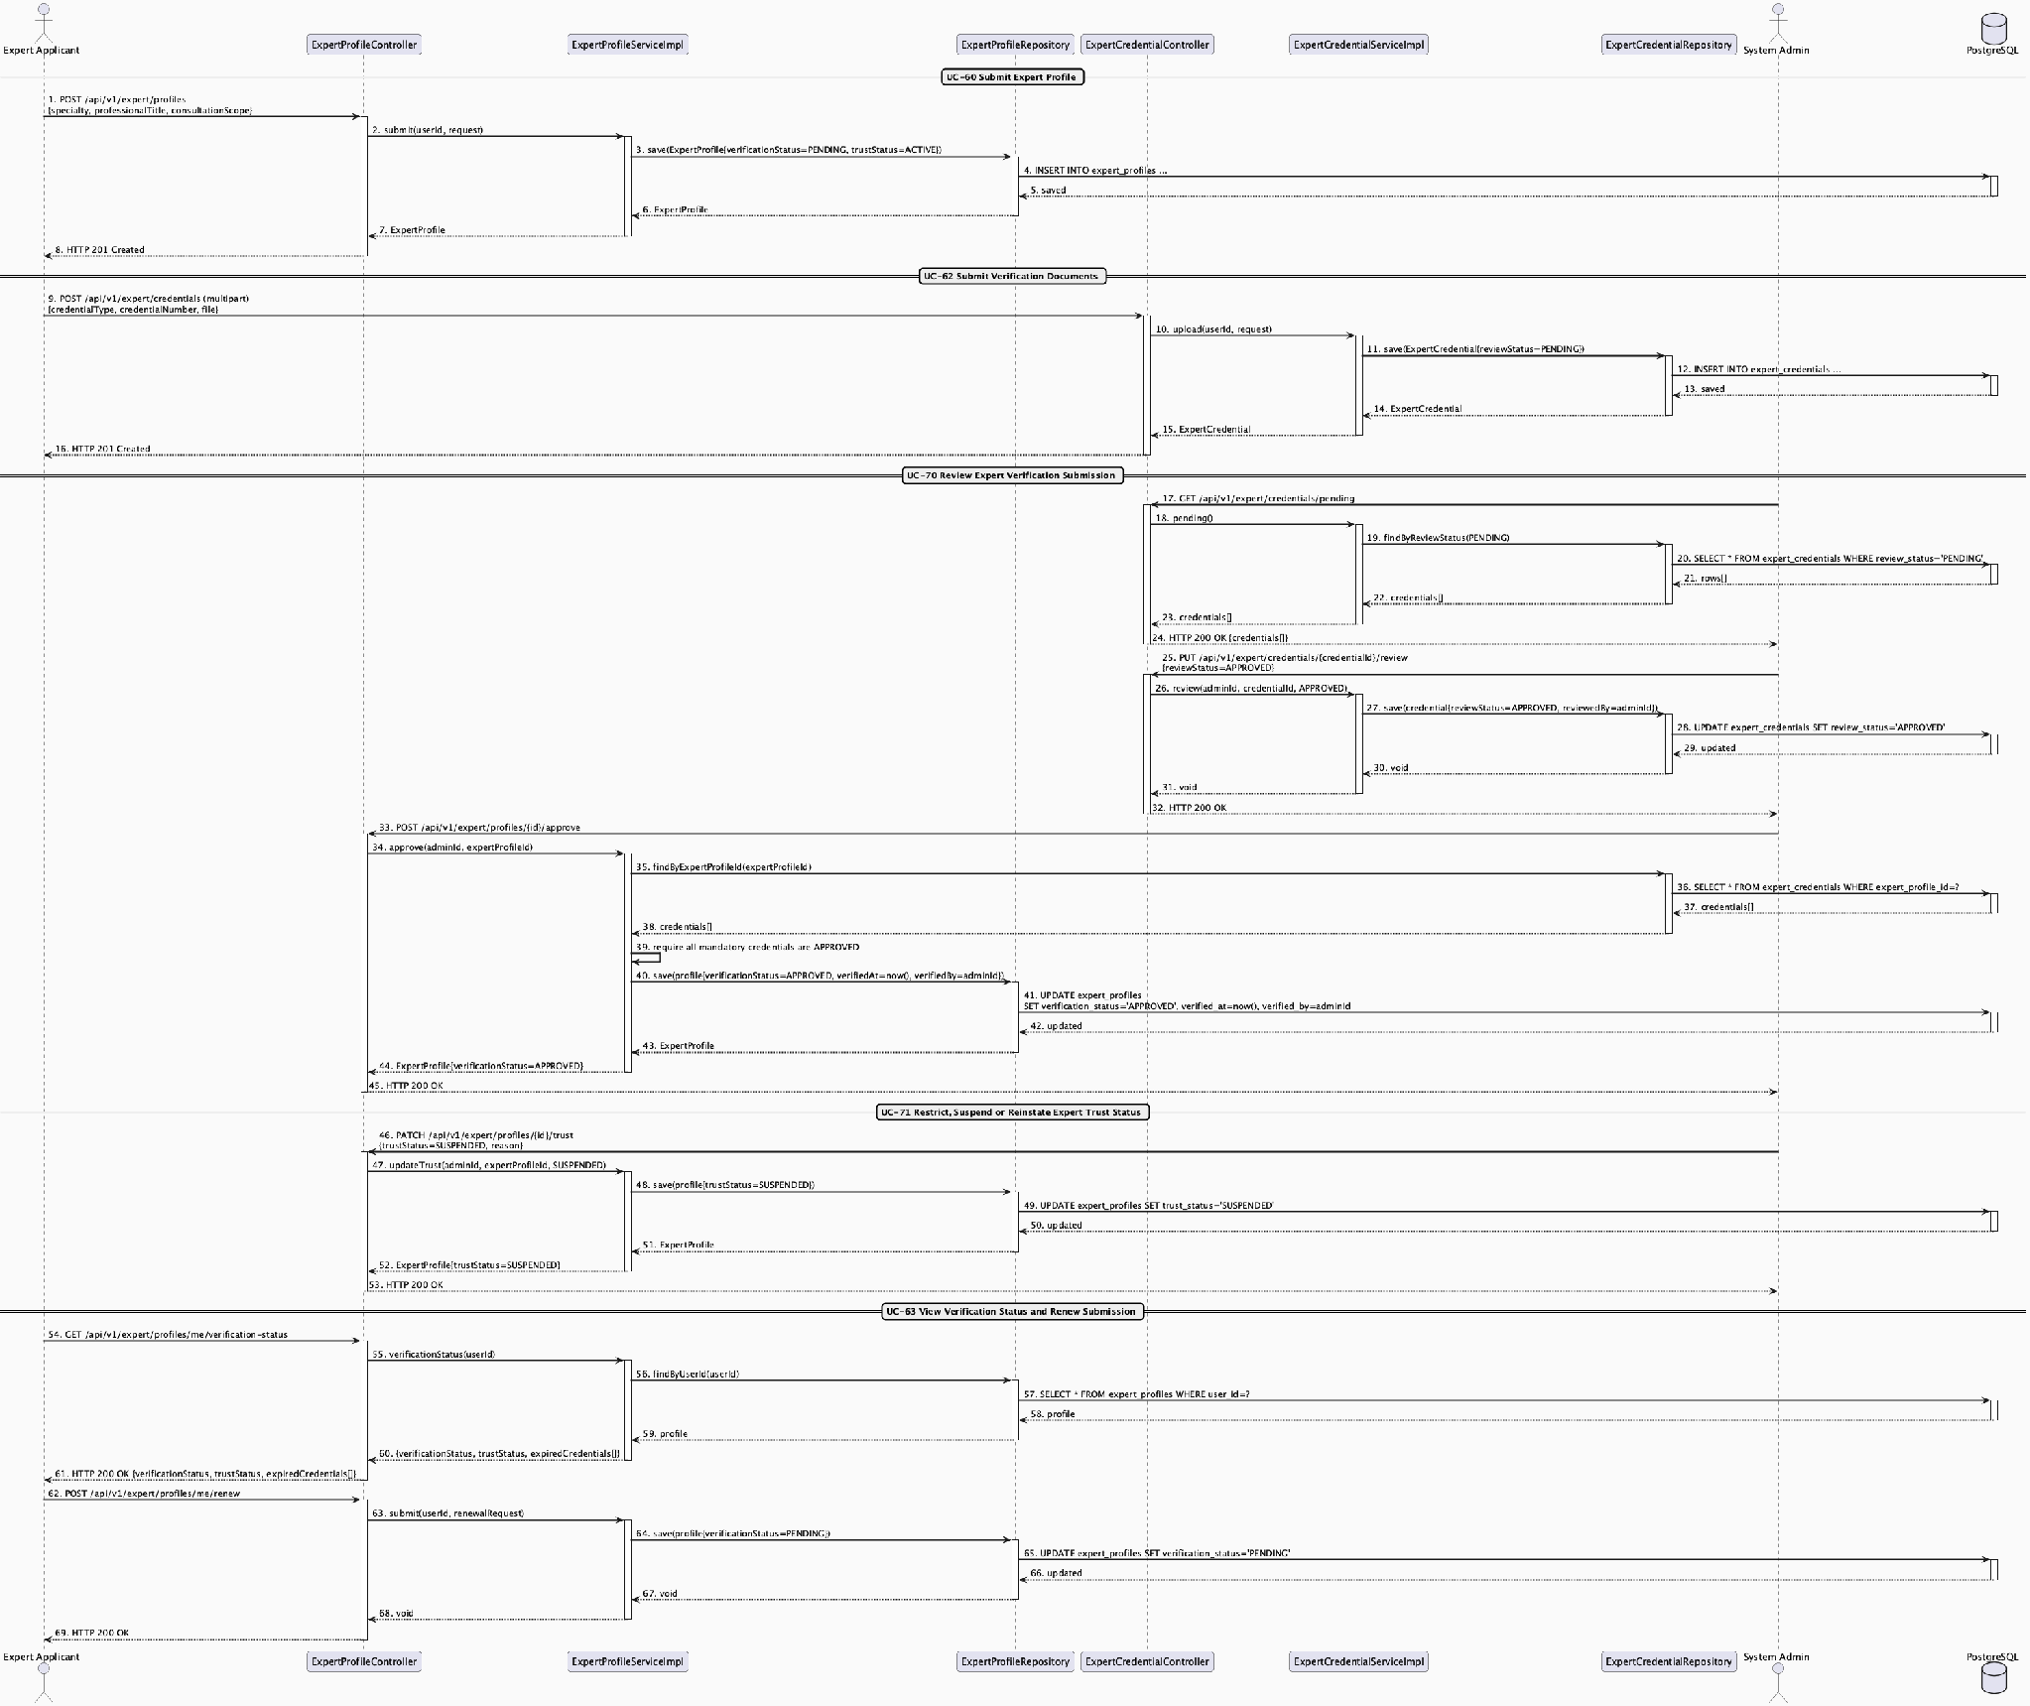
Expert Verification & Trust Lifecycle Sequence Diagram
Detail: Expert Verification & Trust Lifecycle Sequence Diagram

3.5.2 Expert Directory, Contribution & Recognition

3.5.2.1 Class Diagram
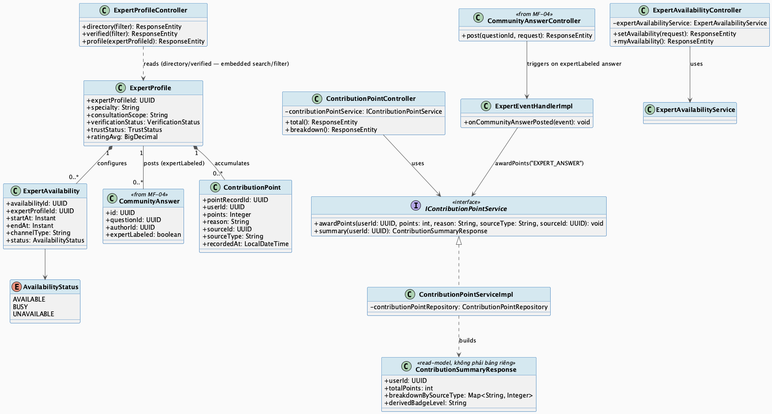
Expert Directory, Contribution & Recognition Class Diagram
Detail: Expert Directory, Contribution & Recognition Class Diagram

3.5.2.2 Sequence Diagram
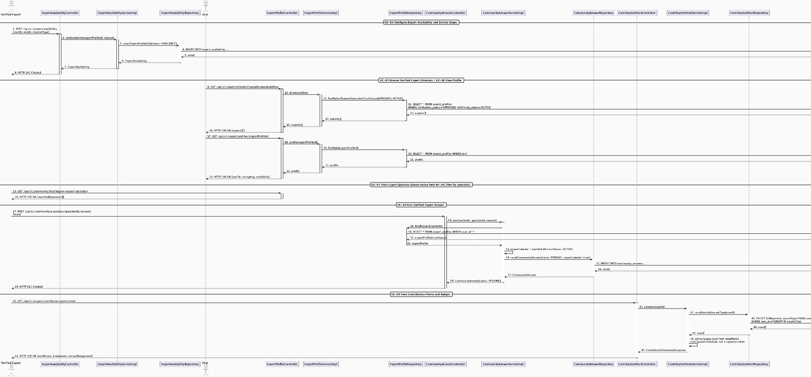
Expert Directory, Contribution & Recognition Sequence Diagram
Detail: Expert Directory, Contribution & Recognition Sequence Diagram

3.6 AI Nurse Assistant & Risk Triage

3.6.1 AI Symptom Intake, Risk Triage & Emergency Handoff

3.6.1.1 Class Diagram
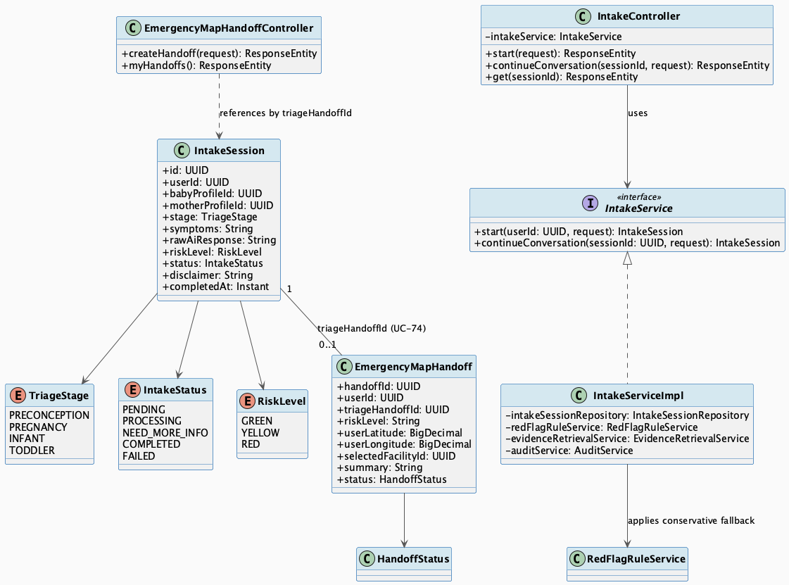
AI Symptom Intake, Risk Triage & Emergency Handoff Class Diagram
Detail: AI Symptom Intake, Risk Triage & Emergency Handoff Class Diagram

3.6.1.2 Sequence Diagram
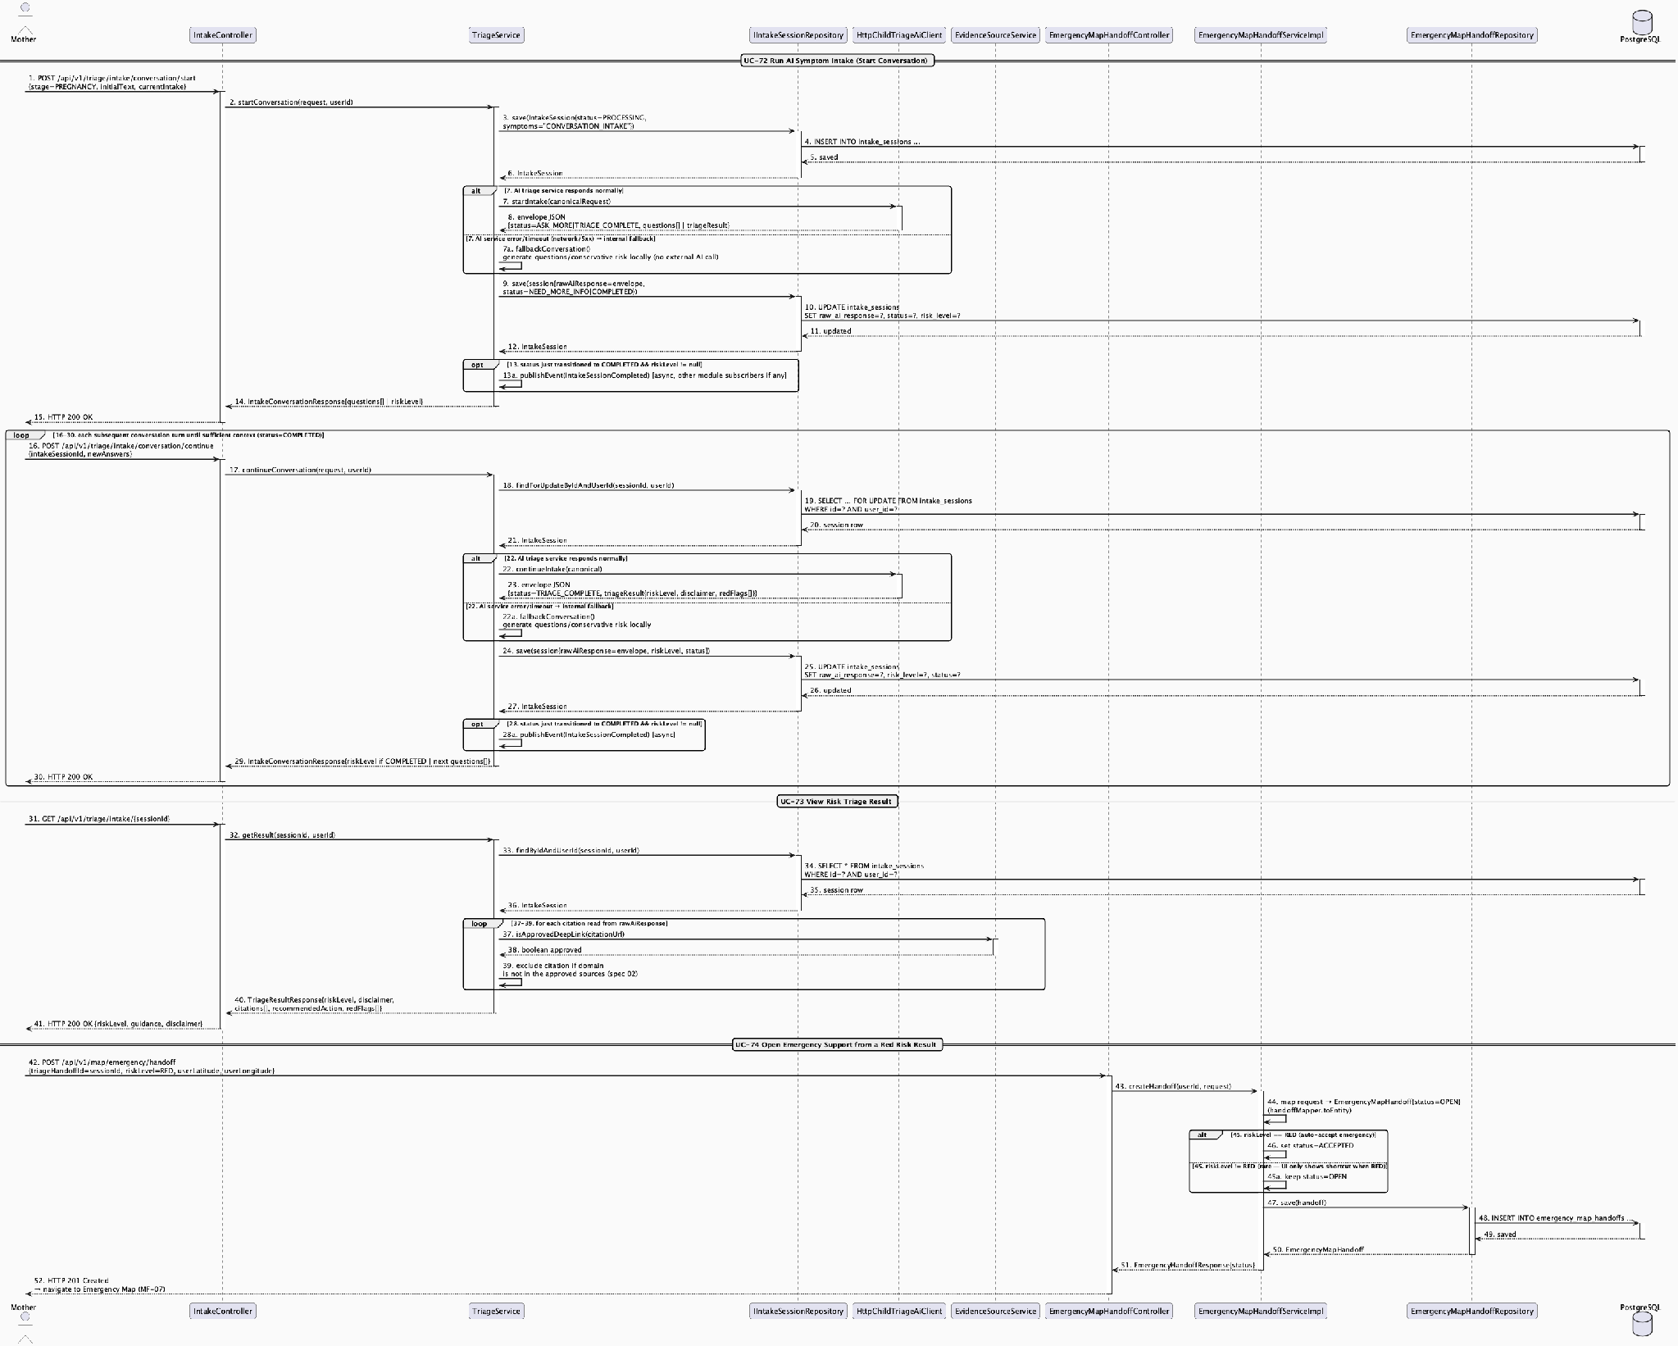
AI Symptom Intake, Risk Triage & Emergency Handoff Sequence Diagram
Detail: AI Symptom Intake, Risk Triage & Emergency Handoff Sequence Diagram

3.6.2 AI Knowledge Source & Red-Flag Rule Governance

3.6.2.1 Class Diagram
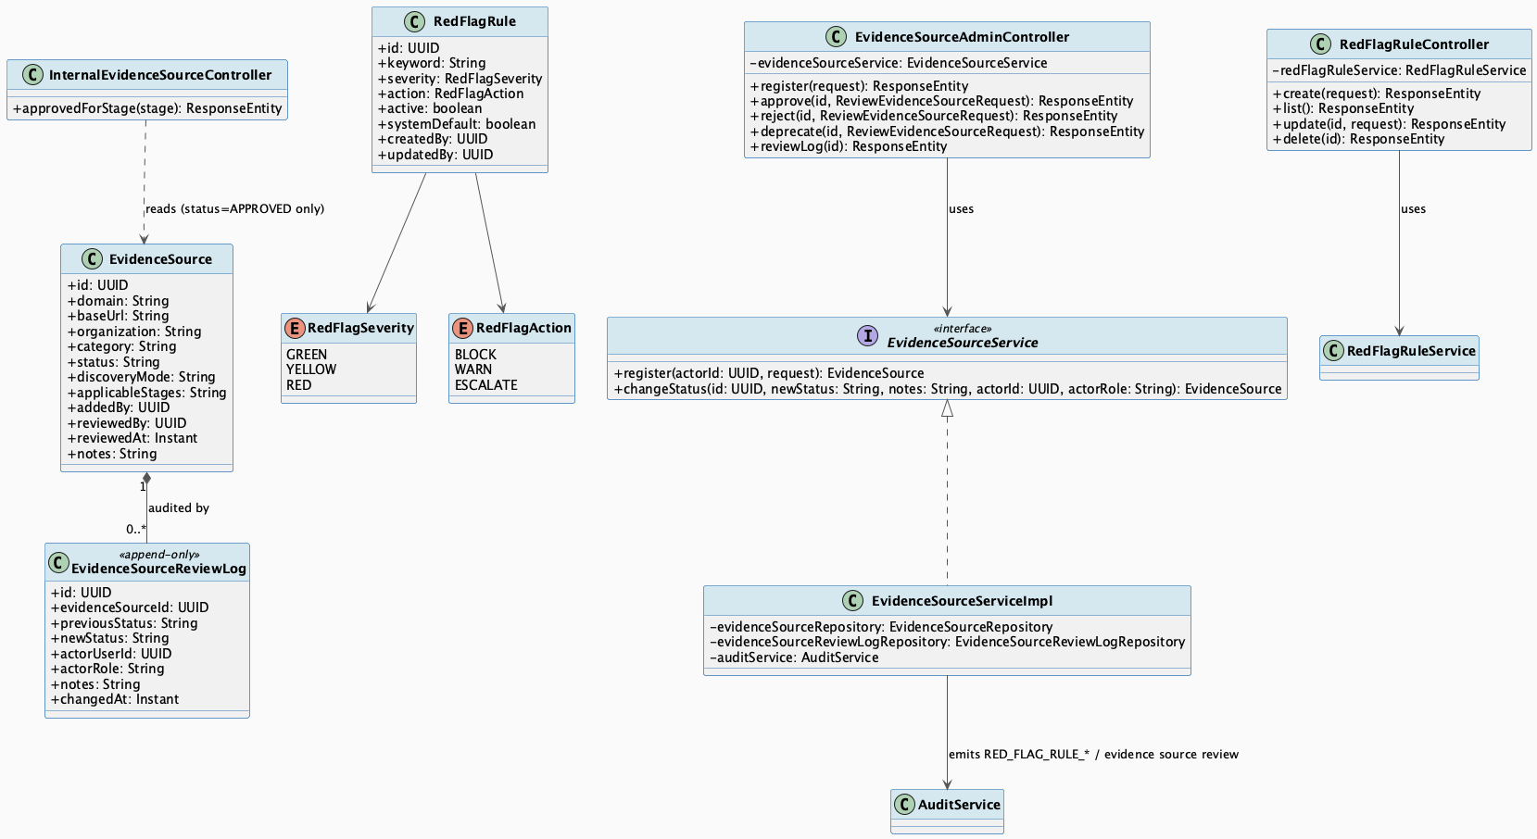
AI Knowledge Source & Red-Flag Rule Governance Class Diagram
Detail: AI Knowledge Source & Red-Flag Rule Governance Class Diagram

3.6.2.2 Sequence Diagram
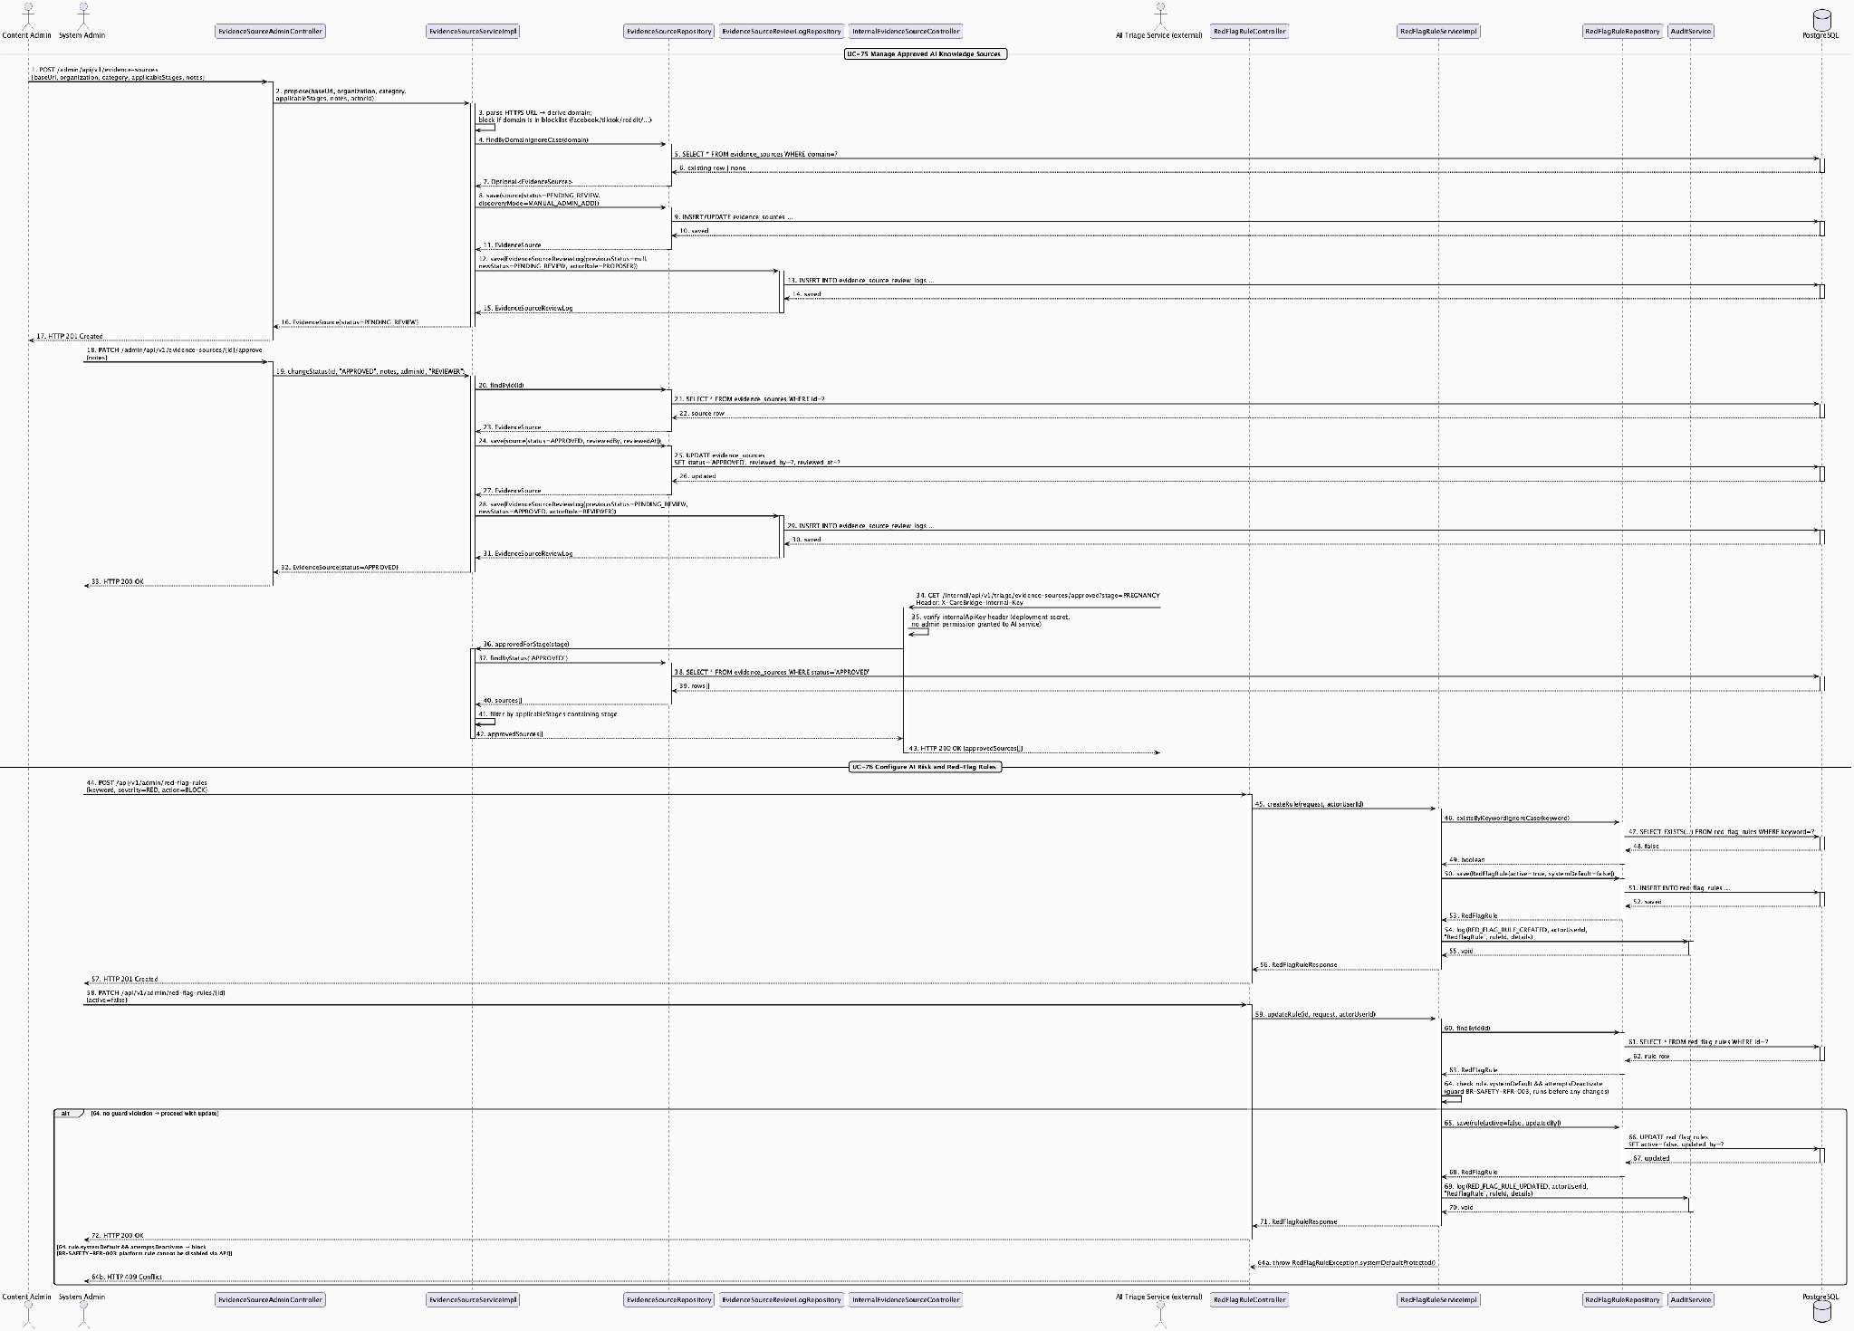
AI Knowledge Source & Red-Flag Rule Governance Sequence Diagram
Detail: AI Knowledge Source & Red-Flag Rule Governance Sequence Diagram

3.7 Emergency Map & Nearby Care Support

3.7.1 Emergency Map, Nearby Facility Search & Route Navigation

3.7.1.1 Class Diagram
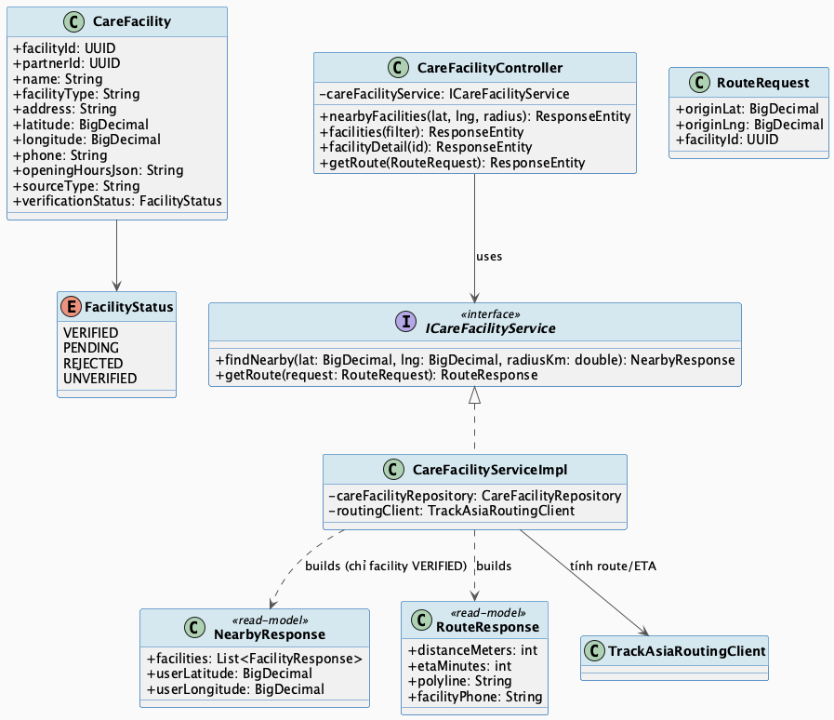
Emergency Map, Nearby Facility Search & Route Navigation Class Diagram
Detail: Emergency Map, Nearby Facility Search & Route Navigation Class Diagram

3.7.1.2 Sequence Diagram
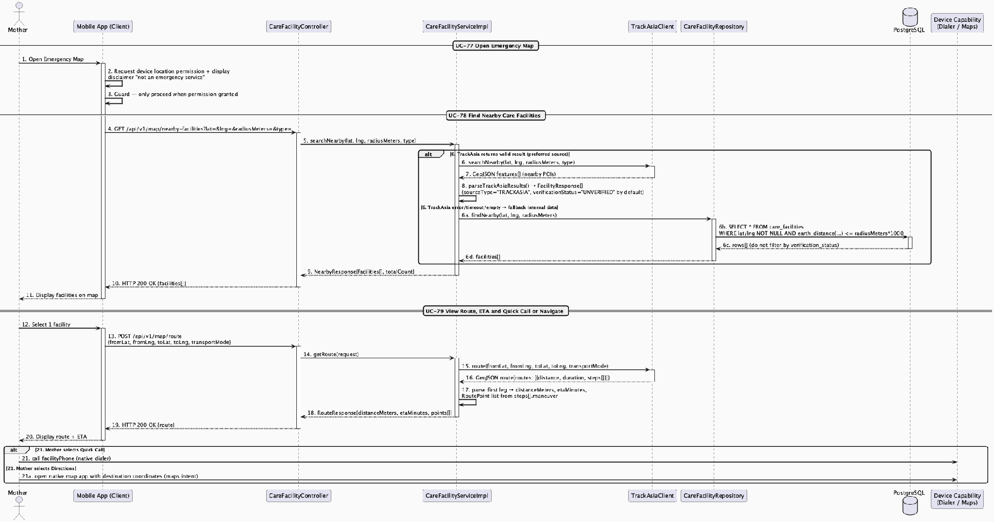
Emergency Map, Nearby Facility Search & Route Navigation Sequence Diagram
Detail: Emergency Map, Nearby Facility Search & Route Navigation Sequence Diagram

3.7.2 Time-Limited Family Alert & Nearby Support Request

3.7.2.1 Class Diagram
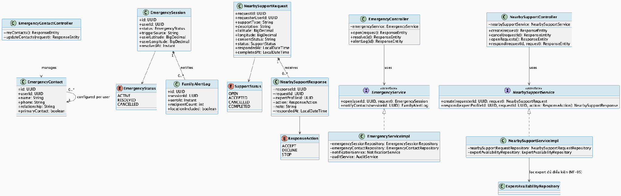
Time-Limited Family Alert & Nearby Support Request Class Diagram
Detail: Time-Limited Family Alert & Nearby Support Request Class Diagram

3.7.2.2 Sequence Diagram
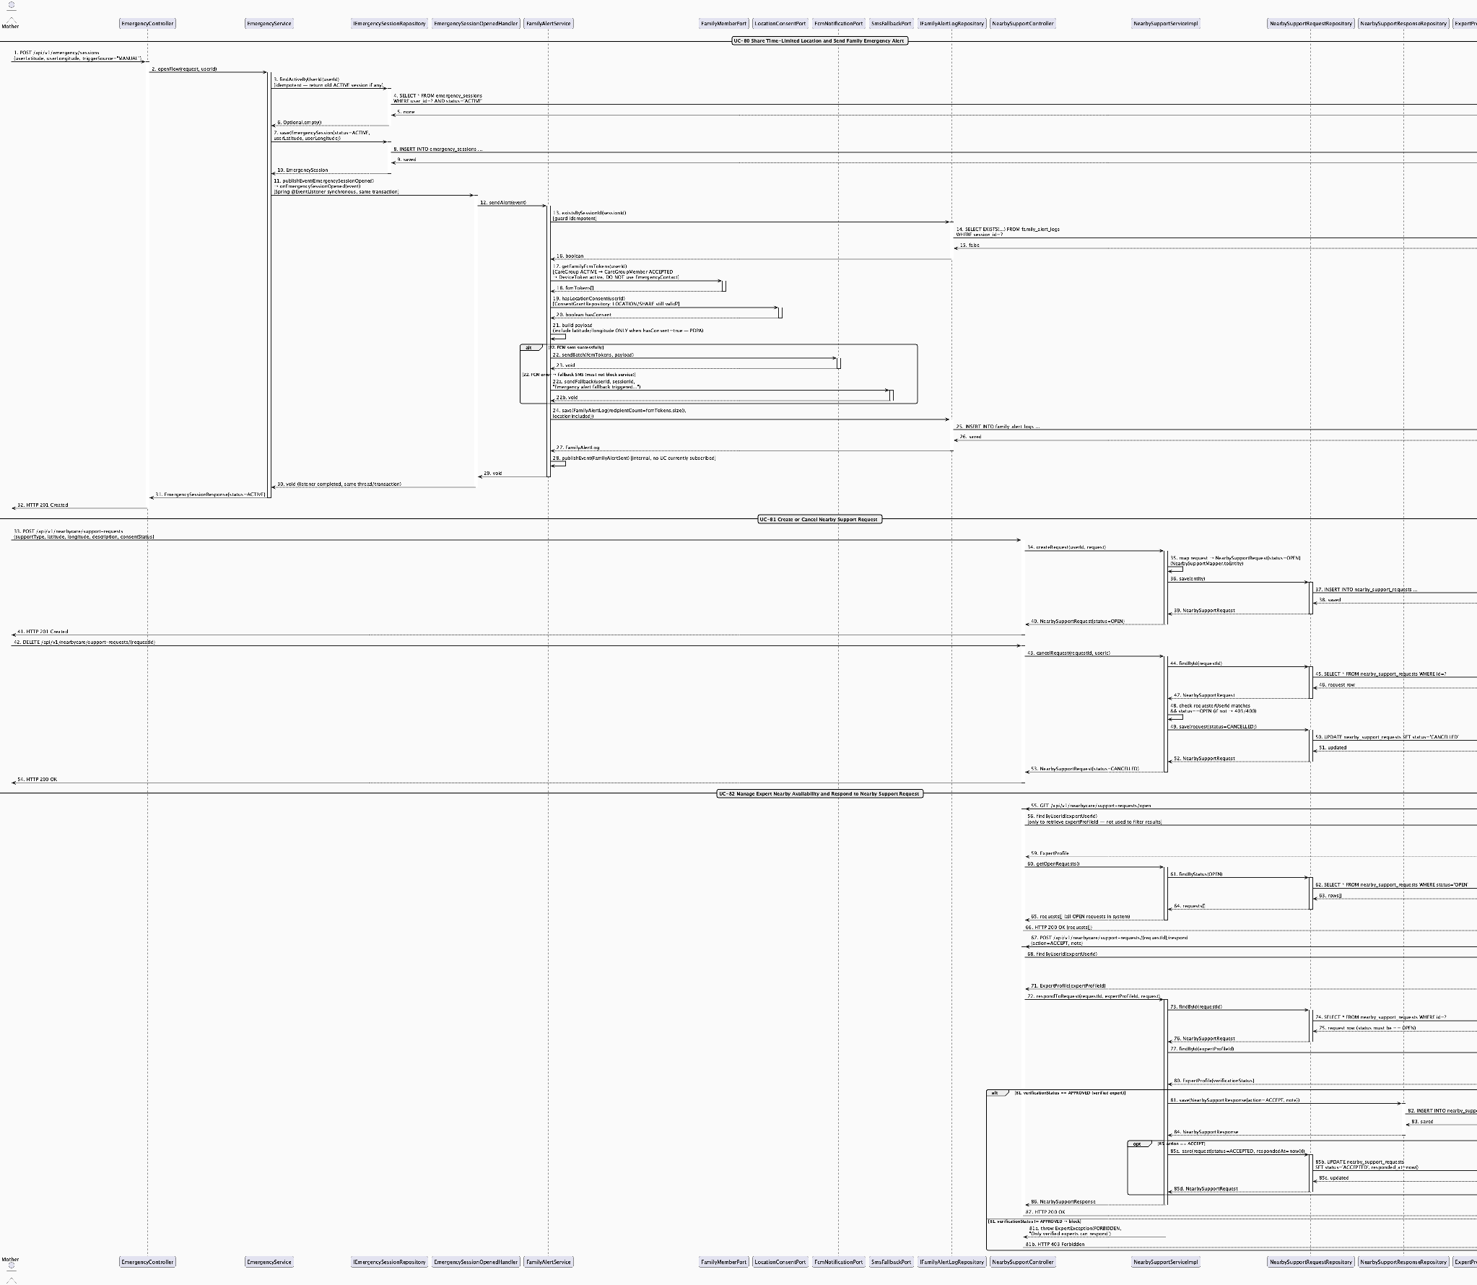
Time-Limited Family Alert & Nearby Support Request Sequence Diagram
Detail: Time-Limited Family Alert & Nearby Support Request Sequence Diagram

3.8 Personal Health Records & Source Labeling

3.8.1 Personal Health Record Lifecycle & Timeline

3.8.1.1 Class Diagram
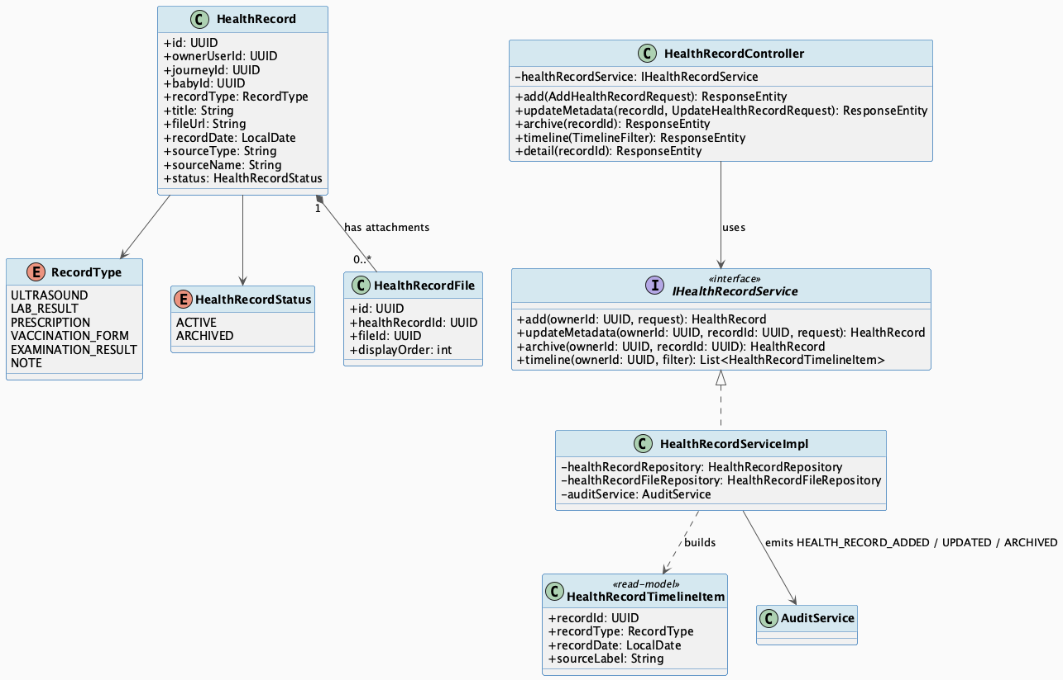
Personal Health Record Lifecycle & Timeline Class Diagram
Detail: Personal Health Record Lifecycle & Timeline Class Diagram

3.8.1.2 Sequence Diagram
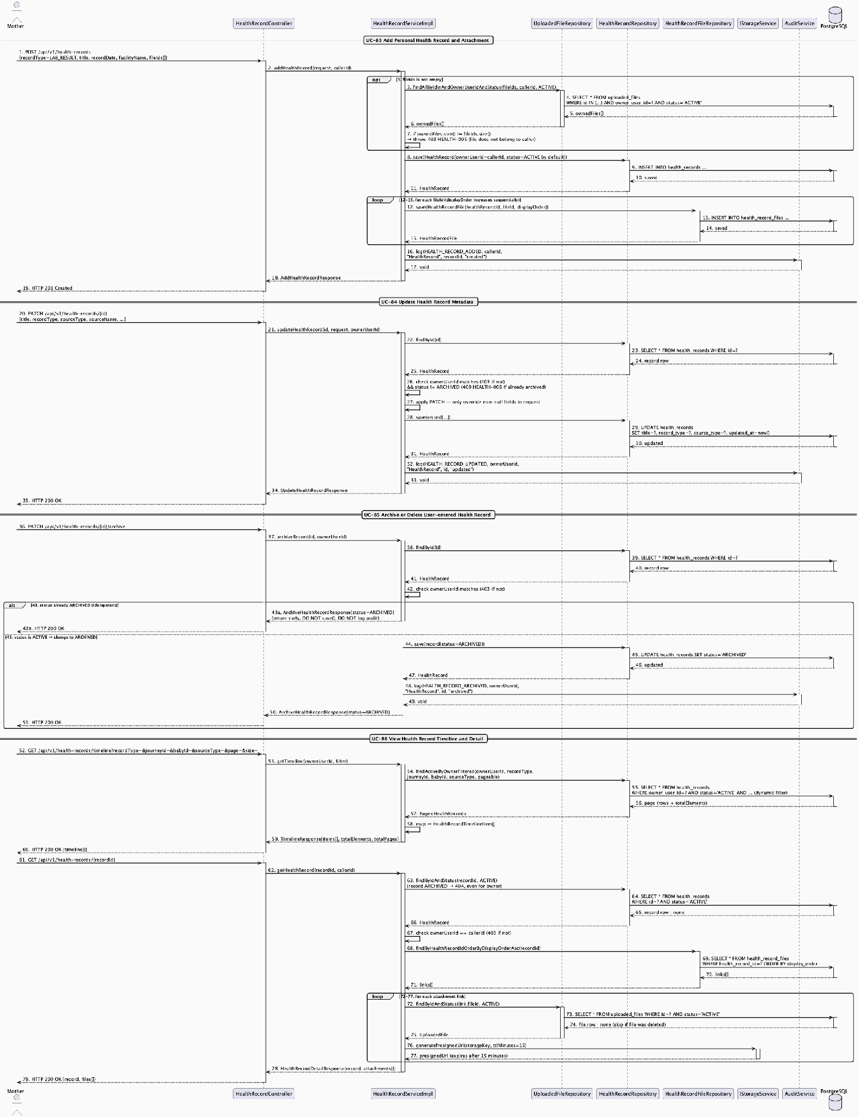
Personal Health Record Lifecycle & Timeline Sequence Diagram
Detail: Personal Health Record Lifecycle & Timeline Sequence Diagram

3.8.2 Health Summary Generation & Consent-Gated Sharing

3.8.2.1 Class Diagram
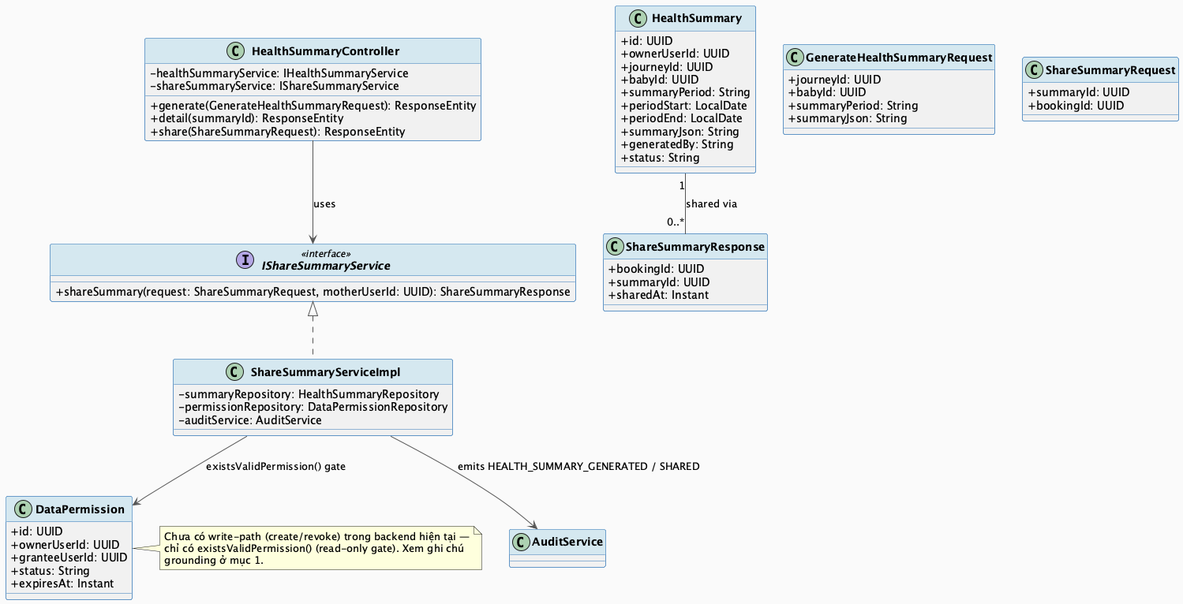
Health Summary Generation & Consent-Gated Sharing Class Diagram
Detail: Health Summary Generation & Consent-Gated Sharing Class Diagram

3.8.2.2 Sequence Diagram
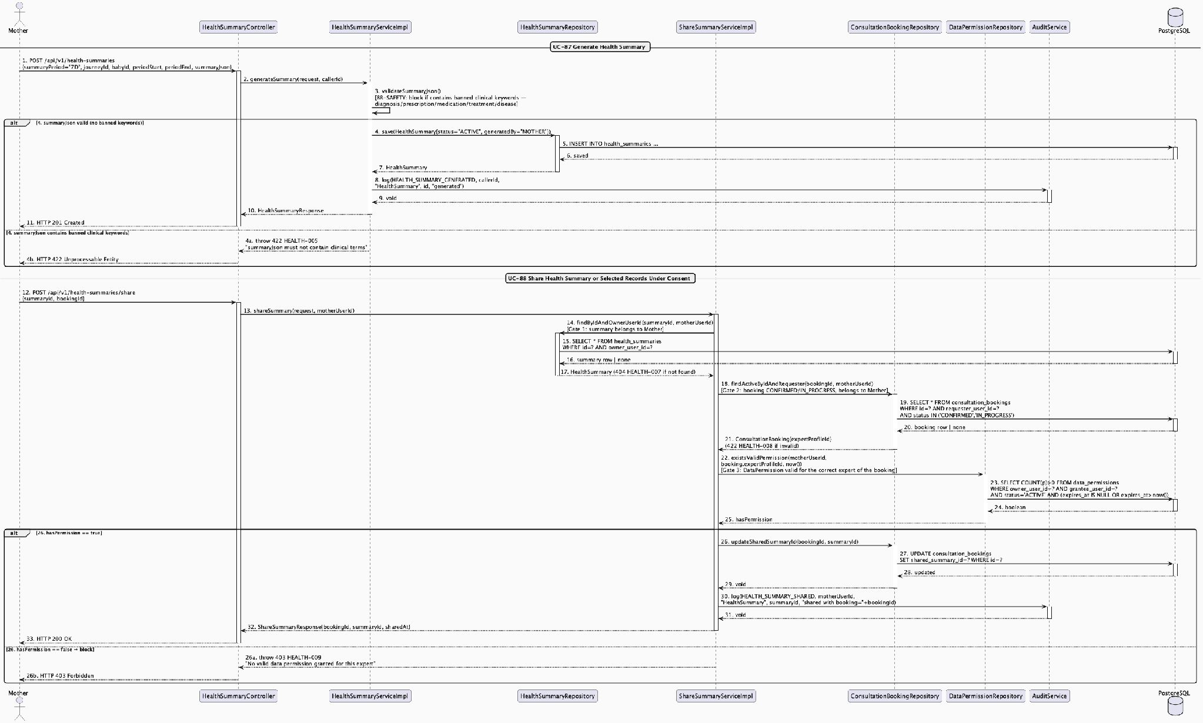
Health Summary Generation & Consent-Gated Sharing Sequence Diagram
Detail: Health Summary Generation & Consent-Gated Sharing Sequence Diagram

3.9 Reminders, Tasks & Care Plan

3.9.1 Reminder Lifecycle & Today Tasks

3.9.1.1 Class Diagram
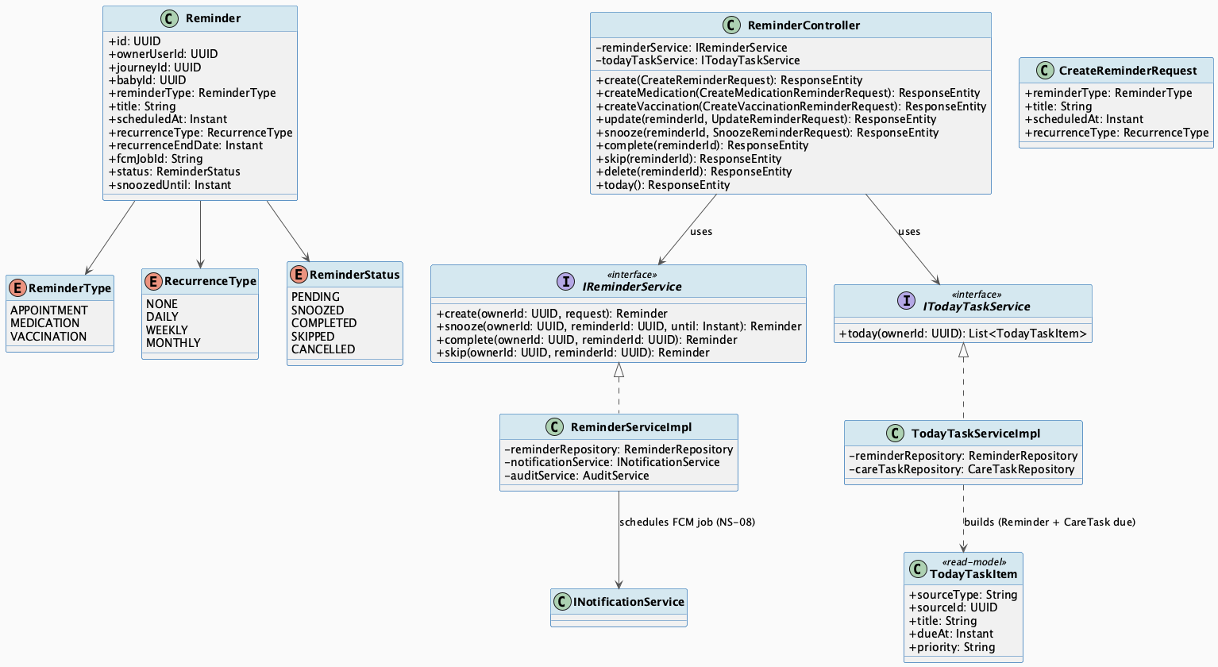
Reminder Lifecycle & Today Tasks Class Diagram
Detail: Reminder Lifecycle & Today Tasks Class Diagram

3.9.1.2 Sequence Diagram
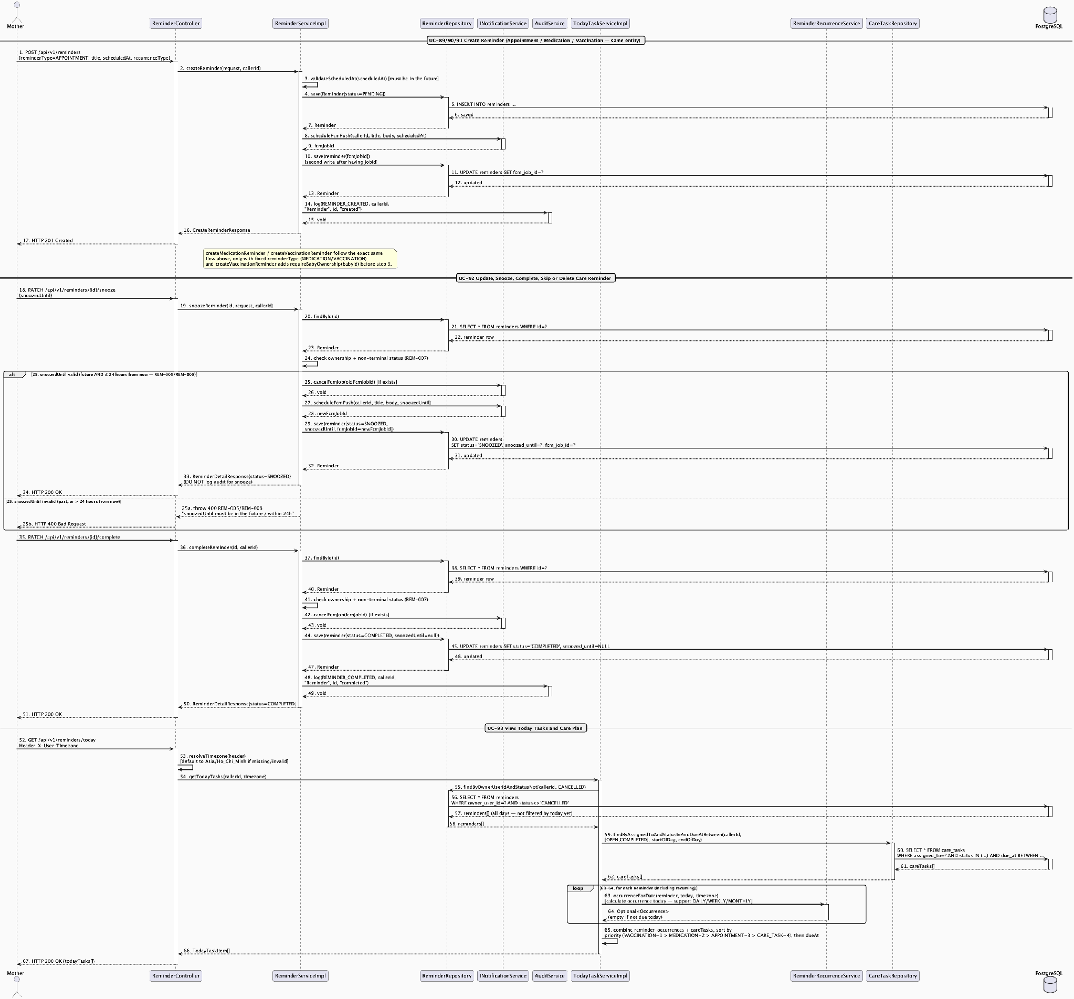
Reminder Lifecycle & Today Tasks Sequence Diagram
Detail: Reminder Lifecycle & Today Tasks Sequence Diagram

3.10 Family Sync & Cooperative Care

3.10.1 Care Group & Invitation Lifecycle

3.10.1.1 Class Diagram
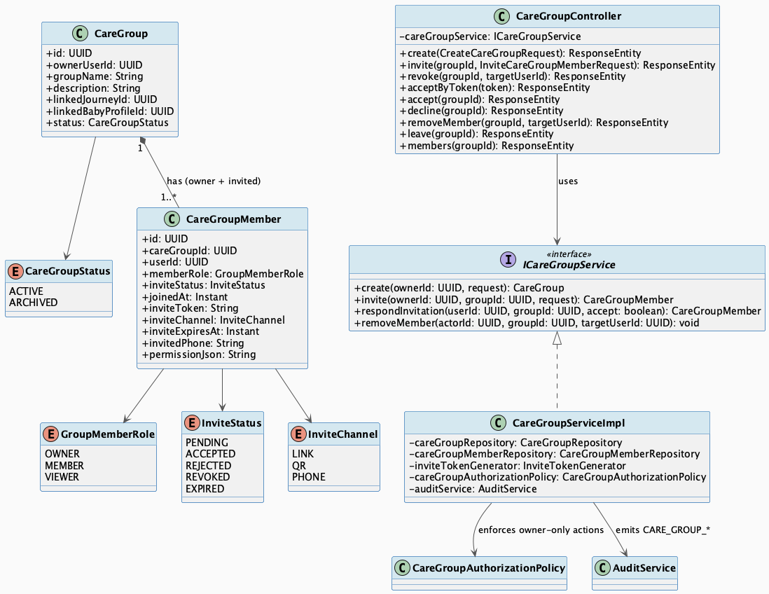
Care Group & Invitation Lifecycle Class Diagram
Detail: Care Group & Invitation Lifecycle Class Diagram

3.10.1.2 Sequence Diagram
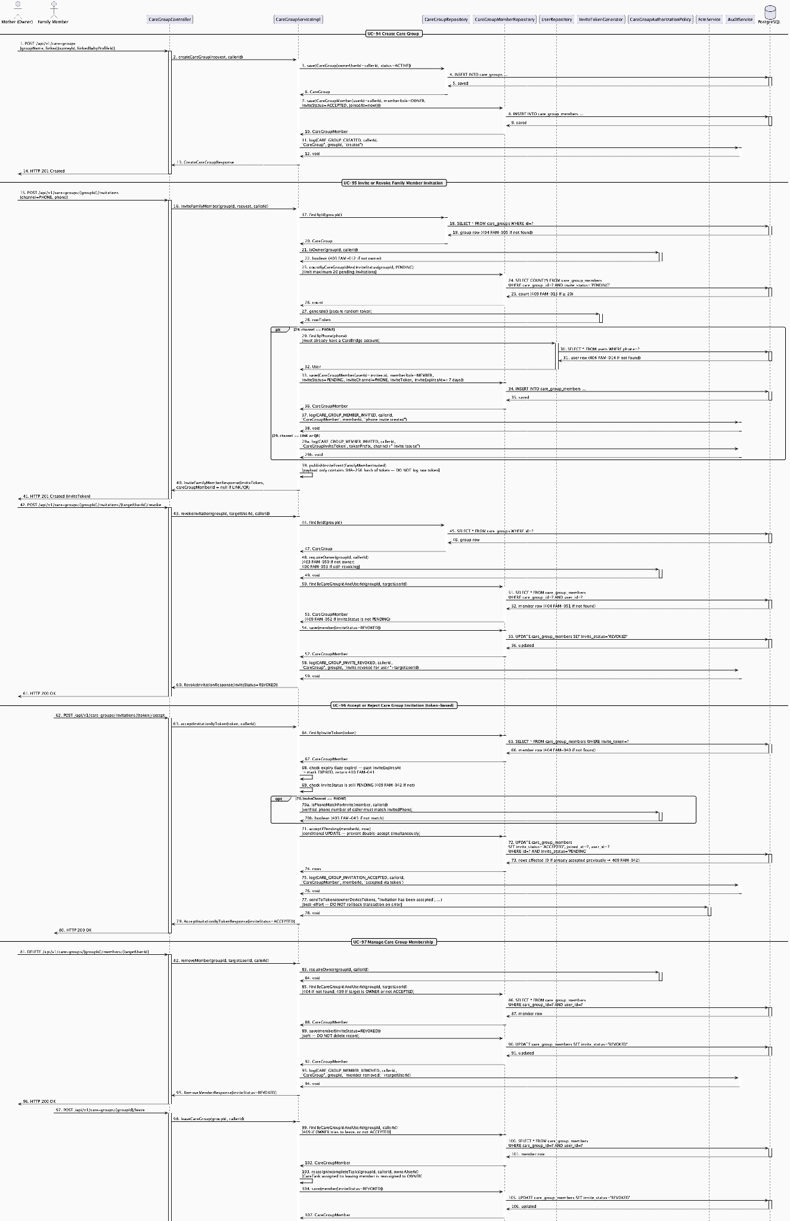
Care Group & Invitation Lifecycle Sequence Diagram
Detail: Care Group & Invitation Lifecycle Sequence Diagram

3.10.2 Family Permission Scope & Shared Care Visibility

3.10.2.1 Class Diagram
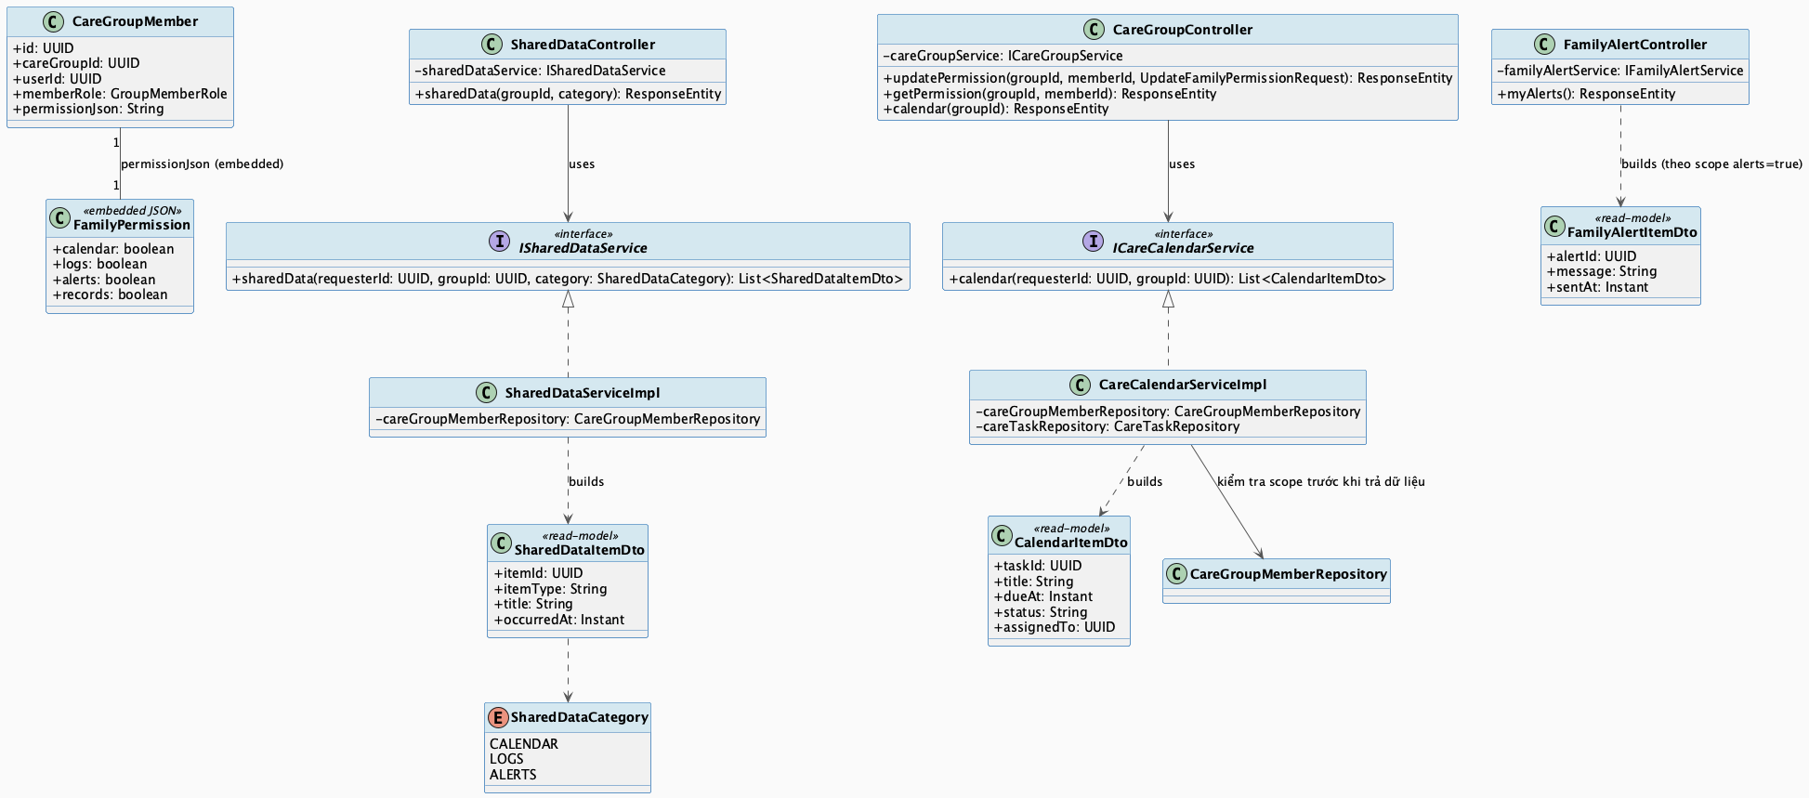
Family Permission Scope & Shared Care Visibility Class Diagram
Detail: Family Permission Scope & Shared Care Visibility Class Diagram

3.10.2.2 Sequence Diagram
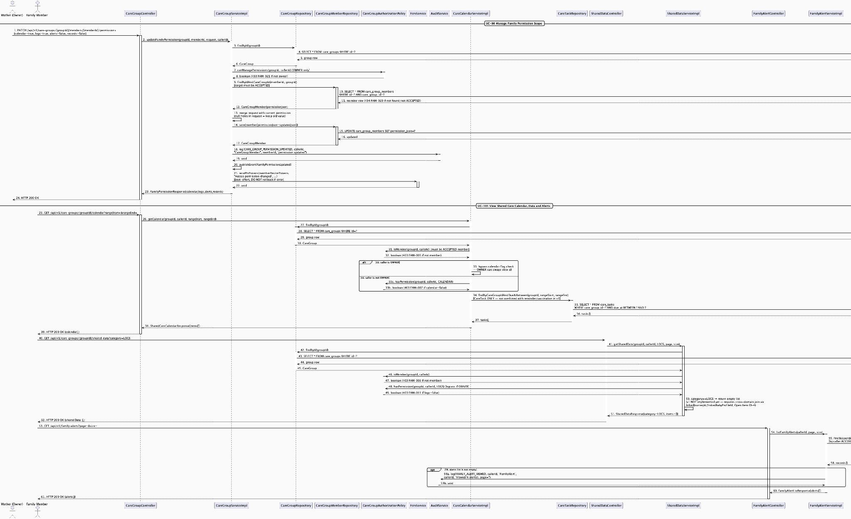
Family Permission Scope & Shared Care Visibility Sequence Diagram
Detail: Family Permission Scope & Shared Care Visibility Sequence Diagram

3.10.3 Family Care Task Assignment & Status Update

3.10.3.1 Class Diagram
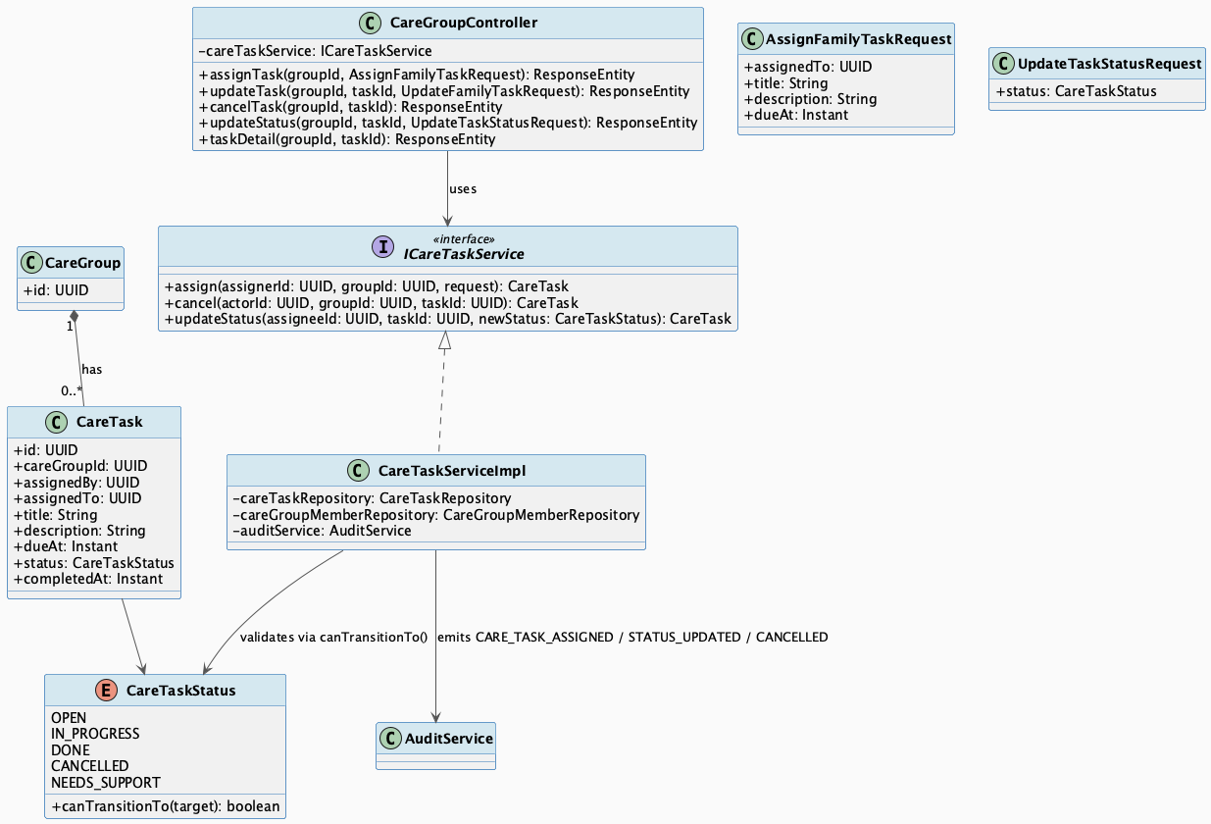
Family Care Task Assignment & Status Update Class Diagram
Detail: Family Care Task Assignment & Status Update Class Diagram

3.10.3.2 Sequence Diagram
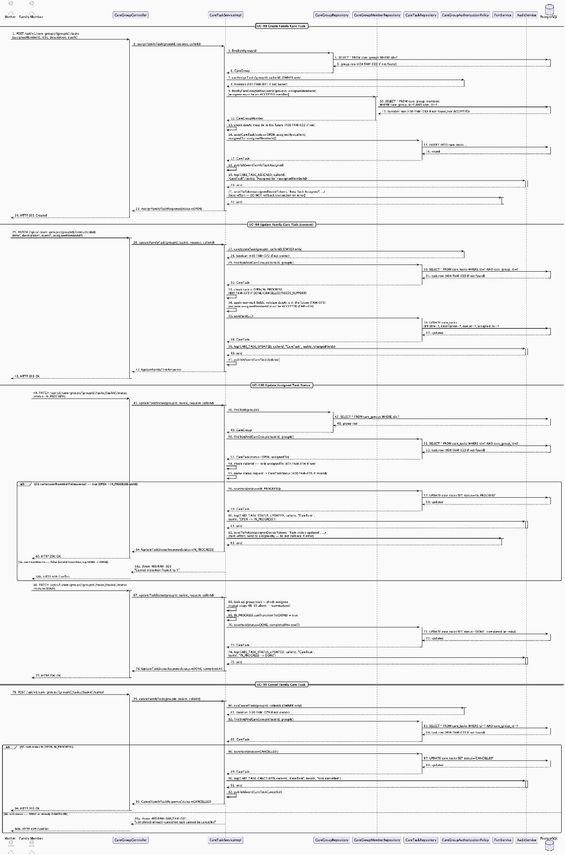
Family Care Task Assignment & Status Update Sequence Diagram
Detail: Family Care Task Assignment & Status Update Sequence Diagram

3.11 Verified Content & Checklist Hub

3.11.1 Verified Content Browse & Consumption

3.11.1.1 Class Diagram
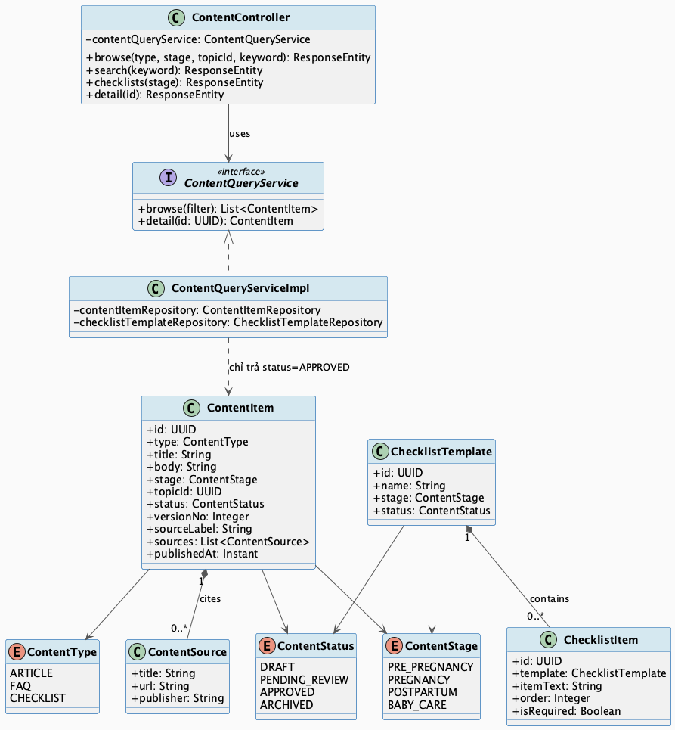
Verified Content Browse & Consumption Class Diagram
Detail: Verified Content Browse & Consumption Class Diagram

3.11.1.2 Sequence Diagram
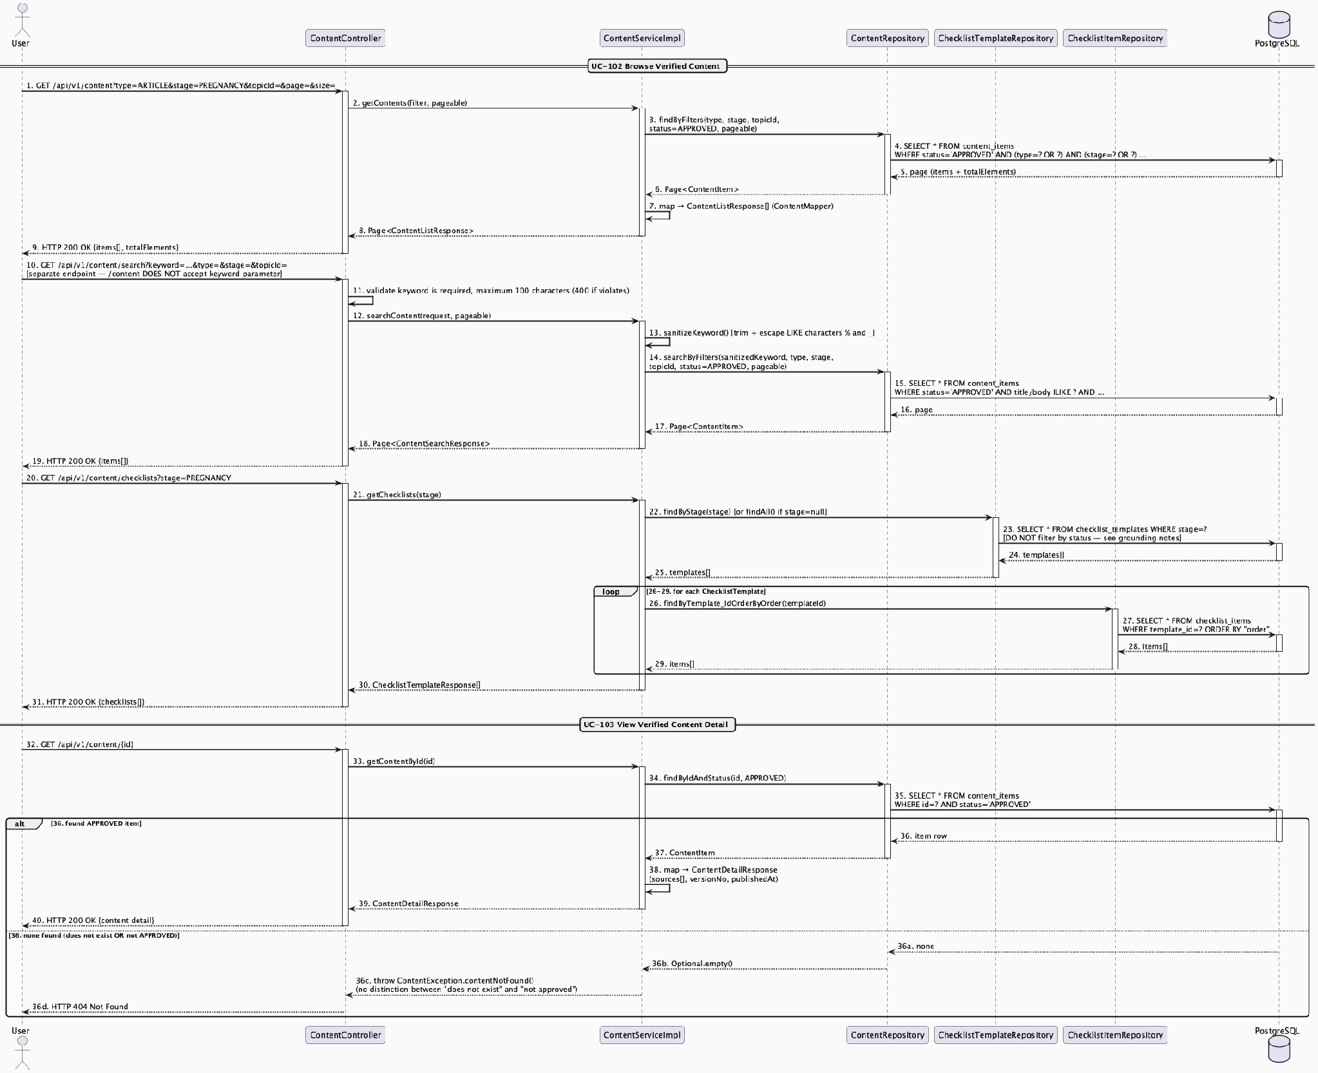
Verified Content Browse & Consumption Sequence Diagram
Detail: Verified Content Browse & Consumption Sequence Diagram

3.11.2 Content Authoring, Review & Publishing Lifecycle

3.11.2.1 Class Diagram
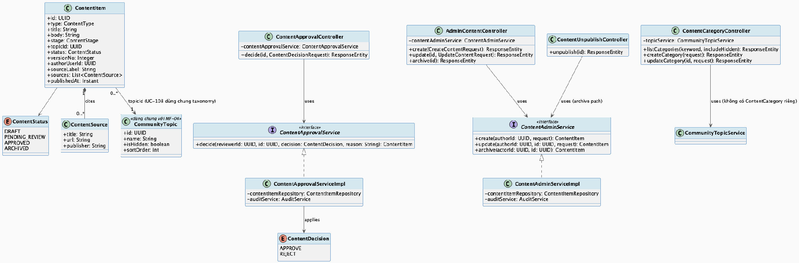
Content Authoring, Review & Publishing Lifecycle Class Diagram
Detail: Content Authoring, Review & Publishing Lifecycle Class Diagram

3.11.2.2 Sequence Diagram
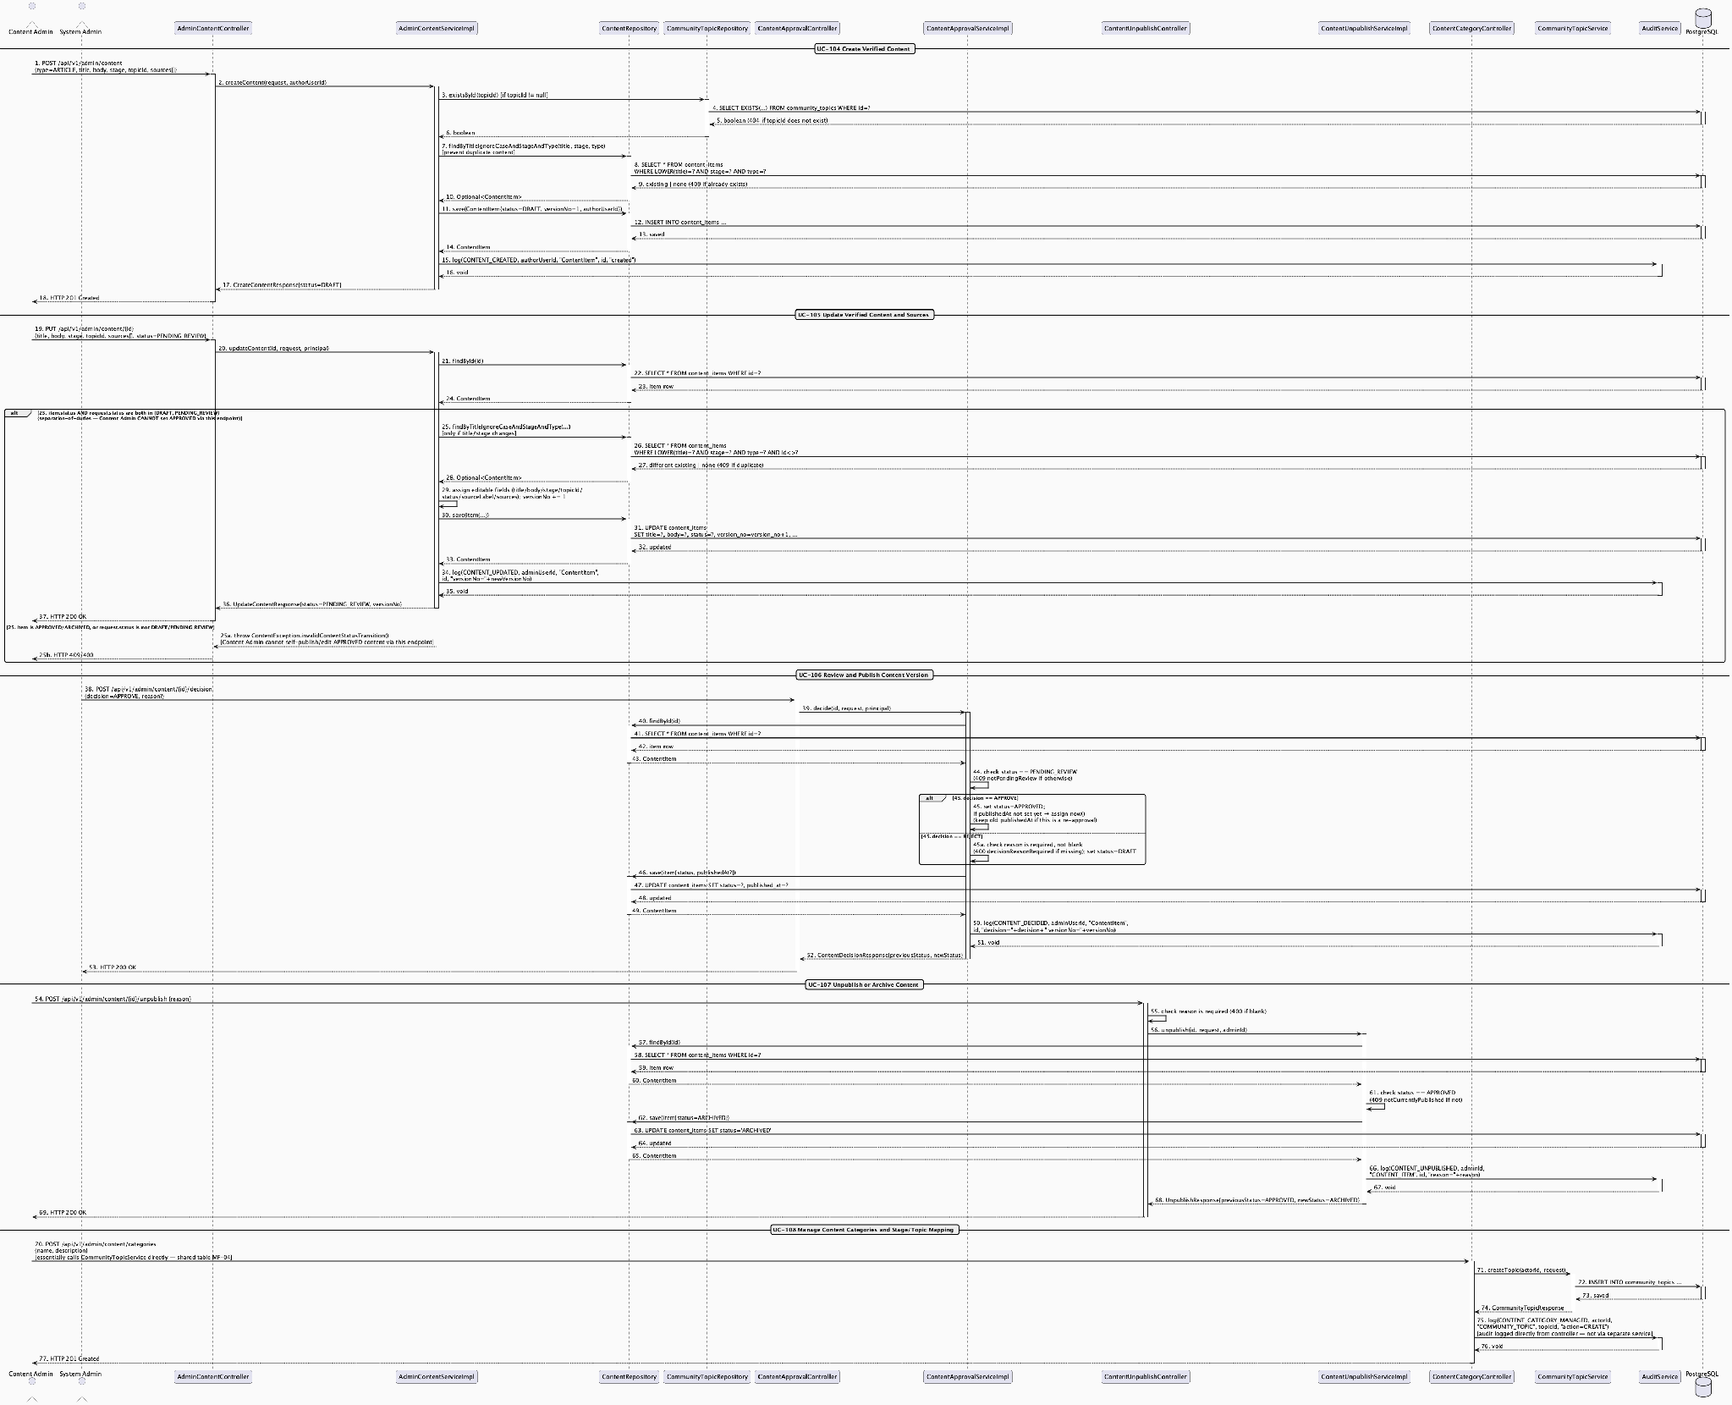
Content Authoring, Review & Publishing Lifecycle Sequence Diagram
Detail: Content Authoring, Review & Publishing Lifecycle Sequence Diagram

3.12 Expense & Preparation Planner

3.12.1 Preparation Expense Entry & Summary

3.12.1.1 Class Diagram
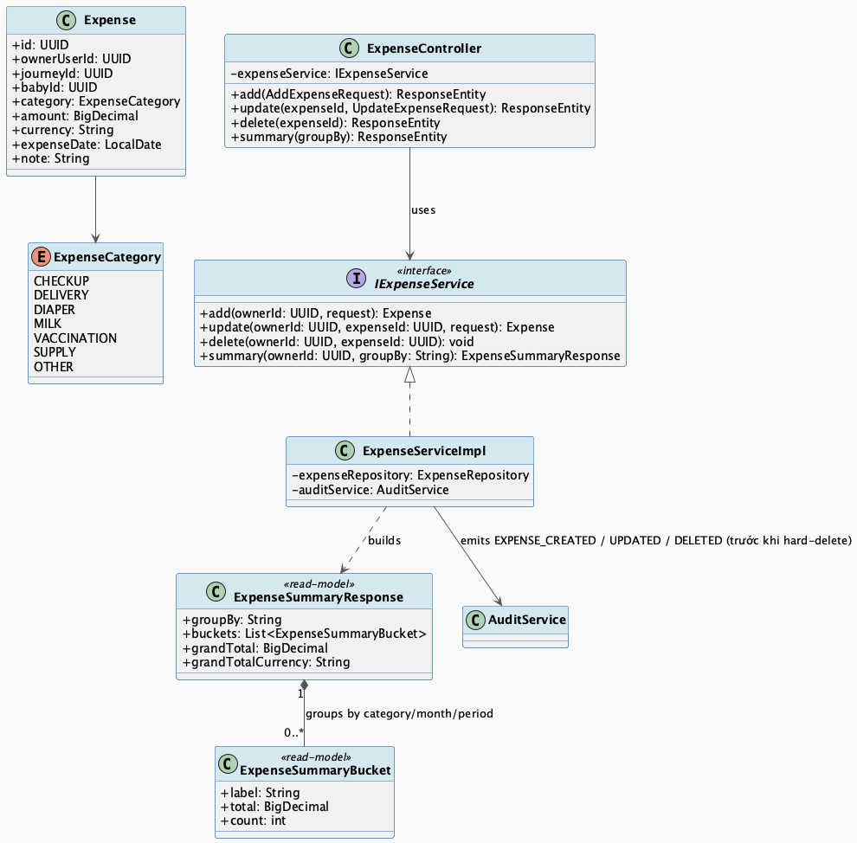
Preparation Expense Entry & Summary Class Diagram
Detail: Preparation Expense Entry & Summary Class Diagram

3.12.1.2 Sequence Diagram
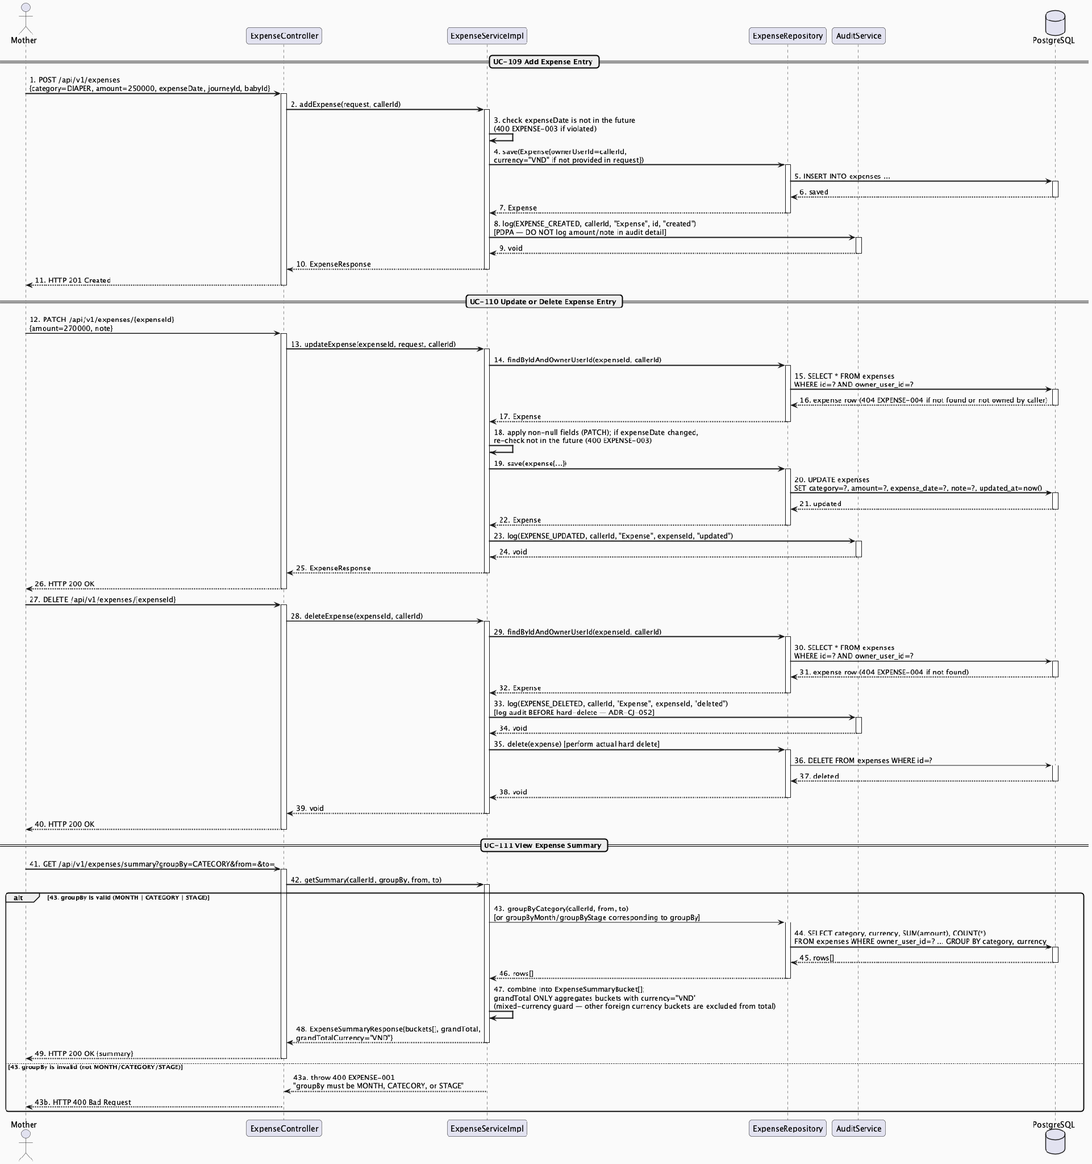
Preparation Expense Entry & Summary Sequence Diagram
Detail: Preparation Expense Entry & Summary Sequence Diagram

3.13 Connected Device & Health Data Integration

3.13.1 Connected Device: Connection, Sync, Trend & Disconnect Lifecycle

3.13.1.1 Class Diagram
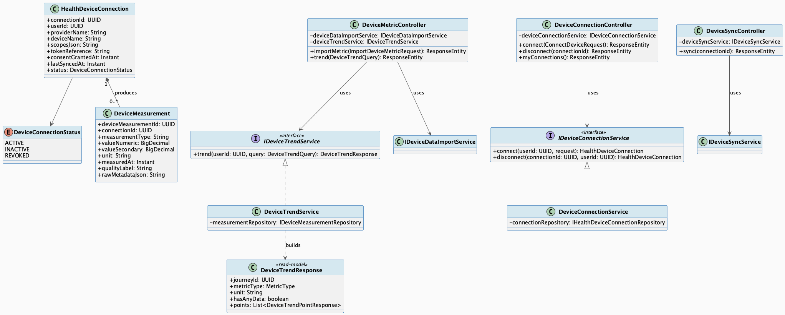
Connected Device: Connection, Sync, Trend & Disconnect Lifecycle Class Diagram
Detail: Connected Device: Connection, Sync, Trend & Disconnect Lifecycle Class Diagram

3.13.1.2 Sequence Diagram
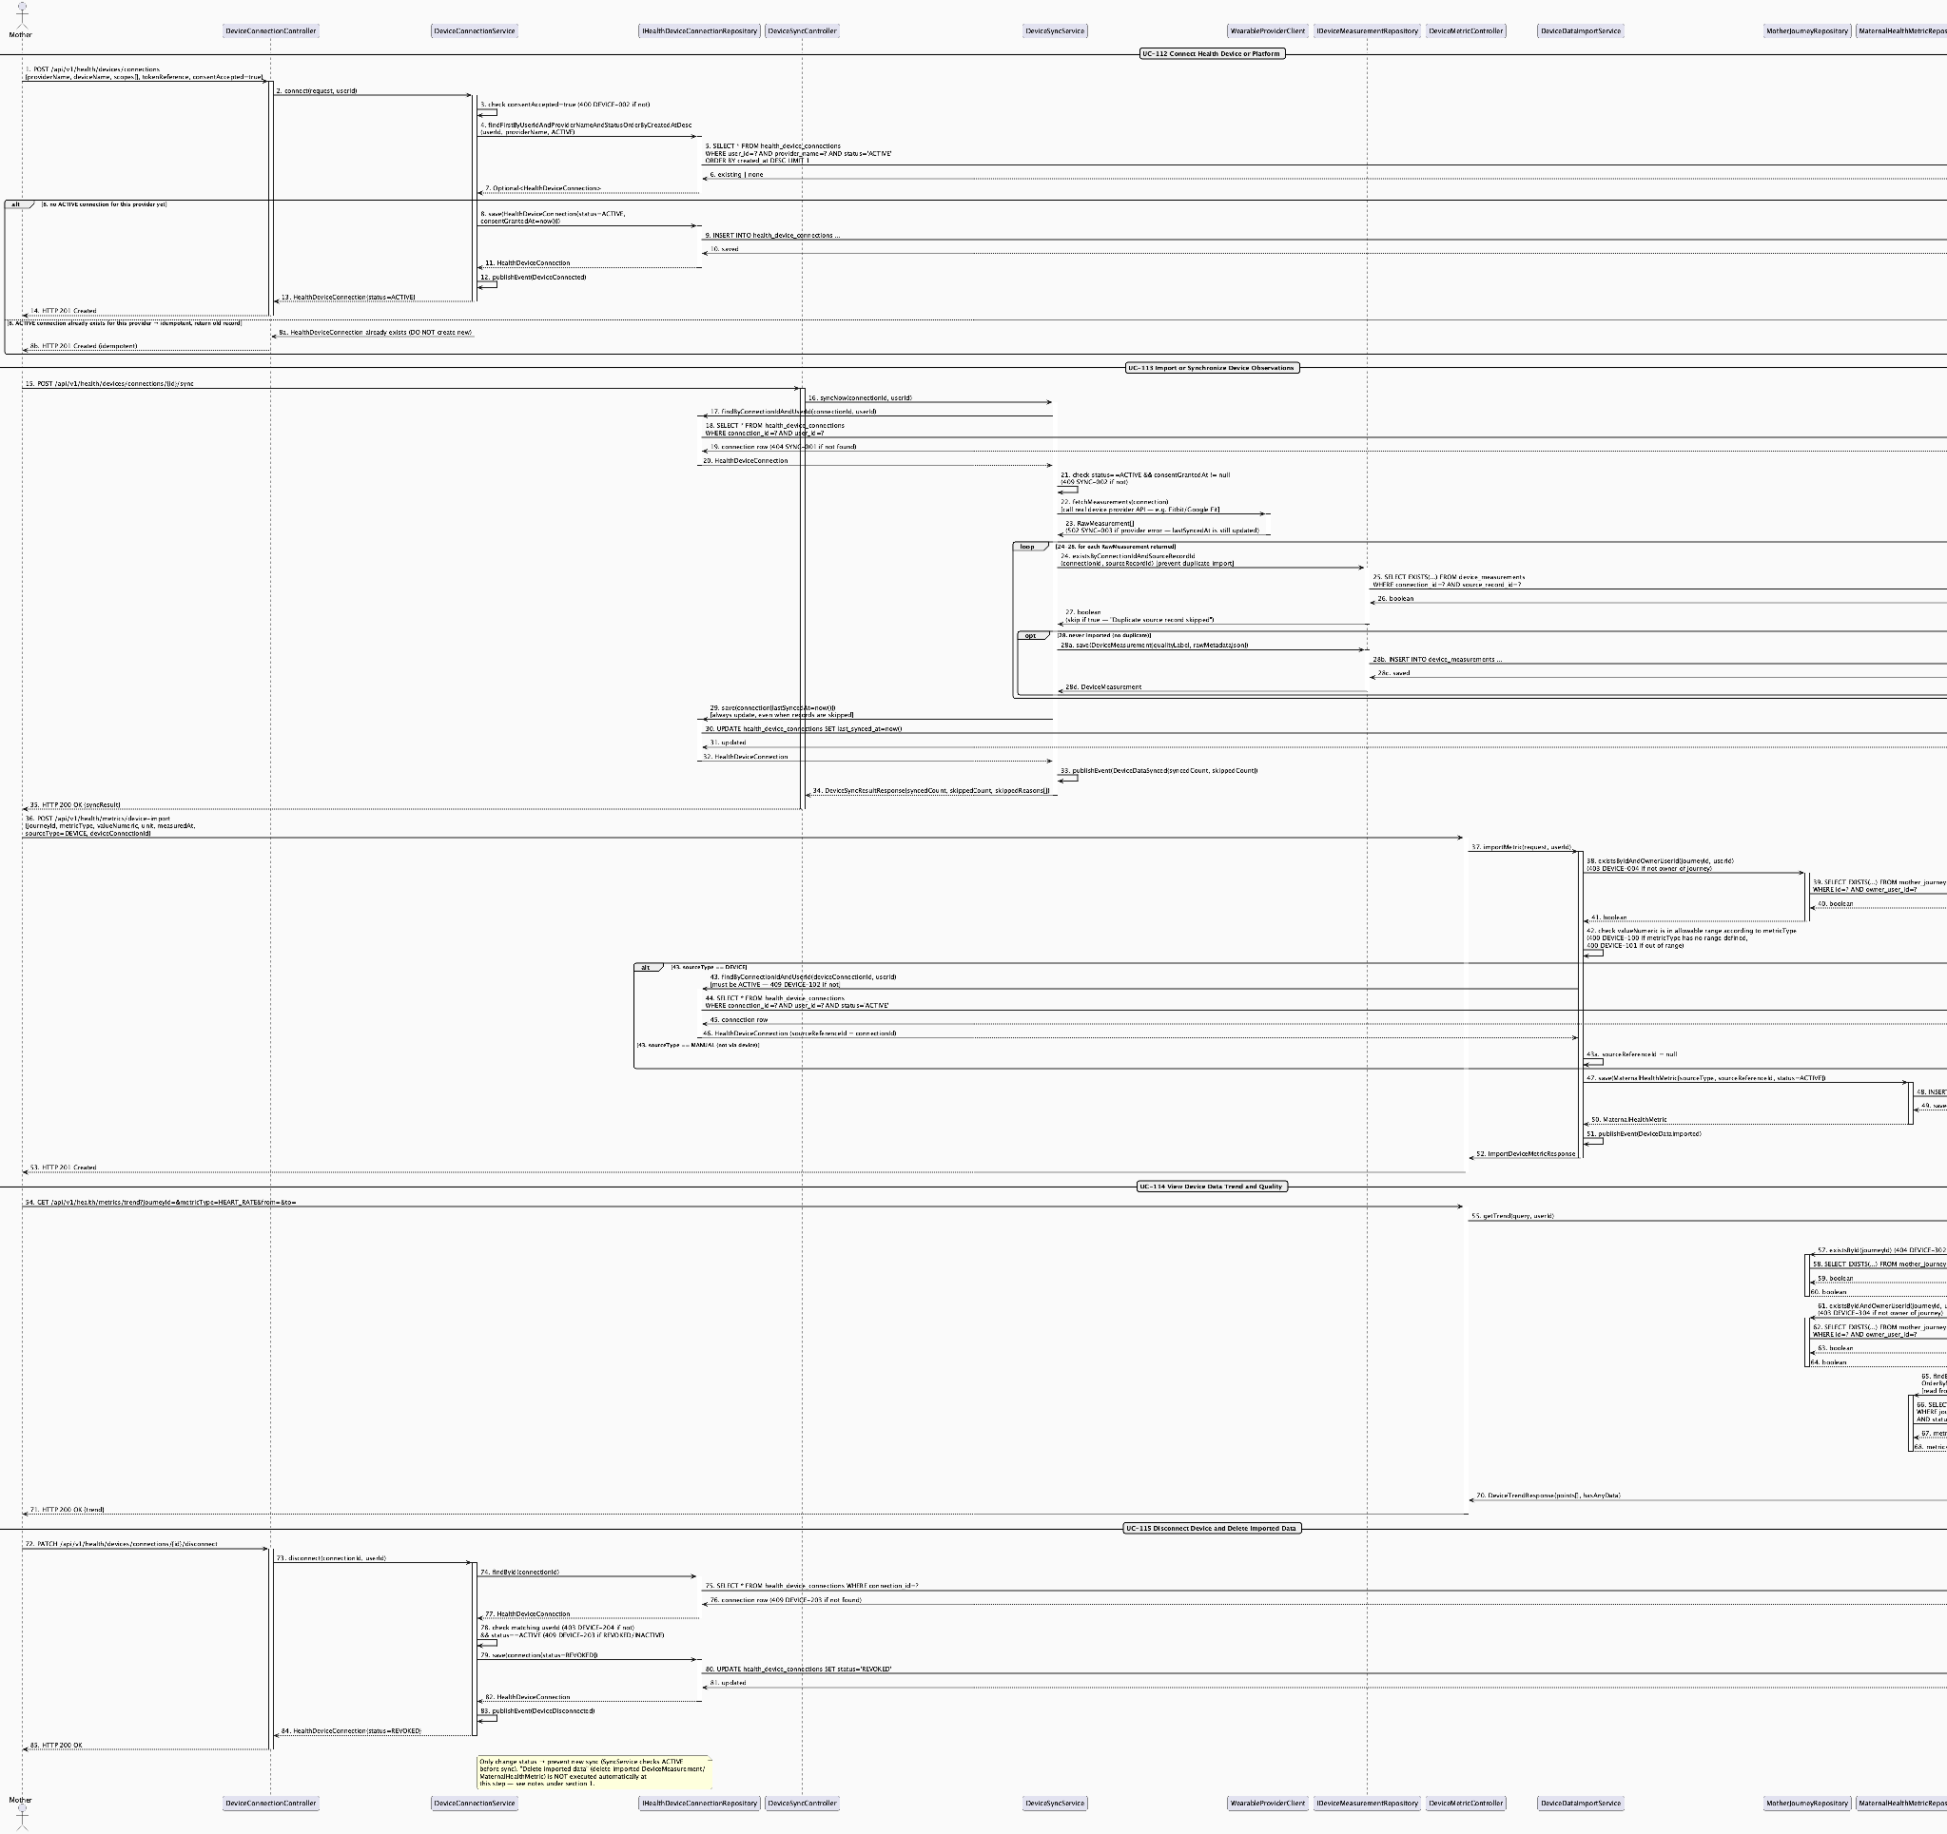
Connected Device: Connection, Sync, Trend & Disconnect Lifecycle Sequence Diagram
Detail: Connected Device: Connection, Sync, Trend & Disconnect Lifecycle Sequence Diagram

3.14 Smart Activity Monitoring & Safety Support

3.14.1 Smart Activity Monitoring: Configuration & Enable/Disable

3.14.1.1 Class Diagram
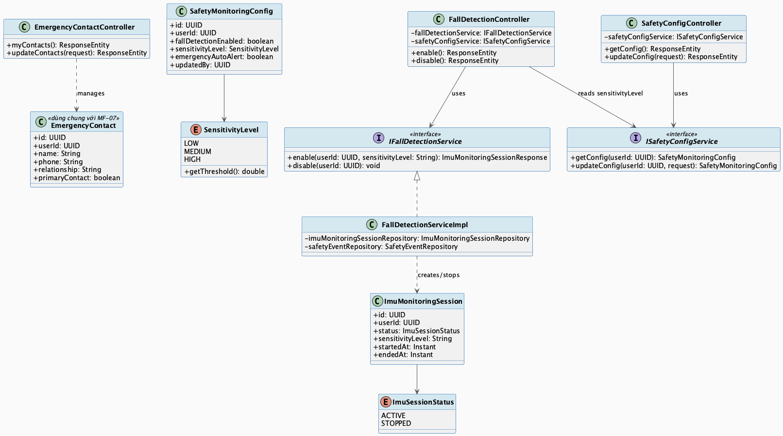
Smart Activity Monitoring: Configuration & Enable/Disable Class Diagram
Detail: Smart Activity Monitoring: Configuration & Enable/Disable Class Diagram

3.14.1.2 Sequence Diagram
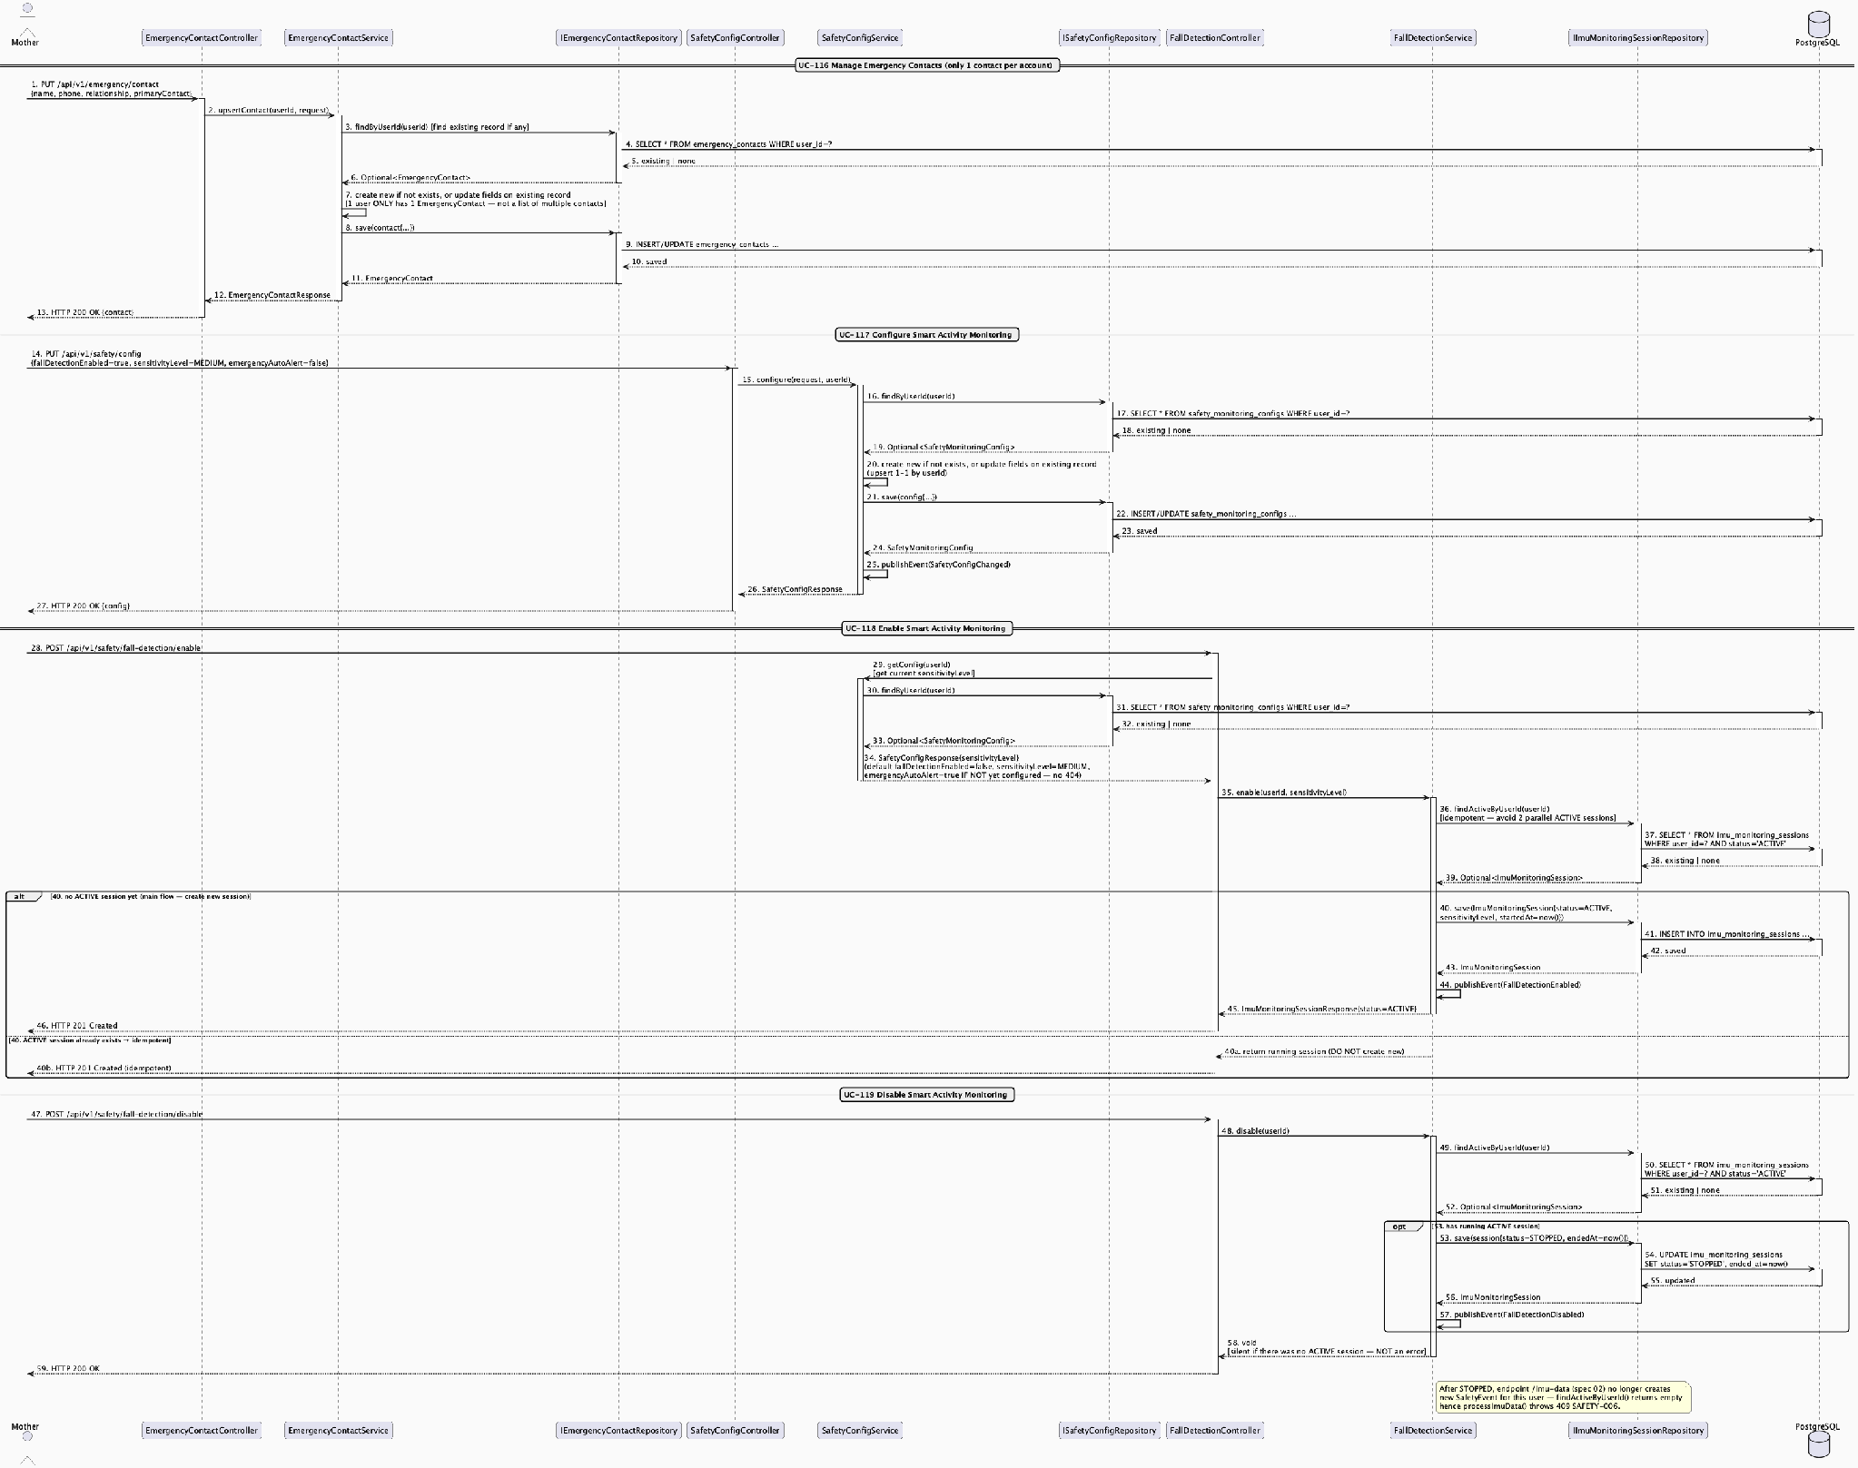
Smart Activity Monitoring: Configuration & Enable/Disable Sequence Diagram
Detail: Smart Activity Monitoring: Configuration & Enable/Disable Sequence Diagram

3.14.2 Suspected Fall/Impact Detection, Safety Check & False-Positive Feedback

3.14.2.1 Class Diagram
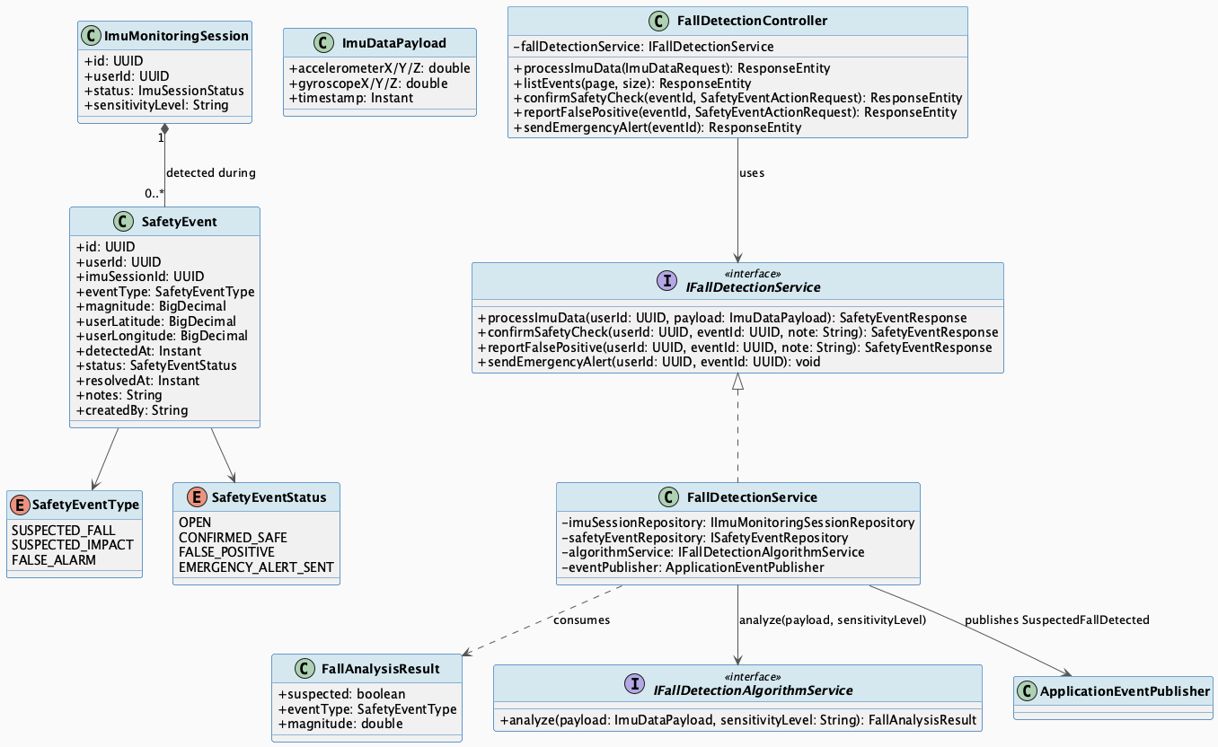
Suspected Fall/Impact Detection, Safety Check & False-Positive Feedback Class Diagram
Detail: Suspected Fall/Impact Detection, Safety Check & False-Positive Feedback Class Diagram

3.14.2.2 Sequence Diagram
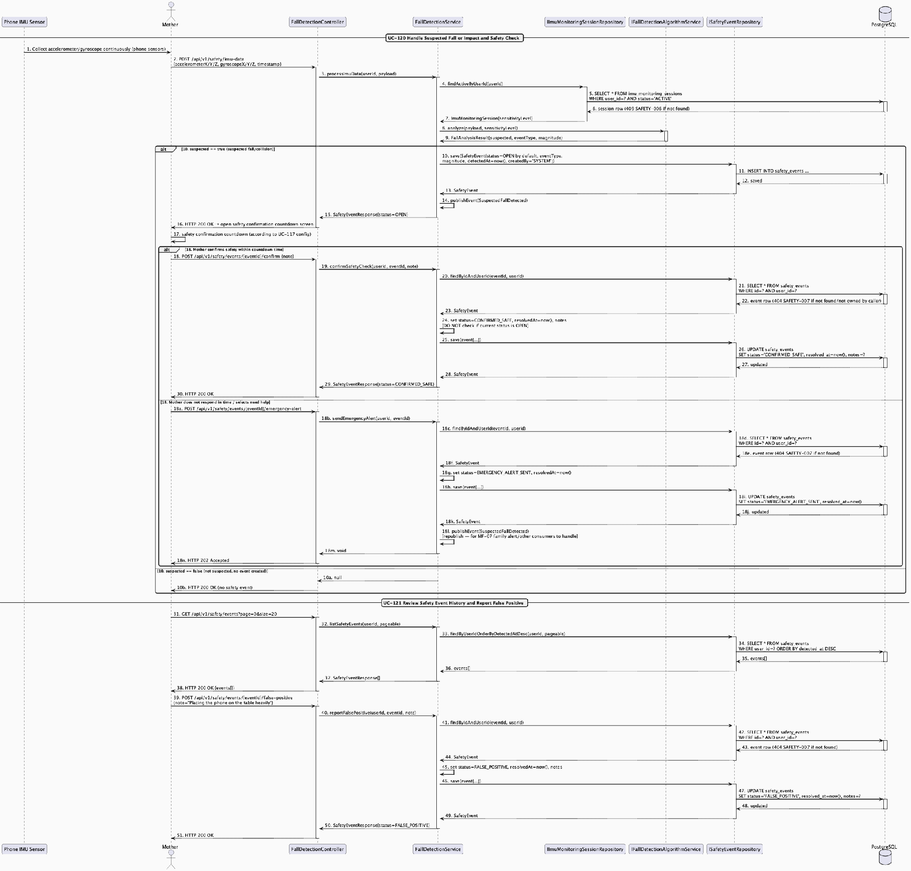
Suspected Fall/Impact Detection, Safety Check & False-Positive Feedback Sequence Diagram
Detail: Suspected Fall/Impact Detection, Safety Check & False-Positive Feedback Sequence Diagram

